
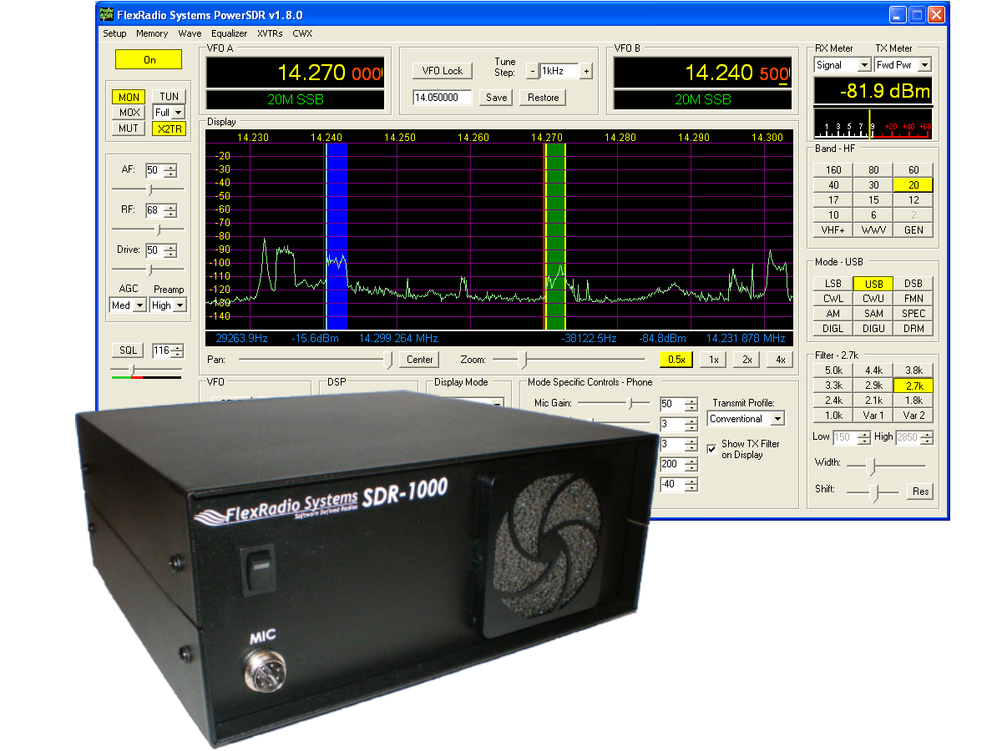
SDR-1000
Operating Manual
Version 1.8.0
SDR-1000 Software Defined Radio

Operating Manual
© FlexRadio Systems
12100 Technology Boulevard • Austin, TX 78727
Phone: (512) 250-8595 • Fax: (512) 233-5143
Email: sales@flex-radio.com

Editor: Joe de Groot – AB1DO

Table of Contents
Preface viii
Acknowledgments x
1 General Description 1
2 Specifications 2
3 Hardware Configuration 3
Standard Configuration 3
High Performance Receiver Preamplifier 3
Fifth Order Low Pass Filters 3
Enhanced 1W PEP Driver 4
28MHz Transverter IF Takeoff 4
Experimental Impulse Generator 4
Enclosure 4
Upgrades 5
2 Meter Transverter 5
100W Power Amplifier 5
Specifications 5
Automatic Antenna Tuning Unit 6
Griffin PowerMateTM VFO Tuning Knob 6
Contour Designs Shuttle Pro V.2 6
External Clock Reference Option 7
USB To Parallel Adapter 7
4 Plug Pinouts 8
External Control Connector (X2) 8
Push To Talk (PTT) Input 9
Mute Receiver 9
External Linear Amplifier Keying 9
Universal Controller Board for Antenna and Transverter Control 9
Enclosure Microphone Connector 10
Keyer Input 11
5 Hardware Setup 12
6 Software Installation & Setup 18
Install Latest Sound Card Drivers 19
Upgrading From an Earlier Version 19
PowerSDR Executable Installation 19
PowerSDR Setup Wizard 24
Sound Card Setup 33
PowerSDR Calibration 34
Frequency Calibration – DDS Clock Adjustment 35
Auto Calibration 35
Manual Calculation 35
Level Calibration – Spectrum & S-Meter 35
Image Null Calibration 36
Automatic Calibration 36
Manual Adjustment 36
Automatic Amplifier Gain Calibration 36
7 Front Console 38
(1) VFO A 40
(2) Tuning Controls 40
(3) VFO B 41
(4) Multimeter 41
RX Meters 41
TX Meters 42
(5) Band Selection & Band Stacking Memories 43
(6) Mode Selection 44
(7) Filter Controls 45
Labeled Filter Buttons 45
Variable Filter Buttons 46
(8) Mode Specific Controls 47
Phone Controls 47
CW Controls 48
Digital Controls 50
(9) Display Controls 50
Panadapter View Controls 51
Display Type Controls 52
Display Type Descriptions 52
Spectrum 53
Panadapter (Panoramic Adapter) 53
Histogram 54
Waterfall 55
Scope 55
Phase 56
Off 56
Cursor and Peak Position 57
(10) Sub-RX Controls 58
(11) DSP Controls 58
(12) VFO Controls 59
(13) CPU % 60
(14) Power (Standby/On) 60
(15) MON (Monitor) 61
(16) MOX (Manually Operated Transmit) 61
(17) MUT (Mute) 61
(18) X2TR 61
(19) ATU Modes 62
(20) TUN (Tune) 62
(21) AF (Audio Frequency Gain) 62
(22) RF (Radio Frequency Gain) 63
(23) Drive (Transmitter Power Output/Tune Power) 63
(24) AGC (Automatic Gain Control) 63
(25) Preamp 64
(26) SQL (Squelch) 64
(27) Date/Time Display 65
(28) Setup Form 65
(29) – (33) Operating Forms 65
8 Setup Form 66
General Tab 67
Hardware Config Sub-Tab 67
Radio Model 67
Hardware Setup 68
DDS 69
Options Sub-Tab 70
Options 71
Process Priority 71
Update Notification 72
Click Tune Offsets (Hz) 72
Auto Mute 72
Main Console (Always On Top) 73
Keyboard 73
Calibration Sub-Tab 74
Freq Cal 74
Level Cal 74
RX Image Reject Cal 75
Filters Sub-Tab 75
Audio Tab 76
Sound Card Sub-Tab 76
Sound Card Selection 76
Buffer Size 76
Sample Rate 77
Line In Gain 77
Mic In Gain 77
Latency 77
Output Voltage 77
Sound Card Setup Details 78
VAC Sub-Tab 79
Gain (dB) 79
Auto Enable 80
Display Tab 80
Spectrum Grid 81
Refresh Rates 81
Waterfall 82
Multimeter 83
Phase Resolution 83
Scope Time Base 83
Averaging 83
Polyphase FFT 84
DSP Tab 84
Options Sub-Tab 84
Noise Reduction 85
Automatic Notch Filter 85
Buffer Size 86
Noise Blanker 86
Noise Blanker 2 87
Image Reject Sub-Tab 90
Receive Rejection 90
Transmit Rejection 91
Keyer Sub-Tab 92
CW Pitch 92
Connections 93
Options 93
Signal Shaping 94
Semi Break In 94
AGC/ALC Sub-Tab 95
AGC 95
Leveler 96
ALC 96
Transmit Tab 97
TX Profiles 98
Transmit Filter 98
Noise Gate 99
VOX 99
TX Monitor 100
Compression 100
AM Carrier Level 101
PA Settings Tab 102
Gain By Band (dB) 102
Ext. Ctrl Tab 103
Appearance Tab 104
Display Sub-Tab 104
Overall Display 104
Cursor/Peak Readout 105
Panadapter 105
General Sub-Tab 106
VFO 107
Band Data 107
Meter Sub-Tab 108
Original Style 109
Edge Style 109
Keyboard Tab 110
Cat Control Tab 111
Cat Control 112
PTT Control 113
Test 114
Tests Tab 115
TX IMD Text: 115
Audio Balance Test 115
X2 116
Impulse Test 116
Signal Generator 116
9 Operating Forms 117
(29) Memory Form 118
Save… 118
Recall… 119
(30) Wave Form 120
Playback 120
Playlist 121
Record 121
TX Gain (dB) 121
Record Options 121
Receive 122
Transmit 122
(31) Equalizer Form 122
(32) XVTRs Form 123
(33) CWX Form 124
Standard CWX Controls 124
CWX Memories 125
Special Characters 125
Keyboard and Extended Controls 126
Extended CWX Controls 126
Morse Definition Editor 128
10 Operation 129
Power-Up Procedure 130
Power-Down Procedure 130
Tuning Methods 131
Spectrum Drag and Click 131
Mouse Wheel 131
Mouse Wheel Hover 131
Spectrum Click Tuning 131
Keyboard Keys 132
USB Tuning Knob 132
Voice Transmission Operation 133
CW Transmission Operation 136
Initial Settings 137
Internal Keyer 138
External Keyer 139
CWX Form 140
Third Party Program 141
Digital Mode Operation 144
CAT Control Setup 147
Install VCOM 147
Configure the VCOM Port Pairs 153
Configure PowerSDR CAT Control 155
Configure PowerSDR Keyer Connections 156
Virtual Sound Connection 157
Create the Virtual Audio Cables 157
Setup VAC in PowerSDR 158
Setting up Third Party Digital Programs 158
Using MixW with PowerSDR 159
Programs Needing to Connect to the Default Sound Device 164
ATU (Antenna Tuning Unit) Operation 166
11 Troubleshooting 168
The software is oscillating quickly between receive and transmit modes. 168
Relays do not click when starting the software or when cycling the software power button. 168
Relays click, but I have no audio. 173
Relays click and I hear static, but no signals. 176
I hear signals, but they sound chopped up, like a motorboat. 176
I hear signals, but cannot null the image. 177
The signals are all off frequency. 178
The noise hiss when no signals are present is fatiguing. 178
Software does not respond to PTT signals. 178
The receiver works great, but I am getting no output power. 179
I am getting some power out, but the power seems low (also, see above—no power issue). 179
I am getting signal reports that indicate echoing or distortion. 180
I am getting signal reports that indicate I am transmitting DSB while in SSB modes. 180
I am getting an error message that says, “Error communicating with ATU.” 181
It seems like the ATU is not tuning correctly. Is there a way to check? 181
I get an error when I try to use my USB Adapter that says “USB Device not found. (-1)” 182
I see a hump around 10kHz below the center line on the display, that doesn’t seem to go away. 182

Preface
Welcome to the exciting world of software defined radio. The SDR-1000 software defined transceiver is by nature ever (rapidly) evolving. It is therefore unlike most other transceivers, which once acquired, rarely if ever change.
Although the rapid development of the SDR-1000 can be exhilarating, it can also be somewhat daunting. When first confronted with an SDR-1000 and its PowerSDR™ operating software, the sheer number of connections, controls, and settings can seem mind boggling even to the most seasoned Ham radio operator. This operating manual attempts to both guide a user step by step through the setup process (both hardware and software) and to act as a reference once the radio has been set up. Additionally, the freely downloadable PowerSDR software will install with default settings that, in most cases, will require little adjustment. Any adjustments that you make are automatically saved and can be imported into an updated version of the software.
Due to the nature of the SDR-1000, the largest part of this operating manual, by far, will refer to software. The operating manual has numerous screenshots of windows and forms to detail the various steps. Although the manual describes the latest official release of the PowerSDR software, you may occasionally notice an earlier version identified in the title bar of a screenshot. This is because FlexRadio Systems™ has decided to only update a screenshot if it changes.
The first three chapters of this manual will give you an overview of the SDR-1000 radio. Chapters 4 and 5 will guide you through the hardware setup, which apart from the connections to the parallel (or USB) port and sound card of a computer, will not differ much from the transceivers to which you are most likely already acclimated.
Chapter 6 details the installation of the PowerSDR software and calibration routines. Once completed, you should be able to engage in your first QSO. For additional guidance on operating the SDR-1000 in various modes, you may want to refer to chapter 10: Operation. This is especially recommended for operating digital modes and CW, as this may be somewhat different from what you are accustomed to.
Chapters 7, 8, and 9 describe in detail the various controls on the Front Console, Setup Form and Operating Forms respectively. You may want to reference these chapters to familiarize yourself with the exact functioning of these controls and their often many options and settings.
Finally, chapter 11 is a troubleshooting guide, which should help you through various issues you may face. If you cannot find an acceptable answer to an issue you may have, please do not hesitate to contact us either by email or by phone (both found on our website). You may also want to check out our website and its ever expanding Knowledge Base
If you have any ideas on how to improve the SDR-1000, please feel free to contact us, or better still, to join our email reflector (see our website for details). Not only is the SDR-1000 a software defined radio; it is also a user defined radio.
FlexRadio Systems is committed to ensuring that your experience with the SDR-1000 will be one of the most enjoyable you have with Ham radio.

[The rest of this page has been left blank intentionally]

Acknowledgments
FlexRadio Systems could not be as successful, nor could the SDR-1000 radio be what it is today without the many selfless contributions of our users all over the world. These contributions have spanned and continue to span improvements to our hardware and software, ranging from bug reports and feature requests to actual design and implementation of certain functionality.
Identifying contributors by name would only risk leaving out others with equally valuable contributions. We therefore wish to suffice with a heartfelt thank you for your support and continued commitment.

[The rest of this page has been left blank intentionally]

General Description
The SDR-1000 Software Defined Radio is an open-software; 1 or 100W transceiver providing general coverage receive operation with amateur radio band transmission between 12kHz and 60MHz.
The FlexRadio SDR-1000 is a complete Software Defined Radio (SDR) transceiver designed for Amateur Radio use. It is the first fully open software transceiver that uses a personal computer (PC) for all Digital Signal Processing (DSP) and control functions of the radio. General coverage receiver operation is provided from 12kHz to 60MHz along with transmit capability on all licensed amateur bands within the coverage range. The theory behind the SDR-1000 is described in detail in a four part QEX magazine series entitled, “A Software Defined Radio for the Masses.” The articles are available for download from the FlexRadio website at www.flex-radio.com. There are also links on the site to other excellent reference materials related to SDR and DSP theory.
Since its introduction, additional hardware components have been added to further improve the functionality and performance of the SDR-1000. The PowerSDRTM software, written in C#.NET, provides a full featured transceiver interface and digital signal processing for the SDR-1000. It is continuously improved over time through open source enhancements supplied by both customers and FlexRadio Systems.
The basic hardware consists of four boards in a stack within an enclosure. The hardware provides a LNA, filters, mixer, power, i/o interfacing and 1W PEP driver. Also provided is a standard interface to the optional Down East Microwave 2 meter low power transverter (intended for use in VHF, UHF, and Microwave systems), as well as an interface to the optional 100W power amplifier and the ATU (LDG Z-100). Additionally available is an
optional interface for an external, customer supplied 10 MHz reference clock oscillator that may provide precision frequency control.
The Contour ShuttlePro v2 USB controller offers the ability to control the radio the way you want to without having to use a mouse or keyboard. With 15 programmable buttons and 2 concentric tuning dials (one spring loaded jog dial), this accessory offers an unparalleled level of programmable hardware control.

Specifications
(Specifications are subject to change without notice)

Table 1: Specifications
Receiver
Receiver Frequency Range | 12kHz-60MHz
IP3 (2kHz Tone Spacing) | +30.3dBm (Preamp MED), 19.3dBm (Preamp HIGH)
IMD DR3 (2kHz Tone Spacing) | 103.5dB (Preamp MED), 100.2dB (Preamp HIGH) ²
MDS | -131dBm (Preamp HIGH), -121dBm (Preamp MED) ²
Minimum Tuning Step | 1Hz (DDS down to µHz)
DDS Clock | 200MHz, <1ps RMS jitter
Max. Receive Bandwidth | 192kHz (Limited by sound card)
Transmitter
Transmitter Frequency Range | 160-6m Bands (2m transverter IF optional)
Transmit Power | 100W HF 160-10m w/optional amp, 500mW 6m
Controls
Control Interface | PC Parallel Port (DB-25 connector) or optional USB
Rear Panel Control Outputs | 15 pin D-connector for external TR relay and band control relays
Input Controls | PTT foot switch, Code Key, Microphone
Audio Interface | Line In, Line Out, Speaker Out, Microphone In
General
Enclosure Dimensions | 10" W x 9.5" D x 4.5" H (25.4cm x 24.1cm x 11.4cm)
Power Supply Requirement | 13.8VDC @ 1.25A (Max). 25A with optional 100W PA

Hardware Configuration

Standard Configuration

High Performance Receiver Preamplifier
The receiver front end incorporates a Sirenza Microdevices SGA-6286 SiGe HBT MMIC amplifier with a noise figure of less than 2dB. With the INA baseband gain of the SDR-1000 set to 26dB, the overall receiver noise figure is approximately 4dB. The TRX board also allows 0dB INA gain setting for large signal handling capability. A 10dB fixed attenuator may be switched in front of the LNA to increase IP3 when needed. Overall there are four gain settings done in hardware to allow you to optimize the front end for your needs.
- The front end of the SDR-1000, provides the following key benefits:
- Lower receiver noise figure
- Reduces relative strength of DDS local oscillator spurs in relation to the signal of interest
- Lowers local oscillator radiation in relation to the signal of interest
- Fixed source/load impedance for the filters
- Fixed source impedance for the QSD (Quadrature Sampling Detector, IQ Mixer)

Fifth Order Low Pass Filters
Nine 5th order low pass filter banks are provided to cover all amateur bands from 160M-6M. Since the filters are low pass, general coverage reception is still provided. The filters improve 3rd harmonic rejection by more than 35dB over the original SDR-1000. There are BPF filters in front of the preamp board (in the signal chain) to provide overload protection for the LNA. The LNA is then followed by the low pass filters, which in turn
drive the QSD (mixer) on the TRX board. A spare filter bank is provided for user configuration to allow improved coverage on other bands such as medium wave or VLF bands. While the SDR-1000 covers frequencies down to 11kHz, additional filtering is required to minimize response to odd order harmonics. The optional filter bank allows the user to customize the radio to add support for such frequencies.

Enhanced 1W PEP Driver
The low power model incorporates a 1W PEP driver amplifier. The driver is between the new front end low pass filters and the band pass filters on the BPF board, which yields increased harmonic suppression. The driver circuit also allows for amplifier stability when driving capacitive loads and increases the gain to reduce sound card drive requirements.

28MHz Transverter IF Takeoff
The RFE provides an internal connector for integration of the Down East Microwave 2M transverter IF (DEMI144-28FRS). Only a single coax cable is required for both RF and TR control. The SDR1K-ENC enclosure has mounting holes to allow either common or separate transmit/receive connections for transverters. You can even set up the SDR-1000 to provide a dual 144/28MHz IF to cover all of the VHF through microwave bands.
Key features of the DEMI144-28FRS are:
- 144-146MHz coverage
- Unity gain receive conversion
- 4dB NF maximum
- +17dBm double balanced mixer
- Three chamber helical filter
- 100mW nominal linear output

Experimental Impulse Generator
An experimental circuit has been incorporated that creates a 4.5ns pulse for equalization of the QSD and sound card quadrature path. DSP software will be written to calculate the impulse response of the circuit and automatically correct for phase and amplitude imbalances between the channels. In theory, this will provide dynamic opposite sideband rejection optimization.

Enclosure
The SDR1K-ENC enclosure is designed to accommodate expansion options including the Down East Microwave 2M IF transverter and the 100W PEP HF linear amplifier and LDG Z-100 automatic antenna tuning unit options. Rear panel connections are provided for the PC parallel control port, sound card interface, 7 external control lines, split or common transverter RF connections, and QRP and QRO RF connections. An AUX mounting hole is provided for the 10MHz reference clock option connector when precision frequency control is desired.

Upgrades

2 Meter Transverter
The DEM 144-28FRSK is a low power, high performance 144 MHz to 28 MHz transverter kit design to be used in conjunction with Flex Radio System’s SDR-1000 Software Defined Radio transceiver. It is intended to be used as a 2nd conversion IF for microwave transverters. The 144-28FRSK has a nominal linear output power of 50 - 100 mW with the 28 MHz. IF drive provided by the SDR-1000. On the receive side, a high dynamic range amplifier, a high level double balanced mixer (+17.0 dBm) and a three chamber helical filter are employed to providing a over load proof, unity gain front end with superior selectivity. It is the same design as our high performance 2 meter transverter but without the GaAs FET front end that would provide excessive system gain not require in a microwave transverter system. The transverter is complete with all interfacing required to install in the SDR1K-ENC enclosure and operate with the SDR-1000.
The 144-28FRSK’s 144 MHz input/output utilize BNC connectors (supplied in this kit) that are mounted in the existing holes in the SDR1K-ENC enclosure. The transverter also has a built in relay for external switching duties if required. It will “Shadow” the TR switch timing of the SDR-1000. The only external wiring required to operate a microwave transverter after the completion of this kit are a simple BNC cable or cables that will carry both TX and RX signals along with the keying voltage to activate the microwave transverters of choice transmit functions. It is a complete, simple to use kit and will provide the highest 2 meter to microwave transverter performance on the market today.

100W Power Amplifier
The SDR-100WPA is a 100 Watt HF linear power amplifier, designed exclusively for installation in SDR-1000 Software Defined Transceivers. Adding the 100WPA to existing radios required limited kit building skills including wire/coax preparation, connector assembly, soldering, and mechanical assembly.

Specifications
- Power output: 100W PEP, 50W on 60m
- Bands: 160, 80, 60, 40, 30, 20, 17, 15, 12, 10 meters
- Elliptical filters on all bands
- Drive requirements: <500mW for full output
- Output transistors: Rugged matched pair 2SC2879s
- Duty cycle: Designed for intermittent SSB service (40W continuous duty)
- Harmonic Content: < -43dBc
- Load tolerance: 2:1 SWR or better
- Software monitoring: Forward/Reverse Power and SWR
- SWR protection: automatic power reduction for SWR > 2:1
- DC power requirements: 13.8VDC @ 25A nominal for full output
- Internal fuse: 25A automotive mini fuse with reverse polarity protection
- Output: BNC 50 Ohm on rear panel
- Cooling: 80x80x15mm, 23dB-A fan provided
- Internal expansion connections: ATU RF In/Out and control

Automatic Antenna Tuning Unit
The SDR-ATU is a fully integrated automatic antenna-tuning unit across the entire HF range. It will tune dipoles, verticals, Yagis or virtually any coax-fed antenna. It will match a wide range of antennas and impedances. Features include:
- Microprocessor controlled, switched L tuning network
- Automatically matches antennas from 6-800 ohms impedance, or a 10:1 SWR, 3:1 on 6m
- Tunes from memory in less than one half second. A full tune will take from 1-6 seconds.
- 200 memories for almost instant return of previously tuned frequencies.
- Continuous coverage from 1.8 to 54 MHz
- Power range 0.1 to 125 Watts, 50 Watts on 6m

Griffin PowerMateTM VFO Tuning Knob
The attractive GCN-SLV Griffin Technology PowerMate control knob connects to a USB port to provide variable-rate VFO tuning for the SDR-1000. A simple click of the knob changes the tuning rate to any of four user configured tuning rates. It can even be programmed to set the volume by a press, hold, and turn of the knob. Made of high-quality machined aluminum, PowerMate feels like a solid volume knob pulled right off the front of a world-class stereo. Its heavy weight and tactile feel are a welcome departure from typical plastic USB peripherals.

Contour Designs Shuttle Pro V.2
The ShuttlePro V.2’s sleek innovative design, pre-configured for many of today's popular applications, advanced programmability, and ease of use is in short, the perfect marriage of form and function.
The ShuttlePro V.2 is a powerful productivity enhancement tool for the PowerSDR software. The ShuttlePro V.2 even comes pre-configured for many of the leading applications. You can also easily customize the ShuttlePro V.2 for virtually any application.
The ShuttlePro V.2 is designed for ergonomic integrity and maximizing productivity, allowing one-hand access to the fully programmable buttons and jog/shuttle knob. Nine (9) of the buttons have removable keycaps for easy labeling and referencing. The inner ring or 'jog' rotates through 360 degrees and provides precision control. The outer black ring or 'shuttle' is rubberized and spring-loaded. It facilitates tuning and radio control. You can also use the jog and shuttle for many other purposes such as scrolling, volume control, and sequencing.

External Clock Reference Option
The SDR-CLK External Clock Reference Option kit provides the connection required to operate the DDS oscillator from an external 10MHz or 20MHz precision frequency reference. GPS locked oscillators may be used in this configuration to provide precise frequency control of the SDR-1000. The internal 200MHz oscillator must be removed to use the external reference clock.
Note: This option requires a customer provided precision clock source not provided by FlexRadio Systems.

USB To Parallel Adapter
The SDR-USB is a USB to parallel communications adapter, specially designed to control the SDR-1000. It allows the radio to be used with computers that do not have a parallel port available. The SDR-USB supports all of the control and status lines required by the SDR-1000 and has special firmware to offload hardware polling tasks from the PC. A separate download and installation of driver software is required.

[The rest of this page has been left blank intentionally]

Plug Pinouts

External Control Connector (X2)
The 15-pin, high-density, female “D” connector is found on the rear panel. It offers seven open collector Darlington outputs that allow control of external devices such as transverters, relays, antennas, power amplifiers, etc. It also includes two dedicated push-to-talk (PTT) inputs (Pins 10 & 11 – see below). The connector has 5VDC power at up to 50mA for powering external relays or logic. The open collector outputs may also be used with external power supplies up to a maximum of 50VDC. The maximum collector current for a single output is 500mA. A common output clamp diode return is provided (Pin 8) to handle relay transients. The table below details the pin connections. If you prefer not to hand-wire the connector for any reason, cut the end off a VGA PC monitor cable and use its respective leads.
Table 2: X2 Pin Connections and Diagram
Pin # | Function | Specification | Diagram
1 | Control 1 | Open Collector – 50V, 500mA Max. | 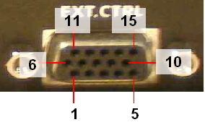
2 | Control 2 | Open Collector – 50V, 500mA Max.
3 | Control 3 | Open Collector – 50V, 500mA Max.
4 | Control 4 | Open Collector – 50V, 500mA Max.
5 | Control 5 | Open Collector – 50V, 500mA Max.
6 | Control 6 | Open Collector – 50V, 500mA Max.
7 | PTT Output (PA Control)* | Open Collector – 50V, 500mA Max.
8 | Common Protection Diode | Connect to Relay + Supply
9 | Not Connected | Not Connected
10 | PTT Input (Secondary) | SSB/AM/FM only (no CW) – Ground this line to key transmitter
11 | PTT Input (Main) [S3] | Works in all modes – Ground this line to key transmitter
12 | Software Audio Mute** | Pull to ground to Mute the receiver.
13 | Not Connected | Not Connected
14 | Vcc | 5VDC Output @ 50mA
15 | Ground | Signal Ground for all inputs/outputs
* Requires enabling X2 TR Sequencing on the Setup Form - General Tab, Options Sub-Tab.
** Requires enabling Auto Mute on the Setup Form - General Tab, Options Sub-Tab.

Push To Talk (PTT) Input
The External Control (X2) connector has two PTT input connections as seen in Table 1 above. Pin 11 works in all modes, while Pin 10 works only in voice modes. Pin 11 is recommended for most applications. PTT is activated by grounding to Pin 15 either of the two respective pins.

Mute Receiver
The External Control (X2) connector has a pin dedicated to muting the receiver for multiple transceiver operation. Simply ground Pin 12 to Pin 15 to activate the software MUT (Mute) control. Note that this does not disconnect the coaxial connector from the receiver. External antenna switching is necessary to ensure that high power signals are not sent directly to the SDR-1000 receiver front end.

External Linear Amplifier Keying
External linear amplifiers may be keyed using Pin 7 on the External Control (X2) connector. Most amplifiers are switched by grounding its keying input. Connect Pin 7 (PTT Output) to the hot lead of keying input and Pin 15 to the amplifier ground. This output uses an open collector Darlington transistor switch that is rated at 500mA, 50VDC maximum.
To ensure that your amplifier keying circuit does not damage the Darlington transistor switch, insert the circuit shown in the figure below between Pins 7 and 15 on X2 and your amplifier.
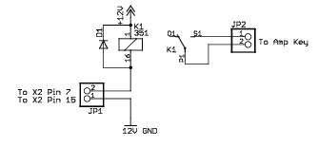
Figure 1: Protective PTT Circuit Between SDR-1000 and Amplifier

Universal Controller Board for Antenna and Transverter Control
The Universal Controller Board (UCB) is a customer developed and supplied accessory that connects to the External Control (X2) connector. It allows automatic software control of up to 16 antennas and/or transverters.
The Universal Controller Board is an extension of the SDR-1000 to enable additional control of external devices by the radio. The SDR-1000 X2 connector provides 6 open collector output pins for user defined functions. The purpose of the UCB is to accept data from the SDR-1000 via the X2 connector to be loaded into a 16X16 memory matrix on the UCB. Pins 1 through 4 of the X2 connector are used as an address field by the UCB to address one of 16 registers within the memory matrix. Each one of these UCB registers has 16 bits, of which any combination can be operational. Each bit in a register corresponds to a relay that will be picked.

Enclosure Microphone Connector
A front panel connector is provided for microphone and push-to-talk (PTT) input. Depending on when your radio shipped, the connector will be a 4 or 8 pin connector. See the table below for the pinouts for each of these connectors. The PTT input must provide a contact closure to ground to activate the transmitter.
The 8-pin microphone configuration offers the ability to connect a balanced microphone through the front panel connector. Keep in mind that it is possible to plug a microphone directly into either of our recommended sound cards (Delta-44 and Edirol FA-66). They both offer ¼” connectors and the Edirol FA-66 has true balanced inputs along with XLR connectors and adjustable Mic Preamps.
Radios shipped after January 11, 2006 have an 8-pin connector. Radios shipped before that date have a 4-pin connector, but the wiring configuration of this connector has been modified on all radios shipped after February 4, 2005 from those shipped before that date. The following table shows the pin connections and the wiring configurations.
Table 3: Microphone Connector Configurations
Ship Date | Pin # | Signal | Diagram
After  Jan 11 2006 | 1 | Not Connected | 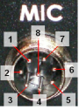
After  Jan 11 2006 | 2 | Not Connected
After  Jan 11 2006 | 3 | Not Connected
After  Jan 11 2006 | 4 | Not Connected
After  Jan 11 2006 | 5 | Chassis GND (Shield)
After  Jan 11 2006 | 6 | PTT (+)
After  Jan 11 2006 | 7 | Mic (–)
After  Jan 11 2006 | 8 | Mic (+)
Before  Jan 11 2006,  After  Feb 4 2005 | 1 | Mic (+) | 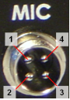
Before  Jan 11 2006,  After  Feb 4 2005 | 2 | Mic (-)
Before  Jan 11 2006,  After  Feb 4 2005 | 3 | PTT (+)
Before  Jan 11 2006,  After  Feb 4 2005 | 4 | PTT (-)
Before  Feb 4 2005 | 1 | Ground
Before  Feb 4 2005 | 2 | Microphone Audio
Before  Feb 4 2005 | 3 | Push To Talk
Before  Feb 4 2005 | 4 | No Connection

We recommend use of the Heil microphones, especially the PR series; however, the HM-10 and Goldline microphones will also work well with the SDR-1000.
Use the procedure found in the Voice Transmission Operation section in order to match the microphone appropriately with the sound card and the DSP.

Keyer Input
To connect either a keyer or straight key to the Key jack on the rear panel use the following table. While the keyer input lines can be reversed on the Setup Form-DSP Tab, Keyer Sub-Tab, we are including this pinout for completeness.
Table 4: Key Plug Pinout
Connector | Keyer Signal | Straight Key
Tip | Dot | Key
Ring | Dash | Key
Sleeve | Common | Common

Note 1: Using a mono 2-conductor type plug will cause problems as the Ring will be shorted to the Sleeve (Key to Common or Dash to Common depending on setup).
Note 2: For optimal (low latency) performance, connect your paddles or keyer directly to a serial port on the PC using the following table. Also see the section on the Setup Form-DSP Tab, Keyer Sub-Tab.
Table 5: PC Serial Port Pinout
Serial Port Pin* | Keyer Signal
4 (DTR) | Common
6 (DSR) | Dot
8 (CTS) | Dash
* Assumes a 9-Pin connector

[The rest of this page has been left blank intentionally]

Hardware Setup
The hardware setup process is as simple as making connections from the SDR-1000 enclosure to the hardware necessary to run the radio (power supply, antenna, parallel port, and sound card). Refer to the numerical callouts in Figure 3 below for the location of all radio connections.
Make sure the power switch on the front panel of the enclosure is in the Off (down – “O” on some models) position. Connect the power supply negative (1) and positive (2) leads to the black (--) and red (+) power supply connectors respectively. Ensure that correct polarity is maintained as reversing the cables can cause damage to the unit. The power supply must provide 13.8VDC at 25A (nominal) for the 100W transceiver and 1.5A for the 1W transceiver respectively.
Make a low impedance connection to earth (RF) ground (8) to properly protect the unit.
Connect the PC parallel port to the parallel connector (10) on the enclosure. Use a 25-pin, male-to-male parallel cable that has all 25 pins connected straight through. These are called RS-232 cables by some manufacturers. Both parallel and audio cables are available from FlexRadio Systems. Make sure the connection is firm as a partial parallel connection can cause sporadic frequency tuning and filter selection.
Note: FlexRadio Systems distinguishes between recommended, legacy and unsupported sound cards. Recommended cards are actively supported and used for system development. Legacy cards are those cards that were previously recommended and are now only passively supported. Unsupported cards include all other sound cards. From time to time FlexRadio Systems will adjust a sound card’s designation; the most up-to-date information is available on our website.
FlexRadio Systems currently recommends two sound cards for use with the SDR-1000: The M-Audio™ Delta-44 is the recommended PCI interface and the Edirol FA-66 is the recommended Firewire (1394) interface card (ideal for laptop connection). Each of these professional grade sound cards offers multiple inputs and outputs which allows us to mix separate monitor and radio outputs as well as leave the radio and microphone connected to the inputs. The audio quality of these recommended cards is also superior to any of our legacy (previously recommended) cards as these legacy cards were all consumer grade. Please refer to the charts and tables on the specifications page of the website that show the superior dynamic range and noise performance of our recommended cards. This is a clear-cut example of professional quality audio equipment (M-Audio) versus consumer quality equipment (Creative). The gap between the two is substantial.
Connect the sound card to the radio as follows. Please consult the Delta-44 Quick Start Guide or the Edirol FA-66 Quick Start Guide. For other cards proceed as follows: First, connect the Line In cable from the sound card Line Input (usually color coded blue) to the plug labeled “To Line In” (14) on the back of the radio. Next, connect the Speaker output from the sound card (usually color coded light green) to the plug labeled “To Line Out” (12). Make sure that if your sound card has multiple speaker outputs you use the one labeled Speaker 1 (or the “front” speakers).
Note: For certain legacy sound cards, it is necessary to install the SDR-LPF/CBL low pass filter on the Line Out connection to prevent wideband noise transmission. The recommended sound cards, Delta-44 and Edirol FA-66, do not require this filter.
Some sound cards, such as the Turtle Beach Santa Cruz and Audigy2 ZS, emit noise that peaks in the 100kHz range and must be suppressed to comply with FCC rules (-43dBc). Instructions for making the SDR-LPF/CBL can be found on the FlexRadio Private Download Page. The cable must be installed with the filter module nearest to the radio. Reversing the cable will not allow the filter to operate properly.
If you have any questions regarding the need to use this filter for your sound card, please contact FlexRadio Systems.
Then connect the Microphone Input from the sound card (usually color coded red) to the plug labeled “To Mic In” (15). Note that this is only necessary if using a microphone connected to the front panel of the enclosure. If using a PC mic, this can be plugged directly into the sound card. Finally, connect amplified speakers to the plug marked SPKR (13). Note that using non-powered speakers or low impedance headphones will load down the transmitter drive to the radio, thereby preventing full power output. This is not an issue with 4-port cards such as the Delta-44 and the FA-66 since the output does not run through the radio.
Note: It is critical that the audio cables used to connect to the sound card are seated flush against the back panel of the enclosure to provide good contact for the stereo input and output. Failure to do so will prevent opposite sideband rejection on both reception and transmission. Cables with wide connector ends are the cause of this issue in most instances. Premium “Gold” cables are NOT recommended because they are typically overpriced and their connectors are usually too large.
If the 100W amplifier is included, connect the HF/6m antennas to the HF/PA (3) connector. WHEN THE 100W AMPLIFIER IS INSTALLED, DO NOT CONNECT ANYTHING TO THE HF/50 MHZ QRP CONNECTOR. This connector is in parallel with the input to the power amplifier. If the amplifier is not installed, connect the antenna to the HF/50 MHz QRP connector for the 1W output configuration.
If the DEMI144-28FRS 2m transverter is installed, its connection(s) go to (6) / (7). Please see the transverter’s installation instructions for connector options that allow for common or split TX/RX. Also, if using the external clock reference option, connect the reference signal to (4).
Note 1: If the 100W amplifier is installed, the AUX hole is covered by the amplifier hardware and the reference connector will be moved to another location (possibly to 6 or 7 if the transverter is not installed).
Note 2: If the amplifier is installed, it is necessary to uncheck the box that enables the PA on the Setup Forms General Tab before attempting to transmit QRP. If the amplifier is disabled in software, the 1W transmitter will be connected straight through to the HF/PA connector. The output on 6m is always QRP since the PA does not cover 6m.
Finally, connect any external hardware control lines (linear amplifiers, transverters, or relays) to the X2 connector (9) as defined in the section on Plug Pin Out above.

[The rest of this page has been left blank intentionally]
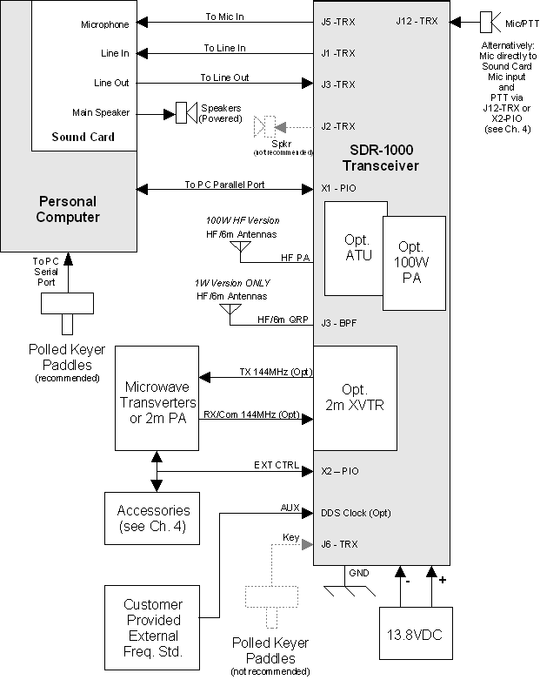
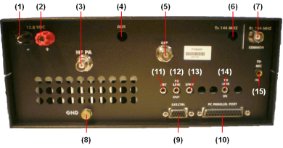
Figure 2: Back Panel of Enclosure
Connections are as follows:
- Power Ground - #12AWG or greater for 100W version.
- 13.8VDC Power - #12AWG or greater for 100W version.
- 100W Power Amplifier Antenna Connector – Use for all bands if 100W amplifier is installed.
- Auxiliary Input Connector for optional External Reference Oscillator.
- 1W QRP Antenna Connector – Use ONLY if 100W amplifier is NOT installed (when installed, this connector is in parallel with the amplifier input circuit.
- Two Meter Transverter Transmit Connector – Used for split transmit/receive operation (See DEMI144-28FRS installation instructions).
- Two Meter Transverter Receive or Receive/Transmit Common Connector – (See DEMI144-28FRS installation instructions).
- Earth (RF) Ground.
- X2 External Control Connector – See Table 1 for connections.
- Parallel Port Connector (to PC parallel port) – Optional SDR-USB USB to Parallel Adapter connects to this port.
- Code Key/Paddles Connector – See previous chapter for connection.
Hint: For optimal (low latency) performance connect the key or paddles to a PC serial port instead (see the section on the Setup Form-DSP Tab, Keyer Sub-Tab in chapter 8 for more information).
- To Line Out (speaker output) on Sound Card – Green color-coded.
- To Amplified Speaker or high impedance headphones.
Note: Do not use if using one of our recommended sound cards (Delta-44 or Edirol FA-66). Instead for best performance and to enable monitoring, connect your speaker(s) directly to the sound card.
- To Line In on Sound Card – Blue color-coded.
- To Microphone Input on Sound Card -- Pink or Magenta color-coded. (This connector is directly connected to the corresponding pins on the front panel mic connector.)

[The rest of this page has been left blank intentionally]

Software Installation & Setup
WARNING! Proper operation of the SDR-1000 depends on the use of a sound card that is officially recommended by FlexRadio Systems. Refer to the Specifications page on www.flex-radio.com to determine which sound cards are currently recommended. Use only the specific model numbers stated on the website because other models within the same family may not work properly with the radio. Officially recommended sound cards may be updated on the website without notice. If you have any question about the sound card you would like to use with the radio, please email support@flex-radio.com or call us at 512-250-8595.
NO WARRANTY IS IMPLIED WHEN THE SDR-1000 IS USED WITH ANY SOUND CARD OTHER THAN THOSE CURRENTLY RECOMMENDED AS STATED ON THE FLEXRADIO SYSTEMS WEBSITE. UNRECOMMENDED SOUND CARDS MAY OR MAY NOT WORK WITH THE SDR-1000. USE OF UNRECOMMENDED SOUND CARDS IS AT THE CUSTOMERS OWN RISK.

[The rest of this page has been left blank intentionally]

Install Latest Sound Card Drivers
Download the latest sound card drivers from the manufacturer. Install the software using the “Driver Only” option if there is one.
Note 1: Using the “Driver Only” option (Audigy 2 ZS, and others) will prevent some software from loading programs that will engage audio effects such as Reverb or Echo by default. This causes problems with the receive and/or transmit performance of the radio. All such sound card audio effects should be turned off to prevent problems with the radio.
Note 2: If using a legacy sound card (or an unsupported sound card without native ASIO drivers) you will need to install ASIO4ALL, which can be found on the Downloads page of our website. If using one of our recommended sound cards (M-Audio Delta-44 or Edirol FA-66), installing ASIO4ALL is unnecessary.

Upgrading From an Earlier Version
It is recommended that you leave older versions of the PowerSDR console installed when upgrading from a previous version. After reviewing the new version and verifying that your setup works, uninstalling previous versions is fine (but not necessary). Note that it is necessary to manually delete the database file (PowerSDR.mdb) from the application directory (usually c:\Program Files\FlexRadio Systems\ PowerSDR x.y.z) in order to completely remove previous versions.

PowerSDR Executable Installation
Download the latest PowerSDR_x.y.z.zip to a directory on your hard drive (saving to the Desktop is recommended) and unzip the contents. Double click the Setup file (Setup.exe) to start the installation process. The PowerSDR installation will prompt you to install the .NET framework if it is not installed and it will point you to the appropriate web address for downloading as seen below.
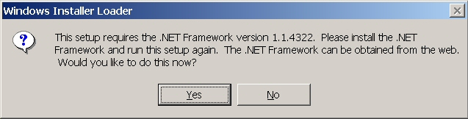
Figure 3: Prompt for .NET Framework
Follow the instructions to install the framework using the download from Microsoft’s website and then restart the Setup.exe program. You should see the following screen.
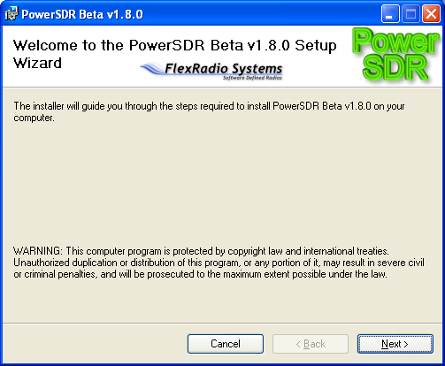
Figure 4: PowerSDR Installation Welcome Screen
Click the Next button to continue.

[The rest of this page has been left blank intentionally]

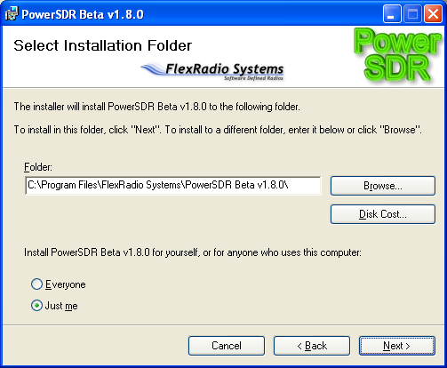
Figure 5: PowerSDR Installation Folder Selection
You can change the installation directory here, though we recommend you use the default for troubleshooting purposes. Click the Next button to continue.

[The rest of this page has been left blank intentionally]

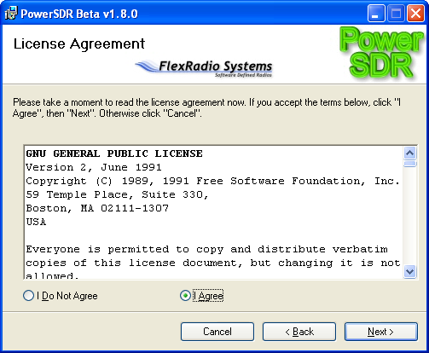
Figure 6: PowerSDR Installation License Agreement
Read the GNU Public License. If you accept, click I Agree and click the Next button to continue. Otherwise click Cancel.

[The rest of this page has been left blank intentionally]

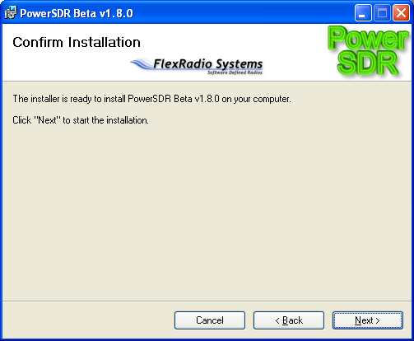
Figure 7: PowerSDR Installation Confirmation
Click the Next button to confirm these settings and to copy the necessary files to the selected install directory. Once the files have been copied, you will see the following screen.

[The rest of this page has been left blank intentionally]

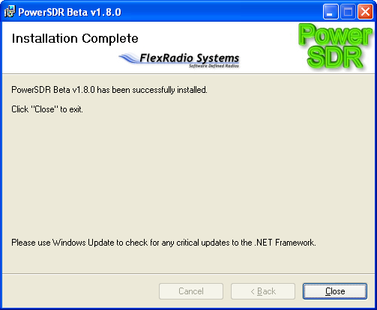
Figure 8: PowerSDR Installation Complete
Click the Close button to complete the installation and close the dialog.

PowerSDR Setup Wizard

Before powering up the radio hardware, load the PowerSDR console using the shortcut on the Desktop (or in the Start menu). When you run (a new release of) PowerSDR for the first time an optimization routine will run and the following screens will appear:

[The rest of this page has been left blank intentionally]
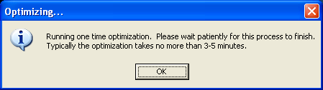
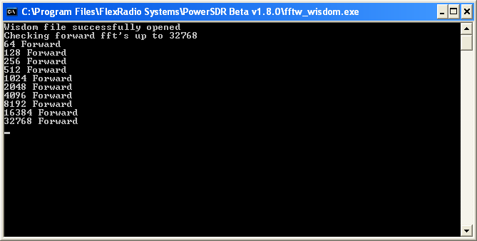

Figure 9: Optimization Routine
Click OK and let the routine run.
Note: This routine aims to optimize the FFT calculations for the environment (hardware and software) in which the calculations will be performed. For optimal performance, you should therefore close all applications you will normally not be running simultaneously with PowerSDR. The routine will save a file called wisdom to the directory in which PowerSDR resides. If you wish to run FFTW again, delete this file from the directory and start up PowerSDR.
When the routine has completed a brief startup sequence will follow, after which you should be greeted by the PowerSDR Setup Wizard as shown in the figure below.

[The rest of this page has been left blank intentionally]
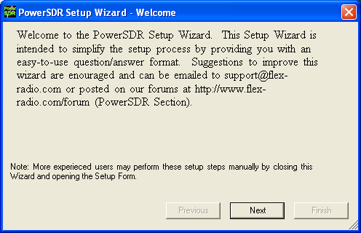
Figure 10: PowerSDR Setup Wizard Welcome
Click the Next button to continue.
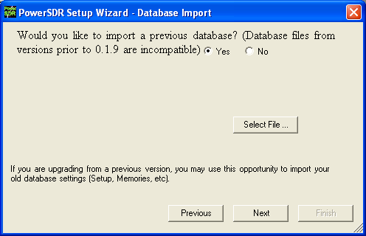
Figure 11: PowerSDR Setup Wizard - Database Import
Click the Yes or No button to indicate whether you would like to import a database from a previous version (assumes you are upgrading). If yes, click the Select File … button and select the PowerSDR.mdb file from a previous version (default directory is C:\Program Files\FlexRadio Systems\PowerSDR x.y.z\). A prompt will confirm that the database file was imported successfully as seen in the screenshot below. Click the OK button.
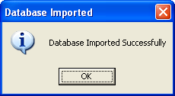
Figure 12: Successfully Imported Database Prompt
Click the Next button to continue. If you imported a database, the rest of the steps will be skipped and you will jump straight to the finished screen.
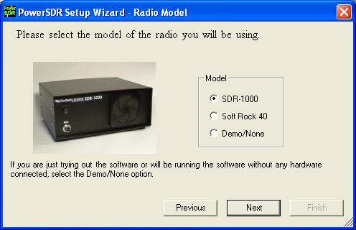
Figure 13: PowerSDR Setup Wizard - Radio Model
Select the radio model you will be using. If you are running without any radio, e.g. for demonstration purposes, select Demo/None. Click the Next button to continue.

[The rest of this page has been left blank intentionally]
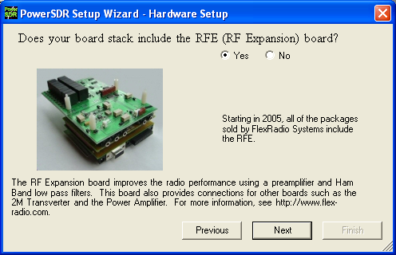
Figure 14: PowerSDR Setup Wizard – RFE
Select the Yes or No button to indicate whether your configuration includes the RF Expansion Board (RFE), and click the Next button to continue.
Note: All SDR-1000s shipped since 2005 include the RFE board.
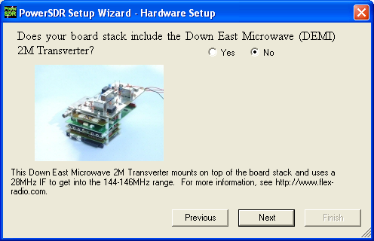
Figure 15: PowerSDR Setup Wizard - 2m XVTR
Select the Yes or No button to indicate whether your configuration includes the optional 2m transverter. If yes, select your model using the drop down box. Note that FlexRadio Systems only sells the DEMI144-28FRS model. It uses negative logic keying on the coax to the transverter. Click the Next button to continue.
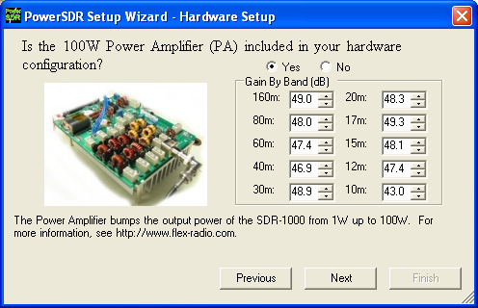
Figure 16: PowerSDR Setup Wizard – PA
Select the Yes or No button to indicate whether your configuration includes the 100W Power Amplifier. If yes, enter the gain values found on the sheet included with the amplifier shipment. Click the Next button to continue.
Note: If you have a dummy load, you should run the Automatic Amplifier Gain Calibration (see later in this chapter) in your own environment for the best calibration.

[The rest of this page has been left blank intentionally]

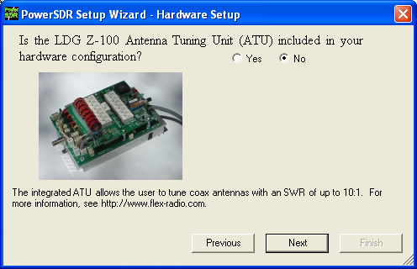
Figure 17: PowerSDR Setup Wizard – ATU
Click the Yes or No button to indicate whether you have the integrated ATU installed. Click Next to continue.
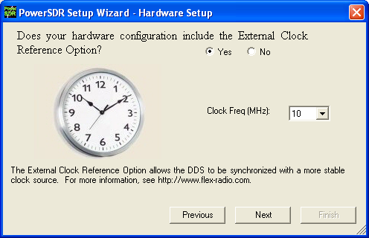
Figure 18: PowerSDR Setup Wizard - Ext. Clock
Click the Yes or No button to indicate if you will be using the optional external clock reference. If yes, select the frequency of your source using the drop down box (10 or 20MHz). Click Next to continue.
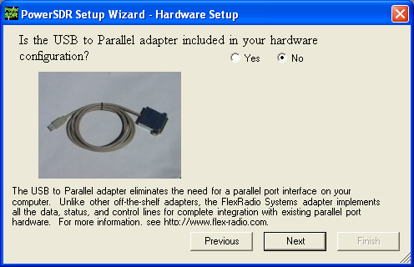
Figure 19: PowerSDR Setup Wizard - USB Adapter
Click the Yes or No button to indicate if you will be using the USB to Parallel adapter. Click Next to continue.

[The rest of this page has been left blank intentionally]

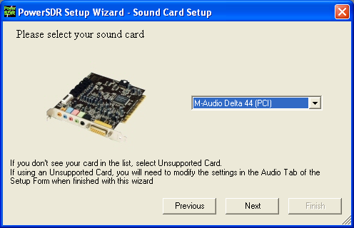
Figure 20: PowerSDR Setup Wizard - Sound Card
Select your sound card from the drop down box. If you are using a card other than the recommended or legacy cards listed on the FlexRadio Website Specifications page, then select the Unsupported Card option (this will require further setup after the wizard is complete). Unsupported sound cards may be used at the customer’s own risk. FlexRadio Systems cannot vouch for proper operation or support for such cards. Click the Next button to continue.

[The rest of this page has been left blank intentionally]
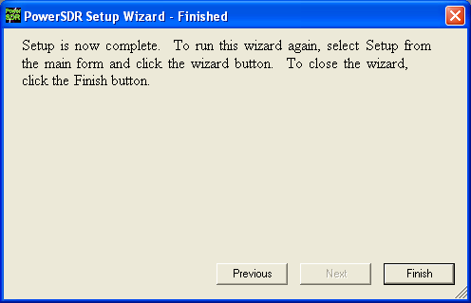
Figure 21: PowerSDR Setup Wizard – Finished
The Setup Wizard is now complete. Click the Finish button to complete the wizard.

Sound Card Setup
Quick Start Guides can be found in our Knowledge Base for the Delta-44 and the Edirol FA-66.
Otherwise, if using a consumer sound card, it may be necessary to do some more software setup. Open the software and look at the Audio Tab on the Setup Form. With the radio powered on and running, adjust the Line In Gain down from 50 until the noise floor just begins to rise. Adjust the value back up 3-4 and call that your optimal Line In gain. If the noise floor never rises, use a value of ‘1’. This will give you the least noise due to the sound card yielding more room for larger signals. This translates into higher dynamic range. Note that making any changes to the Line In gain will invalidate the calibration. So make sure to calibrate after doing this procedure (see below).

[The rest of this page has been left blank intentionally]

PowerSDR Calibration
Power on the radio by pressing the Standby button. Once you have verified that the radio is operational (try tuning a local AM station), it is time to calibrate the software. To bring up the calibration options, click the Setup menu button on the front panel. Once the Setup form is open, click the General tab. The calibration settings are on the Calibration sub-tab.
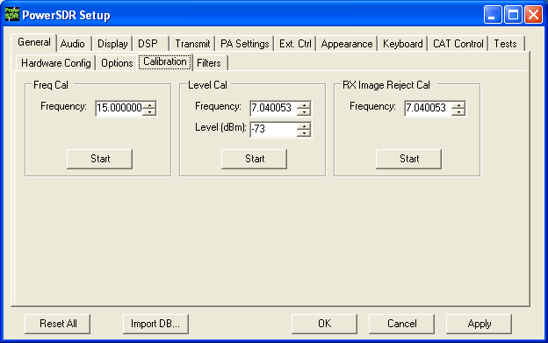
Figure 22: PowerSDR Calibration Settings
The three calibration routines available (Frequency, Level, and Image Null) are detailed in the sections below.
Note: Before calibrating the frequency, the radio needs at least a 5-minute warm-up period to ensure temperature drift is negligible.

[The rest of this page has been left blank intentionally]

Frequency Calibration – DDS Clock Adjustment

Auto Calibration
To calibrate the frequency, enter the frequency of the source in the entry box as seen in the figure above (e.g. 15.000000MHz). A calibrated signal generator is ideal, but a frequency standard station such as WWV may be used instead so long as its signal is at least 30dB above the noise floor. A separate transmitter may also be used as the signal source. We do not recommend calibrating on local AM stations as the correction may not be as accurate at such low frequencies. Once the frequency of the station or signal generator is entered, click the top Start button (across from the word Frequency) to run the calibration routine. Using the manual adjustment routine below may allow slightly better results due to fine adjustments.

Manual Calculation
The calculation for the DDS adjustment is not complicated. Divide the DDS frequency (200MHz) by the known signal frequency (say, 10MHz WWV) and then multiply by the difference between the known signal and the measured signal. For example, say you tune the VFO to 10MHz and the peak shows up at 9.999700MHz (difference is 10.0 – 9.999700 = +300Hz). The Clock Offset would be 200/10 * 300 = 6000. Plugging in 6000 into the Clock Offset control should zero beat the signal. The frequency offset is the actual clock oscillator offset from its nominal 200MHz output. The oscillator is rated at 100ppm, which yields a maximum offset of +/- 20kHz from 200MHz. Note that if the measured frequency were 10.000300MHz, the offset would be -6000. Fine adjustments may be made directly on the Clock Offset control on the General Tab of the Setup Form.

Level Calibration – Spectrum & S-Meter
For proper calibration of the spectrum and S-meter, some type of calibrated signal source is required. If no signal generator is available, Elecraft offers an inexpensive XG1 1uV and 50uV Receiver Test Set. To calibrate the visual spectrum and the S-Meter, set the signal generator to a known strong signal level such as -73 dBm (no less than 30dB above the noise floor) and tune the radio to place the carrier inside the filter passband. Enter the frequency (in MHz) and the signal level of the generator in the Frequency and Level (dB) text boxes respectively as shown in the figure (e.g. 7.040053 MHz and -73dBm). If no calibrated signal source is available, you may use a second transceiver to either transmit a signal or to find a steady signal on the air (this will give a much less accurate level calibration). Without use of a calibrated signal source, the spectrum display and power meter may be off by as much as 10dB or more. Click the middle Start button across from the word Level to start the calibration. This calibration is accurate to within 0.1dB with respect to the source.

[The rest of this page has been left blank intentionally]

Image Null Calibration
Since the SDR-1000 has an analog front end, phase and amplitude imbalances can exist between the I and Q channels. Fortunately, this is a simple correction for the DSP software. The procedure for calibrating the receiver is described below. For a description of how to minimize the transmit image, look at the Setup Form chapter below in the section on Transmit Rejection.
Note: A signal generator or a separate transmitter with dummy load is required for this alignment.

Automatic Calibration
Increase the signal generator output level to -50dBm so that the image signal will be large enough to give optimal calibration. On the General tab of the Setup form, enter your signal generator frequency. Then click the lowest Start button next to the words “Image Null” to automatically find the optimal Phase and Gain settings. Using the settings found by the automatic adjustment as a starting point, manually adjusting the controls may offer slightly better results. Note that any other signals in the passband besides the image may hinder the routine from finding the best null.

Manual Adjustment
The controls for the Image Rejection are on the DSP tab of the Setup form. They allow fine adjustment of amplitude and phase to allow a null of the opposite sideband image in the time domain. The image can be found roughly 22kHz above a strong signal. The null actually moves around in a 3kHz window centered at Signal+22.050kHz if Spur Reduction is on. Alternately modify the Gain and Phase controls on the DSP Tab of the Setup Form to find the best possible null. Clicking on the track bar will give unit increment/decrements to the value and then tweaking can be done using the Up/Down control (for fractional component).

Automatic Amplifier Gain Calibration
Note: If no dummy load is available the factory test values must be entered manually on the Setup Form-PA Settings Tab using the factory test data provided with the amplifier in the Gain By Band section of the PA Settings tab.
Amplifier Gain Calibration (a 100W resistive dummy load is required) is recommended since slight differences in equipment (sound card, power supply, etc.) can give slightly different results. The following procedure automatically determines the RF signal chain gain (SDR-1000 and SDR-100WPA) by band in order to calibrate sound card drive requirements in the PowerSDR software. The resulting gain values, measured in dB, are stored in the PowerSDR database. All gain values are determined at 100W (75W on 10m) output into a resistive dummy load.
WARNING! A 100W resistive dummy load must be connected to the amplifier output for the Automatic Amplifier Gain Calibration procedure. Failure to do so could cause damage to the amplifier.
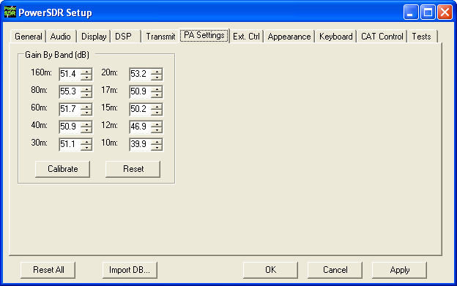
Figure 23: PA Settings Tab
Press the Calibrate button in the Gain by Band section of the PA Settings tab to start the calibration process. Through an iterative process, the software will transmit an estimated drive for 60W (default) output to the dummy load on each band. The power will be measured on the internal directional coupler to determine the gain for a given drive level. The software will apply any necessary correction and save the total system gain value for each band on the form. A progress bar will show the status of the calibration process. An Abort button is available on the progress bar if needed to stop the calibration process. If you get an error message during the calibration process, double check the sound card and antenna connections and try again. Press the Apply button when finished to save the values in the database.
Note: Be sure to use the Import Database function when installing future PowerSDR software releases in order to preserve the calibration values.

Front Console
In this chapter and those following many types of software controls will be referred to. The myriad of various bells and whistles can sometimes be a bit overwhelming. The image shown below is a key that will help to introduce the basic controls for those less familiar with windows software.
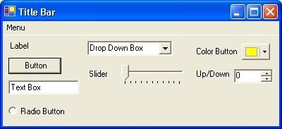
Figure 24: Control Key
- The Form refers to the entire window with the Title Bar showing the Form Name.
- The Menu is just under the Title Bar. Menu controls generally open other forms.
- Labels are callouts usually for other controls.
- Buttons can trigger events or act like an On/Off switch.
- Text Boxes allow text to be entered or displayed.
- Radio Buttons allow the user to choose between several options.
- Drop Down Boxes (also called Combo Boxes) enable the ability to offer many options without taking up as much window space as a Radio Button.
- Sliders allow easy modification of a numerical value.
- Color Buttons are used as color selectors. You can pick a generic color (yellow or green) or even make your own using the drop down menu.
- Up/Down controls are similar to a Text Box, but are limited to numeric input. They also have arrows for simple increment/decrement behavior.
- 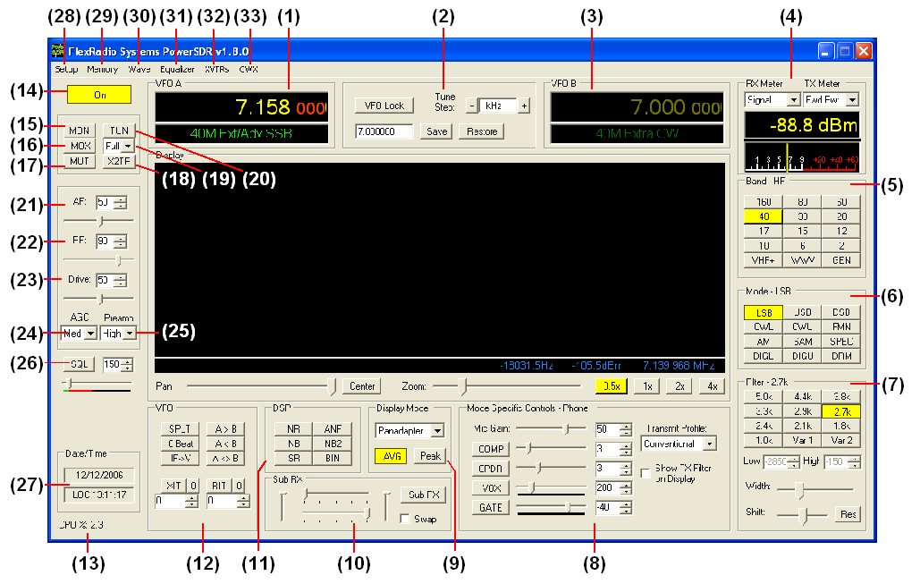
Figure 25: PowerSDR 1.8.0 Front Console
Note: The front console controls the basic facets of the radio: frequency, mode, filters, and display. In addition to these basic features, there are many other controls that are described in detail below.

Hint: Hovering with your mouse over any control will show a brief description of that control’s function.

[The rest of this page has been left blank intentionally]

(1) VFO A
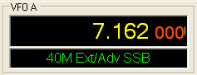
Figure 26: VFOA
VFO A is the main tuning VFO for the radio. It consists of a frequency and a band description (related to the selected frequency). The frequency area is a simple Text Box and may be edited as such (click and drag highlighting, etc). Entering a numeric character (without any mouse interaction) is also a good way to change your frequency quickly. The underlined digit will show visually the digit that will be tuned when hovering over the frequency display. See the Tuning Methods section in the Operation chapter for more details on how to tune. Note that you can return to the previous frequency at any time by pressing the ‘Escape’ key.
The band text information underneath the frequency gives general information about the FCC Amateur bands as well as the Short Wave Radio bands and WWV. If not on a recognized frequency, the text will display “Out Of Band”. If not in an amateur band, the text background will change from black to gray. Note that this information is only a lookup in a database and has no bearing on the current operating mode. This information can be edited in the BandText table using Microsoft Access.

(2) Tuning Controls
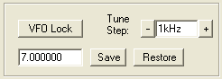
Figure 27: Tuning Controls
VFO Lock keeps the frequency from being changed inadvertently. This is a handy feature to use while in a QSO to keep from accidentally losing the frequency due to clicking in the wrong area or hitting the wrong key on the keyboard.
The Tune Step displays the current tuning rate for using the mouse wheel (or Ctrl + Up/Down Arrow) to tune the radio. Rotating the mouse wheel away from you will increase the frequency by the step rate per click while rotating the wheel toward you will decrease the frequency. You can change the Tune Step by clicking either of the – or + buttons, clicking the mouse wheel button (or using Ctrl + Left/Right Arrow).
The Save button quickly saves a frequency, mode and filter. The saved frequency is shown in the box to its left. The Restore button restores the most recently saved frequency (displayed), mode and filter.

(3) VFO B
Split Transmit Frequency | Sub RX Frequency
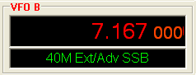 | 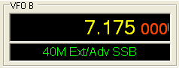
Figure 28: VFOB
The operation of VFO B is similar to that of VFO A. However, VFO B is used only in specific instances. When operating split (SPLT button under VFO), VFO B determines the transmit frequency (both “VFO B” and the frequency are displayed in red). When activating the second receiver (Sub RX button under Sub RX), VFO B determines the second receiver’s frequency, which is displayed in yellow. Otherwise, it can be viewed as a storage container to copy VFO data to and from VFO A (see the VFO Controls section below).

(4) Multimeter
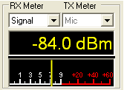
Figure 29: Multimeter
The multimeter functions as another way of feeding information back to the user. The two drop down boxes at the top offer an independent selection of RX and TX multimeter options.
The text display below the meter selections shows the digital data for either the receiver or the transmitter (Signal strength in the screenshot above). The display at the bottom of this section shows the data graphically as an edge meter. A bar graph display can be selected instead (see the Appearance section in the next chapter).

RX Meters
- Signal (Signal Level): Calculates the true RMS power in dBm of the current signal within the passband.
- Sig Avg (Signal Average): Calculates the true RMS power in dBm of a time-averaged signal within the passband.
- ADC L (Analog To Digital Left): Calculates the level in dBFS (decibel full scale) of Left input from the sound card.
- ADC R (Analog To Digital Right): Calculates the level in dBFS (decibel full scale) of Right input from the sound card.
- Off: Used for debugging purposes or to save CPU cycles on slower machines.

TX Meters
- Fwd Pow: Reads out forward power minus reflected power in Watts as measured by the hardware ADC on the PA if it is installed. If the PA is not installed (the 1W configuration), this meter shows the calculated power output according to the DSP based on 1W full output. In either case, the meter shows average power.
Note: In SSB, the typical male voice peak to average ratio is 14dB. This means that when you do not have the compressor and/or compander enabled an average meter will only read 4-10W (with a typical voice) when peaking at 100W.
With the ALC we are using the average power. With these controls, very high average power can be tolerated.
- Ref Pwr (PA Reflected Power): Reads out reflected power as measured by the hardware ADC on the PA. (Only available with the PA)
- SWR (PA Standing Wave Ratio): Reads out the standing wave ratio as calculated from the hardware ADC on the PA. (Only available with the PA with TUN on)
- Mic: Reads modulation power from -20 dB to 3 dB. Ideal operation will peak around 0 dB and will rarely if ever hit 3 dB. If it is hitting 3 dB, the ALC is cutting back the power. Adjust the MIC control on the front console to give more or less modulation.
- EQ: Reads the power in Watts following the equalizer. If the equalizer is not enabled, the equalizer power is equal to the Mic power.
- Lev: Reads the power in Watts following the leveler. The leveler attempts to level the voice coming from the microphone as the head and mouth change position relative to the microphone element. If the leveler is not enabled, this power is identical to EQ.
- Lev Gain: Reads the gain in dB currently being applied by the leveler.
- Comp: Reads the power in Watts after the compressor. If it is not enabled, it reads the same as Lev.
- CPDR: Reads the power in Watts after the compander. If it is not enabled, it reads the same as Comp.
- ALC: Reads the power in Watts after the ALC.
- ALC Comp: Reads the gain in dB applied by the ALC algorithm. The gain is always <=0 in dB. The minus sign is implicit.
- Off: Used for debugging purposes or to save CPU cycles on slower machines.

(5) Band Selection & Band Stacking Memories
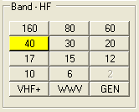
Figure 30: Band Selection
The Band Selection controls perform multiple roles on this radio. First, when tuning the VFO to a specific frequency the band indicator will move to the appropriate band (GEN if not in one of the specific bands listed). This is used to quickly identify which band you are in, or when you are stepping over a band edge boundary.
The second role is a feature called Band Stacking Memories. A single memory is defined as a frequency, mode, and filter combination. Each band has several memories associated with it. Clicking on a band button repeatedly will cycle through the available memories repeating from the beginning after the last memory (hence the stacking memories). This is useful to quickly tune to various frequencies within a band. To replace one of the memories with the frequency, mode, and filter of your choice, first click the band button for the band memory you would like to modify. Then change the frequency, mode, and filter to the desired settings (the frequency must be in the band selected). Finally click the band button again to save the values. Note that some band memory frequencies (such as 60m and WWV) are fixed in software and cannot be changed. The modified memories will be saved to the database upon graceful exit of the console. A crash will prevent changed memories from being saved in order to keep faulty data from making it into the database.
Note that the VHF+ button will swap between the typical HF bands and any configured transverters (see the XVTRs Form in chapter 10). The VHF band buttons work in the same way, but for the frequencies within the transverter frequency range.

[The rest of this page has been left blank intentionally]

(6) Mode Selection
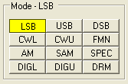
Figure 31: Mode Selection
The Mode Selection controls allow you to change the selected demodulation routine. Changing modes will select the last frequency and filter used for that mode. Additionally, it will display the (configurable) filter settings available for that mode as well as display the appropriate mode specific controls on the front console (see below). Following is a list of the available modes:
- LSB: Lower Side Band
- USB: Upper Side Band
- DSB: Double Side Band
- CWL: CW Lower Side Band
- CWU: CW Upper Side Band
- FMN: Frequency Modulation (FM) Narrow
- AM: Amplitude Modulation
- SAM: Synchronous (PLL) Amplitude Modulation
- SPEC: Spectrum mode (DC IF, max bandwidth determined by your selected sound card sampling rate)
- DIGL: Digital Lower Side Band (Enables VAC if VAC Auto Enable is engaged)
- DIGU: Digital Upper Side Band (Enables VAC if VAC Auto Enable is engaged)
- DRM: Digital Radio Mondiale (requires licensed external demodulator software not available from FlexRadio Systems; Enables VAC if VAC Auto Enable is engaged)
Hotkeys are available in the Setup-Form, Keyboard Tab to cycle through the various modes using the keyboard.
[The rest of this page has been left blank intentionally]

(7) Filter Controls
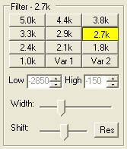
Figure 32: Filter Controls
The filter controls consist of ten customizable, mode-specific, labeled filter buttons and two variable filter buttons.

Labeled Filter Buttons
Clicking on any of the labeled buttons in the top half of the filter controls section sets the filter bandwidth. The available filters depend on the selected modulation mode. The 3 groups of default filter selections for CW (CWL, CWU), SSB (LSB, USB, DIGL, DIGU) and DSB (DSB, FMN, AM, SAM) are shown below. The SPEC mode has no filters associated with it and the DRM filter is fixed at 10MHz.
CW Default Filters | SSB Default Filters | DSB Default Filters
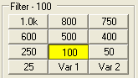 | 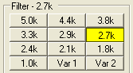 | 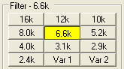
Figure 33: Default Mode Dependent Filters
Each of the 10 labeled filter buttons can be customized for any of the modes. To do so, right click on a filter button and select Configure… to bring up the following screen.

[The rest of this page has been left blank intentionally]
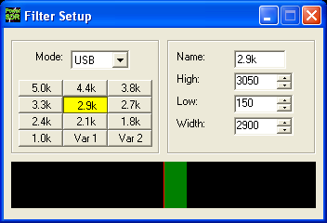
Figure 34: Filter Setup Screen
On the left, select the Mode for which to setup the filter and select the filter button to change. Then on the right adjust its settings. An indication of the filter is displayed in the lower section of this screen. When done, you can select another button and/or mode to change the filter for. When finished, just close the Filter Setup Screen. To revert back to the default settings, right click on a filter button, select Reset to Defaults and click Yes.
Note: Although there are 3 groups of mode-dependent default filter settings, you can customize the labeled filter for each mode independently. E.g. you can have different filters for LSB and USB, for FMN and AM, etc.

Variable Filter Buttons
The variable filter buttons Var 1 and Var 2 offer two separate filters, each of which can be adjusted with the Low, High, Width, Shift and Res controls described below as well as the mouse. The Panadapter display setting is good for visualizing changes to variable filter controls
- Low: Selects the low cutoff frequency for the filter. The value is the plus or minus offset from the center frequency as shown in the VFO display. Note that in lower side band modes (LSB, CWL and DIGL) this value can be negative.
- High: Selects the high cutoff frequency for the filter. Note that in lower side band modes (LSB, CWL and DIGL) this value can be negative.
- Width: Widens the filter as the slider is moved right, and narrows the filter as it is moved left.
- Shift: Shifts the selected filter passband up or down from its normal center frequency. This can help to eliminate interference caused by signals in close proximity of the received signal. After a variable filter (Var 1, Var 2) has been shifted you can use the IF->V button to translate a filter shift to a new VFO frequency (see the VFO Controls section below)
- Res: Returns the Shift control to the default middle position and restores the filter to the original values (i.e. before the Shift was used).
- When the display is set to Panadapter, the mouse can be used to directly adjust the selected variable filter (Var 1 or Var 2). To do so right click with the mouse on the Panadapter display until no cross- hairs are showing. Then click on the filter and drag it to shift the filter as a whole or click on a band edge and drag it to adjust the filter bandwidth.
The Var 1 and Var 2 filters are saved just like the labeled filters and are mode-dependent (i.e. you can save a different Var 1 filter for LSB mode than for AM mode). Hotkeys are available in the Setup Form-Keyboard Tab to change the filters using the keyboard.

(8) Mode Specific Controls
This section of the front console displays key controls specific to the selected modulation mode. There are three sets of controls: Phone, CW and Digital.

Phone Controls
The phone controls, shown below, are available for all phone modes (LSB, USB, DSB, FMN, AM and SAM). Most of these controls can also be found on the Setup Form-Transmit Tab (see next chapter, where you can also find a more detailed description).
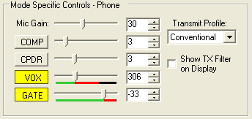
Figure 35: Mode Specific Controls - Phone
- Mic Gain: adjusts the software microphone gain. This is a simple multiplier applied to the input samples when in transmitting. The control can be adjusted using either the slider or the textbox. This control is helpful for sound cards without mic preamps such as the Delta-44. Note that increasing the MIC Gain control will also raise the amount of noise in the signal. A hardware preamp will give the best performance for amplifying microphone signals. Having said that, the software gain works very well in many setups. Voice modes are typically optimized when the peak reading on the TX Mic Meter reads just below 0dB (see above)
- COMP: click to enable the feed forward compression and adjust its level with either the slider or the textbox. See also the Setup Form-Transmit Tab.
- CPDR: click to enable the compander and adjust its level with either the slider or the textbox. See also the Setup Form-Transmit Tab.
- VOX: click to enable the VOX and adjust its level with either the slider or the textbox. See also the Setup Form-Transmit Tab. When enabled, a bar graph will show just below the slider control. The green part of this bar graph shows the portion of the sound level that will not activate the transmitter; the red part the portion that will. VOX should be adjusted such that ambient noise will not activate the transmitter, but a normal voice will.
- GATE: click to enable the Noise Gate and adjust its level with either the slider or the textbox. See also the Setup Form-Transmit Tab. When transmitting, a bar graph will show just below the slider control. The green part of this bar graph shows the portion of the sound level that will not open the Noise Gate; the red part the portion that will. The level should be adjusted such that ambient noise will not open the Noise Gate, but a normal voice level will.
Hint: The Noise Gate can (and should) be enabled in all situations where ambient noise will render your transmissions less clear, irrespective of whether VOX is engaged.
- Transmit Profile: select the transmit profile to use for phone transmissions. See also the Setup Form-Transmit Tab.
- Show TX Filter on Display: when checked, the band edges of the transmit filter, set on the Setup Form-Transmit Tab (see next chapter) will be shown as 2 yellow lines on the display when set to Panadapter. It can be an especially useful visual aid when operating split to position your transmit frequency where desired (in a pile-up) using VFO B. Additionally, it will give you a quick visual impression of whether your transmit filter needs to be adjusted or not.

CW Controls
The CW controls, shown below are available when either CWL or CWU is selected. Most of these controls can be found on the Setup Form-DSP Tab, Keyer Sub-Tab (see next chapter, where you can also find a more detailed description).

[The rest of this page has been left blank intentionally]
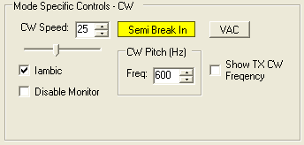
Figure 36: Mode Specific Controls - CW
- CW Speed: sets the CW speed when using the internal keyer in Iambic mode. Adjust the speed with either the text box or the slider.
- Iambic: check to set the internal keyer to Iambic mode.
- Disable Monitor: check to disable the monitor (this can be useful when using an external keyer).
- Semi Break In: click to enable Semi Break In for the internal keyer.
- CW Pitch (Hz): sets the desired audio frequency for CW listening at the center of the CW filters. This will determine the offset that is applied to the carrier in receive and transmit. The display will continue to read the actual carrier frequency (if the radio is calibrated) but the software will provide for an offset to get the desired CW tone. This pitch will determine the automated tuning frequency using the display and mouse “click tune” functions.
- VAC: click to enable the virtual audio cables, setup on the Setup Form-Audio Tab, VAC Sub-Tab (see next chapter, where you can also find a more detailed description). VAC is not automatically enabled for CW modes, even if Auto Enable has been checked on the VAC Sub-Tab.
- Show CW TX Frequency: check to show the CW TX frequency as a single yellow line when the display is set to Panadapter. It can be an especially useful visual aid when operating split to position your transmit frequency where desired (in a pile-up) using VFO B.

[The rest of this page has been left blank intentionally]

Digital Controls
The digital controls, shown below are available when either DIGL, DIGU or DRM is selected. These controls can also be found on the Setup Form- Audio Tab, VAC Sub-Tab (see next chapter, where you can also find a more detailed description).
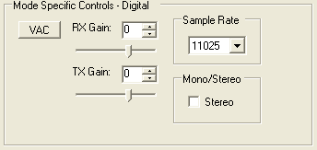
Figure 37: Mode Specific Controls - Digital
- VAC: click to enable the virtual audio cables. If Auto Enable has been checked on the Setup Form- Audio Tab, VAC Sub-Tab, then VAC will automatically be enabled when either DIGL, DIGU or DRM is selected.
- RX & TX Gain: Adjust the gain for signals coming in and out of the VAC interface. Use the RX Gain control to adjust the audio level going to third party programs. (Note that for third party applications this control supercedes the front panel AF control). Similarly, use the TX control to adjust the volume of audio coming from third party applications (adjust for 0 dB on the ALC meter).
- Sample Rate: sets the sample rate of the VAC interface. This needs to be matched to your third party software sample rate.
- Mono/Stereo: sets the VAC interface to operate either mono or stereo. This can be of importance, depending on your third party software. (E.g. MixW requires the mono setting, whereas DREAM requires stereo).

(9) Display Controls
The main display controls, shown below, consist of two sections: Panadapter view and display mode controls.

[The rest of this page has been left blank intentionally]
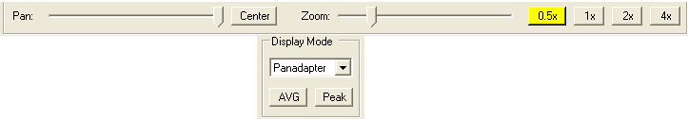
Figure 38: Display Controls

Panadapter View Controls
The Panadapter view controls adjust the view of the Panadapter display (see below), they are not functional for any of the other display settings.
- Pan: adjust the slider to pan the Panadapter display from left to right. Click on Center to quickly center the display.
- Zoom: adjust the slider to zoom in on or out of the display. Additionally click on either on of the 4 buttons to the right to quickly zoom to the labeled setting. (The maximum frequency span of the Panadapter is dependent on the sampling rate setting of your sound card)
Depending on the zoom setting, the Center button may not return the 0Hz mark to the exact center of the screen. This is because of the asymmetry of the bandwidth in our receive signal (see the image below). The incoming signals can be viewed as a window of bandwidth with exactly half above 0Hz and half below. For a 96kHz sampling rate this window would span -48kHz on the left to +48kHz on the right. (This is what you will see in SPEC mode and usually you will notice a "hump" or spike at 0Hz where DC noise is picked up).
To avoid signal distortion due to this DC noise we use an 11kHz IF offset prior to demodulation. This puts the DC offset at -11kHz (as many will notice on the display), but it also shifts the center of the window of bandwidth. Now the window spans -48 - 11 = -59kHz on the left to +48 - 11 = 37kHz on the right.
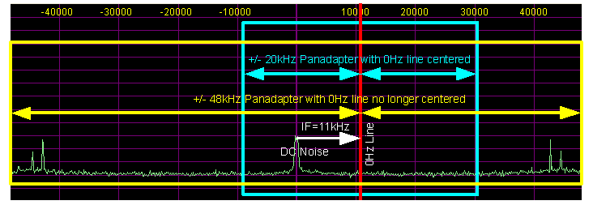
Figure 39: Impact of 11kHz IF on Location of 0Hz Line Within the Panadapter
When you are displaying only +/- 20kHz in the Panadapter, it is no problem to display 0Hz in the center. But suppose we want to display +/-40kHz. We now run into a problem on the right because we run out of spectrum at +37kHz. The Panadapter does not display spectrum where there is no possibility of signals and instead shifts the 0Hz mark to the right.

Display Type Controls
The main display is able to visualize received (and transmitted) signals in various ways (display types), which can be selected from the list box. These various display types are detailed below with a snapshot of each type. The sampling rate (Frames Per Second, FPS) of the main display can be modified on the Setup Form-Display Tab.
- AVG (Average): click to view time-averaged signals. This will smooth fast-changing signals and is a good way to separate real from stochastic (noise) signals. The averaging time can be set on the Setup Form-Display Tab. Average must be enabled for the 0 Beat function to be enabled.
- Peak: click to hold the peak value for each frequency in the display.

Display Type Descriptions
Note 1: All displays show a 7.0401MHz, -73dBm signal from an Elecraft XG-1 signal generator.
Note 2: The actual software display is crisper than the compressed images shown below.
There are four frequency domain display types (Spectrum, Panadapter, Histogram, and Waterfall) and three time domain display types (Scope, Phase and Phase2). The colors of everything on the display (text, data line, background, etc) are completely customizable using the Setup Form-Appearance Tab.

[The rest of this page has been left blank intentionally]

Spectrum
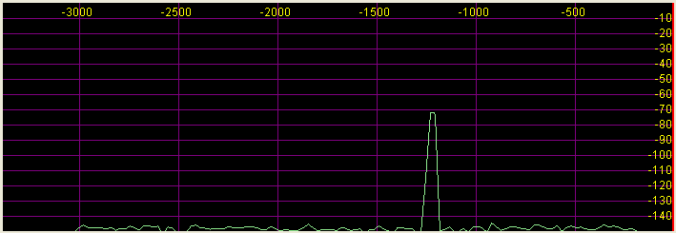
Figure 40: Spectrum Display
The Spectrum Display shows a classical spectral view of the frequency with the ends of the display determined by the bandwidth of the filter. The scale across the top shows the frequency offset in Hz from the VFO A frequency. Rather than only using half the display window when in lower or upper sideband, we expand the display moving the 0Hz line to the left or right margin (LSB mode with a 2.9kHz filter shown).

Panadapter (Panoramic Adapter)
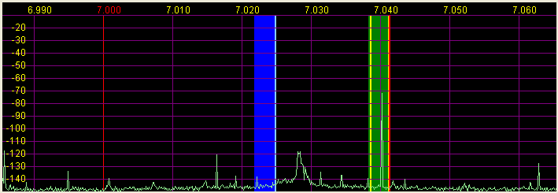
Figure 41 Panadapter Display
The Panadapter Display is similar to the Spectrum Display with several differences.
- The maximum display width is a function of the selected sound card sampling rate, no matter what filter bandwidth is selected.
- The selected filter is displayed as an overlay to help the user visualize the filter. Shown are the Main RX filter (green), the Sub-RX filter (blue) and the TX filter edges (yellow vertical lines). The color of all the filter overlays can be changed independently using the Setup Form-Appearance Tab.
- The frequency scale shows the actual frequency (in MHz).
- The edges of the amateur bands are marked as red vertical lines.
- With the mouse, filters and filter edges can be varied by dragging and dropping
The Panadapter is useful because although you hear only the signals within the audio passband, you can see in real time all signals within the receiver’s passband (as determined by the sound card’s sampling rate). This gives a much more complete picture of the surrounding area in the band, especially when there is abundant signal activity (e.g. contest and DX situations).

Histogram
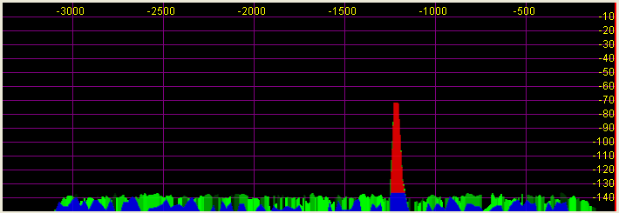
Figure 42: Histogram Display Mode
The Histogram Display is similar to the Spectrum Display, but instead of a single color data line, additional colored data is used. Blue signals are real-time (current) signals that are below a signal threshold (roughly below the average plus a small margin). The red signals are real-time (current) signals that are above that same threshold. The green signals are previous peaks on that same frequency that will fade as time goes by (a type of history, hence the name).

[The rest of this page has been left blank intentionally]

Waterfall
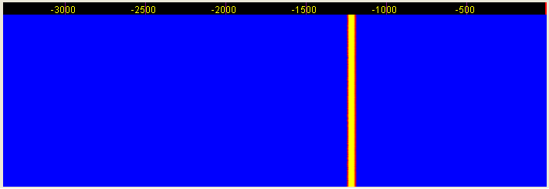
Figure 43: Waterfall Display
The Waterfall Display shows a scrolling view of activity within the passband. This makes tracking narrow band signals much easier and can even allow visualization of CW signals at slower speeds (longer line is a dash, short line is a dot, no line is a pause). The Waterfall Display can be customized on the Setup Form- Display Tab This allows custom setting of the dynamic range and coloring for the display. (See the Setup Form-Display Tab in the next chapter for more details.)

Scope
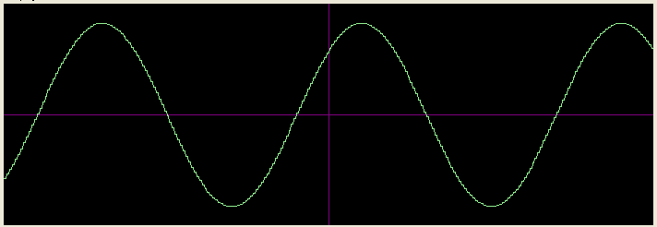
Figure 44: Scope Display
The Scope Display shows a single channel in the time domain. In essence this is a traditional waveform view of the input data. Shown is effectively a 1kHz tone (tuned to 7.0411MHz with the signal at 7.0401MHz). The Scope Display is particularly useful when transmitting to monitor your transmitted waveform. The time base can be adjusted on the Setup Form- Display Tab.

Phase
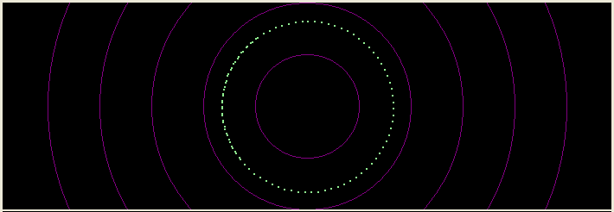
Figure 45: Phase Display
The Phase Display maps the filtered I and Q (Left and Right) channels to the X and Y coordinate planes. This is useful for making sure the two channels are 90 degrees out of phase as they should be. There is also a Phase2 Display that maps the unfiltered data directly from the sound card. When a continuous carrier signal is received, the unfiltered data in the Phase2 Display should produce as near to a perfect circle as possible. If the circle distorts into an oval or a straight line, the input phase is off balance which would indicate a connection or hardware problem.

Off
In this setting the display is turned off. It is mainly used for debugging purposes, but can also be used with slower systems to decrease the CPU load to more reasonable levels.

[The rest of this page has been left blank intentionally]

Cursor and Peak Position
There are two sets of data side by side under the display that are used to communicate cursor (left) and peak signal (right) information to the user. For each the data shown is Offset from VFO, Signal Level and Frequency. For example, in the screenshot shown, the (peak) signal is 1216.8Hz offset from the VFO frequency (7.0413MHz). The signal level is –71.8dBm, and the signal is at 7.040094MHz. Note that these values are fairly low resolution due to the discrete nature of the pixel display.
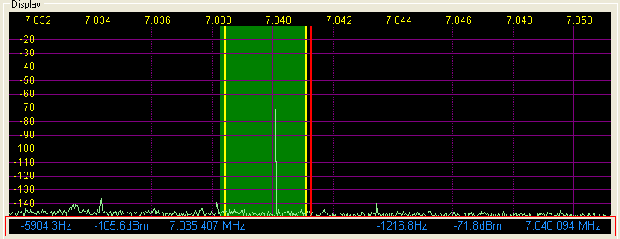
Figure 46: Display Position Features
In the spectrum displays (Spectrum, Panadapter, Histogram, Waterfall), you can click the right mouse button to bring up yellow crosshairs that span the width and height of the display. The crosshairs, along with the AVG control, allow easy measurement of signals on the display. Another feature of the yellow crosshairs is click tuning. Clicking the left mouse button with the yellow crosshairs tunes VFO A to the frequency indicated by the cursor position data. This is an excellent way to tune CW signals as it will zero beat the tone to the set CW pitch.
Hint: When either Split or Sub-RX is enabled clicking on the right mouse button will cycle the crosshairs through yellow, red and none. When the red crosshairs are showing, clicking the left mouse button will tune VFO B.

[The rest of this page has been left blank intentionally]

(10) Sub-RX Controls
The Sub-RX controls, shown below, allow you to enable a second, sub-receiver. In essence this is a second audio passband within the total passband determined by the sound card’s sampling rate. Both the main and the sub-receiver can be positioned independently in the audio spectrum to facilitate separating the two signals in your head.
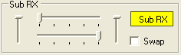
Figure 47: Sub-RX Controls
Click Sub RX to enable the second receiver. The Sub-RX will be tuned to the frequency shown in VFO B. In the Panadapter Display, the sub-RX passband is shown in blue, but only if it is within the range of the Panadapter. Use the upper and lower horizontal sliders to position the Main and Sub-RX respectively anywhere in the left-right audio spectrum. Use the left and right vertical sliders to adjust the volume of the Main and Sub-RX respectively. Check mark Swap if to swap the audio from the left and right speakers.

(11) DSP Controls
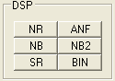
Figure 48: DSP Controls
These controls enable the DSP functions. The first four are described in detail in the Setup Form-DSP Tab, Options Sub-Tab (see next chapter).; SR is described in the Setup Form-General Tab, Options Sub-Tab.
- NR (DSP Noise Reduction): Activates the DSP Noise Reduction algorithm.
Note: NR is not available when Binaural (BIN) audio is selected unless BLMS is checked on the Setup Form.
- ANF (Automatic Notch Filter): Activates the Automatic Notch Filter algorithm.
Note: ANF is not available when Binaural (BIN) audio is selected unless BLMS is checked on the Setup Form.
- NB (Impulse Noise Blanker): Activates the Noise Blanker algorithm.
- NB2 (Mean Noise Blanker): Activates the Mean Rank Noise Blanker algorithm.
- SR (Spur Reduction): Activates the Spur Reduction algorithm.
- BIN (Binaural Audio): Activates the Binaural algorithm. Binaural audio is a special feature of PowerSDR. It generates a pleasing effect as the two phased channels (I and Q) are mapped to the left and right audio channels. The phasing of the demodulated and filtered audio signal within the passband gives a stereo-like effect to the received signal. When tuning across CW signals, they will seem to move in “space” as you tune the radio. Many experienced operators feel that binaural audio gives them a competitive advantage under contest conditions where the effect allows them to more easily pick signals out of a pile up. Wearing headphones increases the effect of the spatial separation.

(12) VFO Controls
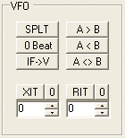
Figure 49: VFO Controls
- SPLT (Split): Enables Split operation using VFO B for the transmit frequency. The frequency text in VFO B will turn red to indicate that Split operation is active.
- 0 Beat: Takes the peak signal and sets it to the center of the filter passband. An exception is made while in CW mode if the CW Pitch is within the passband. In this case, the signal is tuned to the CW Pitch.
Note: 0 Beat is only available if AVG is enabled for the Display.
- IF->V: Takes any offset based on Filter Shift and the Filter Width and shifts it back to baseband. Useful when chasing a signal with the Filter Shift control.
- A > B: Transfers the contents of VFO A to VFO B (frequency, mode, and filter).
- A < B: Transfers the contents of VFO B to VFO A (frequency, mode, and filter).
- A <> B: Swaps the contents of VFO A and B (frequency, mode, and filter).
- XIT (Transmit Incremental Tuning): Click to enable XIT. XIT may be used as a quick way to operate split at a specific offset. When enabled, the transmit frequency is increased from the VFO A frequency by the amount shown in Hz while leaving the receive frequency intact. Note that XIT cannot be used in combination with the SPLT function. Click the 0 button next to the XIT button to clear the XIT control to 0.
- RIT (Receive Incremental Tuning): Click to enable RIT. When enabled, the receive frequency is increased from the VFO A frequency by the amount shown in Hz while leaving the transmit frequency intact. Click the 0 button next to the RIT button to clear the RIT control to 0.

(13) CPU %
This displays the total CPU load as seen in the Windows Task Manager under the Performance Tab. Note that running other applications will cause the CPU load to increase. If your CPU load is peaking at 100%, audio and possibly video artifacts will become noticeable. Closing additional applications and turning down some of the functions will allow systems that meet the requirements on our website to stay below the 100% mark.

(14) Power (Standby/On)
Switches the hardware and software between Standby and On. As can be seen below, this button also acts as a RX/TX indicator.
Standby | On/Receive | On/Transmit
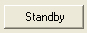 |  | 
Figure 50: Power Button States
If the SDR-1000 is connected properly and powered on, you will hear relays switch (click) as you cycle the software Power button.
Note1: In Standby, the software Power button places the hardware in a lower, standby power state (around 500-600mA), but does not turn off the 12VDC power to the hardware.
Note 2: The front panel switch on the SDR-1000 enclosure will remove power to the hardware, but not to the PA if installed. It is recommended to always turn off the main power supply when the radio is not in use.
Note3: Please see the Operation chapter for information on best practices for Power On/Off sequences.

(15) MON (Monitor)
When enabled, the transmitted audio is monitored through the receiver’s speakers. The MON function is not available in AM, SAM, or FM modes as those modes are transmitted at an Intermediate Frequency (IF) of 11.025kHz. In voice operation the MON feature will allow you to hear the effects of MIC gain, TX equalization, compression and the compander and to adjust them in real time. When using the Delta-44 or the Edirol FA-66 sound card, the AF control can be used to adjust the monitor volume.
Note: Due to audio buffering, you may experience a delay between spoken and monitored audio. You can reduce this latency by using smaller sample buffers (see Setup Form, Audio and DSP Tabs).

(16) MOX (Manually Operated Transmit)
When enabled MOX activates the transmitter. It is used primarily for voice operation. MOX will not generate a CW carrier. To generate a carrier for tuning, refer to the tune (TUN) button description.
Note1: If the radio ever seems like it is stuck transmitting, try disabling the Push-To-Talk (PTT) function by selecting Disable PTT on the Setup Form-General Tab, Options Sub-Tab.
Note2: To use the PowerSDR software without the SDR-1000 being attached to the parallel/USB port you must disable PTT. On the Setup Form-General Tab, select either Disable PTT on the Options Sub-Tab, or Demo/No Hardware on the Hardware Config Sub-Tab

(17) MUT (Mute)
This button Mutes the speaker audio. The receiver may also be muted by pressing the * (asterisk) key on the keyboard. Also, refer to the Auto Mute option on the Setup Form-General Tab, Options Sub-Tab.

(18) X2TR
Click to enable using pin 7 of the external controls connector (X2) on the rear panel of the SDR-1000 to control an external amplifier (see the Plug Pinouts chapter). This is the same control as X2 TR Sequencing on the Setup Form–General Tab, Options Sub-Tab.

(19) ATU Modes
The LDG Z-100 ATU has three tuning modes: Bypass, Memory, and Full. Selecting Bypass will instantly bypass the ATU. Selecting Memory or Full requires the TUN button to be pressed in order to perform the tuning. Note that if VFO A is tuned outside of the band in which the radio was tuned, the ATU is automatically bypassed to protect the unit.

(20) TUN (Tune)
- Without the ATU, TUN transmits a continuous (CW) carrier at the level set with the Tune Power control (default 10W – 10% without PA) on the Setup Form-Transmit Tab and outputs a tone at the CW Pitch. This power is shown on the Drive (Power) control while TUN is activated. Any changes to the Drive control while TUN is active are saved when the TUN button is turned off. This feature is used to simplify the antenna tuning process for proper load matching.
WARNING! DO NOT OPERATE THE 100W AMPLIFIER ABOVE 40W IN CONTINUOUS CARRIER MODES (E.G. CW, AM, FM, AND DIGITAL) FOR LONGER THAN 15 SECONDS. HIGHER LEVELS CAN CAUSE DAMAGE TO THE AMPLIFIER. THE AMPLIFIER IS RATED AT 100W PEP FOR SSB DUTY CYCLES.
- With the ATU, TUN combines with the ATU control below it to perform the ATU tuning function. When the ATU is in Bypass, the TUN function operates just as if the ATU were not present.
Note: The TUN button will stay enabled after a tune cycle in Memory or Full mode. The button will become deselected when it is bypassed, whether it be due to tuning to another band or manually selecting Bypass from the ATU control.

(21) AF (Audio Frequency Gain)
This control sets the monitor audio gain. The AF gain may also be adjusted by pressing the + (plus) and – (minus) keys on the numeric keypad. For best performance, the external speaker volume control should be set to the high end of the scale so that the AF control can be set to a lower value. If the AF control is set too high, it may cause feedback in the receiver.

[The rest of this page has been left blank intentionally]

(22) RF (Radio Frequency Gain)
This control sets the maximum gain of the AGC. It is the same control as can be found on the Setup Form-DSP Tab, AGC/ALC Sub-Tab. Although strictly speaking this control does not set the RF gain, it is denoted as such on the front console as its operational use is identical to that of a true RF gain control.

(23) Drive (Transmitter Power Output/Tune Power)
This control adjusts the percentage of maximum power that will be available in transmit mode. A typical setting for the 1W SDR-1000 radio might be 50% (roughly 500mW), while a radio configured with the 100W PA may be operated at full power (100W) into a proper 50 ohm load. The Drive control may be adjusted while in either receive or transmit mode.
Note: The control doubles in function as the power level setting for the TUN (Tune) button described above. The Tune power may be adjusted while the TUN button is activated or by using the control on the Setup Form-Transmit Tab.
While great care is taken to ensure that this value is accurate and that selecting a Drive value will give approximately that amount when using the 100W PA, there are variances in the filter components and transmitter characteristics that make it difficult for this to be exactly right over the whole range (1-100). When using the 100W PA, these values are most likely to be accurate on the higher end. For example, it is not unusual if you select 10 on the Drive control, but only see something like 5W out. This was a design decision made to favor the higher power users. This will likely be improved in the future with a more accurate algorithm.

(24) AGC (Automatic Gain Control)
This control sets the receiver Automatic Gain Control to one of the following settings: Fixd (Fixed), Long, Slow, Med (Medium), Fast, or Custom. The Custom setting uses the controls on the Setup Form-DSP Tab, AGC/ALC Sub-Tab. The following table details the AGC parameters used in the various settings.
Table 6: AGC Setting Details
Setting | Attack | Decay | Hang | Fast Hang
Fast | 2ms | 100ms | 100ms | 100ms
Med | 2ms | 250ms | 250ms | 100ms
Slow | 2ms | 500ms | 500ms | 100ms
Long | 2ms | 2000ms | 750ms | 100ms

[The rest of this page has been left blank intentionally]

(25) Preamp
This control sets the preamp level to one of four settings: Off, Low, Med (Medium), and High. It replaces the Gain and ATT controls used previously. See the table below for details on each setting. The typical setting for HF frequencies (and default for the software) is Med. Higher settings should be used for weak signal work while lower settings are ideal for large signal activity.
Note: When using the 2m transverter, Low and High are the only options available.
Table 7: Preamp Setting Details
With RFE |  |  |  |  | W/O RFE
Setting | ATT  (10dB) | Gain  (26dB) | Net Gain  (dB) |  | Setting | Gain  (dB)
Off | On | Off | -10 |  | Off | N/A
Low | Off | Off | 0 |  | Low | N/A
Med | On | On | 16 |  | Med | 26
High | Off | On | 26 |  | High | 40

(26) SQL (Squelch)
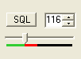
Figure 51: Squelch Controls
The SQL button enables the Squelch function. The threshold can be set with either the value to its right or the slider below. The bar graph displays in green the signal level below the threshold and in red above (only the red level is audible with SQL enabled). Squelch can be very useful to remove all noise from CW signals, especially in narrow filter settings.

[The rest of this page has been left blank intentionally]

(27) Date/Time Display
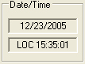
Figure 52: Date/Time Display
The date and time display can be especially helpful when taking screenshots, but can also be a quick reference to UTC time for those of us who are “time zone challenged.” Click inside the Date or Time area to switch between Local (LOC), UTC, and Off modes.

(28) Setup Form
The Setup Form contains numerous controls for everything from the hardware configuration to transmit settings. Please refer to the next chapter for more detailed information.

(29) – (33) Operating Forms
Each of these items open forms, which are used while operating. Please refer to the Operating Forms chapter below for more detailed information on each one.

[The rest of this page has been left blank intentionally]

Setup Form
The Setup Form contains a vast assortment of controls from hardware Setup to detailed DSP options. These controls are available on Tabs of the Form. Due to space concerns, several of the Tabs (General, Audio and DSP) have been split into Sub-Tabs. Take care when changing the controls to pay attention which Tab (and Sub-Tab) you are on. Descriptions of these controls will be followed by control descriptions for each individual Tab.
- Reset All: Resets all of the controls on all tabs to their default values. An exception is made for the hardware configuration controls. These will not be reset. A warning will pop up to ensure that accidentally pressing this button does not cause loss of settings.
- Import DB (Database): Allows a backwards-compatible database to be imported. The database saves all of the radio options and current state. To import another database, click this button and then browse to the directory of the database to import. If you have used the default directory during installation as recommended, the database file will be in C:\Program Files\FlexRadio Systems\ PowerSDR x.y.z\. The database file is called PowerSDR.mdb. Double click this file and it will attempt to import all the settings. A confirmation message will let you know if the import was successful.
- OK: Saves the current values to the database and closes the form.
- Cancel: Reloads the values from the database into the setup form and closes the form. This button can be used to reverse unintended changes to the Setup controls.
- Apply: Saves the current values to the database immediately.

[The rest of this page has been left blank intentionally]

General Tab

Hardware Config Sub-Tab
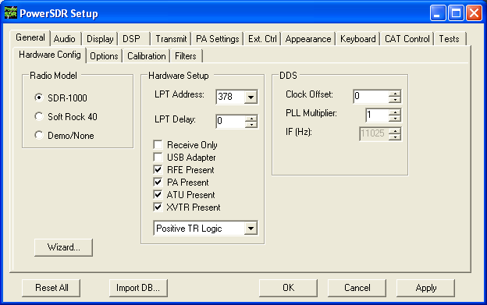
Figure 53: Setup Form - General Tab, Hardware Config Sub-Tab
Wizard…: Click this button to repeat the wizard that runs the first time you run the software. This is a handy way to update your configuration if your hardware has changed (i.e. added the PA, changed sound card, etc.).

Radio Model
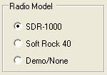
Figure 54: Radio Model Selection
Use this selection to choose the hardware (if any) that is connected to the computer running the PowerSDR software.

Hardware Setup
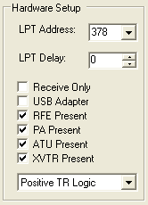
Figure 55: Hardware Setup
The Hardware Setup section allows the user to configure the software to match the SDR-1000 hardware configuration.
- LPT Address: The memory location of the parallel port used to connect the SDR-1000. This is nearly always 378 (LPT1) unless using an add-on parallel port card. If using an add-on card, note the memory address in the Device Manager and enter the value manually if it is not one of the options in the drop down box.
Warning: Changing this value without verifying your LPT address could keep the software from correctly communicating with the radio.
- LPT Delay: Allows a delay to be added in milliseconds for longer/more capacitive cables. The default value of ‘0’ should work fine for most six-foot cables. We only recommend changing this value if a long cable is necessary and control signals are sporadic. Increasing the value will add additional delay to each control signal sent. Note that this will slow each signal sent to the radio by the time selected. A delay value of 20ms could cause the radio to take nearly half a second (20ms x 24 signals = 480ms) to tune each time the frequency is changed. To use an old adage, a little bit goes a long way.
- Receive Only: Used to force the console to be used only as a receiver (disables the transmitter). This is useful for those with Receive Only hardware or simply those that want to ensure that they do not accidentally transmit.
- USB Adapter: Should be checked if using the USB to Parallel adapter available from FlexRadio Systems. An error message will be shown if the adapter is not plugged in and installed before attempting to use this option.
Warning: Once installed and running, do not unplug the USB adapter from the PC without first closing the software or unchecking this option. Doing so could cause the system to crash.
- RFE Present: Should be checked if the RF Expansion board is installed in the stack. The RFE is installed in all current (2005) SDR-1000 packages. Note that if the RFE is not installed (and the box is not checked), none of the controls below it will be visible.
- PA Present: Should be checked if the FlexRadio Systems 100W PA is installed. Note that if the PA is not installed (i.e. the box is not checked), the ATU option will not be visible.
- ATU Present: Should be checked if the Automatic Antenna Tuning Unit for the SDR-1000 is installed.
- XVTR Present: Should be checked if the DEMI144-28FRS 2m transverter is installed. Make sure to select the appropriate TR logic using the combo box below. If you purchased the DEMI 2m XVTR (DEMI144-28FRS) before May 2005, it should be configured for negative TR logic. Otherwise (more recent orders) you should use positive TR logic.

DDS
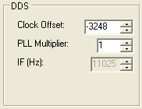
Figure 56: DDS
DDS Stands for Direct Digital Synthesis. The DDS chip in the SDR-1000 produces an analog sine wave at up to micro Hertz resolution. The DDS is used as a local oscillator to tune the radio.
- Clock Offset: Allows software corrections to be made due to the DDS clock oscillator not running at exactly 200MHz. The specification for the oscillator is 200MHz +/- 20kHz (100ppm). The correction routine is described above in Software Installation under PowerSDR Calibration (frequency calibration). Typically this value will be set automatically by the frequency calibration routine.
- PLL Multiplier: Unless the external clock option is installed, this value is always ‘1’. If using the external clock option, this value should represent the multiplier needed to get the external source up to the clock rate (200MHz). Therefore, if the source were 10MHz, the PLL Multiplier would be 20 (10MHz x 20 = 200MHz).
Warning: Using a PLL Multiplier/external signal that equates to a clock value greater than 200MHz can cause heat damage to the DDS chip.
- IF (Hz): Displays the Intermediate Frequency used in the software to avoid low frequency noise. This is currently locked to 11.025kHz.

Options Sub-Tab
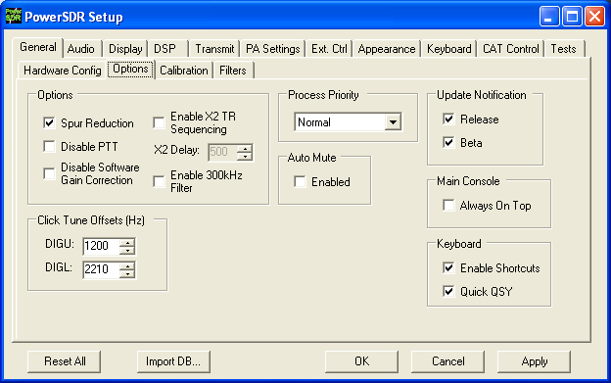
Figure 57: Setup Form - General Tab, Options Sub-Tab

[The rest of this page has been left blank intentionally]

Options
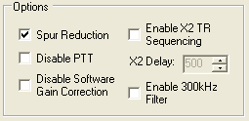
Figure 58: Options
- Spur Reduction: Adds the use of a software oscillator to avoid DDS frequencies known to have a higher phase truncation related spurious response. In short, rather than tuning each frequency using the DDS (this is what happens when this option is turned off), the software tunes the DDS in 3kHz steps and does fine-tuning in software. Tuning in 3kHz steps also has the advantage of having to send fewer command signals to the hardware. For a complete description of the spur reduction algorithm used, see A Technical Tutorial On Digital Signal Synthesis available from Analog Devices.
- Disable PTT: Disables the ability to use external Push-To-Talk lines to key the radio. It is necessary to use this function if evaluating the software without the parallel port terminated (i.e. without a radio) to prevent the software from engaging the PTT.
- Disable Software Gain Correction: Disables the compensation usually used to correct for the 0/26dB gain options as well as the 10dB attenuator on the RFE. The signal is then reflecting the signal to the sound card rather than what is at the antenna. This function is not recommended for normal operation because it invalidates the signal calibration of the spectrum display and multimeter.
- Enable X2 TR Sequencing: Enables X2 pin-7 transmitter sequencing for an external linear amplifier, relay, or transverter. Check the box to enable this option and to set the delay. The sequence when switching from RX to TX is: MOX → X2-7 goes high → Delay → SDR-1000 transmit relay gets set. The sequence when switching from TX to RX is: MOX → SDR-1000 transmit relay is reset → Delay → X2-7 goes low. Note that the delay is set in the following control.
- X2 Delay: Sets the delay in milliseconds when using the X2 TR sequencing. If no delay is desired, simply enter 0. Note that when using the X2 TR Sequencing option, transitions to and from transmitting will both be delayed by the entered value.
- Enable 300kHz Filter: Engages the custom filter bank on the RFE on low frequencies. This is only useful if the custom filter bank is populated with a low frequency filter (not typical).

Process Priority
Sets the process priority for the PowerSDR process. Some users have reported that setting the priority higher than Normal can allow slower systems to perform more reliably and with smoother audio. While FlexRadio Systems recommends using the Normal setting, if you are experiencing audio glitches or are using a slower machine, moving this control up to Above Normal or High might improve the performance of the software. Note that FlexRadio Systems does not recommend using the Real Time setting as this could cause timing problems with the operating system.

Update Notification
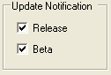
Figure 59: Update Notification Options
Use these checkboxes to enable a pop-up notification when new versions come out. Check the Beta box to receive update messages when new Beta versions are available. Similarly, check the Release box to receive update messages when official release versions become available.

Click Tune Offsets (Hz)
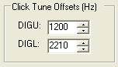
Figure 60: Tuning Options
- DIGU: Sets the offset in Hz to use when click tuning in DIGU mode. Defaulted to 1200 for SSTV.
- DIGL: Sets the offset in Hz to use when click tuning in DIGL mode. Defaulted to 2210 for RTTY.

Auto Mute
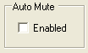
Figure 61: Auto Mute
Click the box to enable the Auto Mute option. When enabled, pulling pin X2-12 (see the chapter on Plug Pinouts) to ground will automatically activate the MUT (Mute) function to mute the receiver.
CAUTION: This is an audio only mute. It does not protect the RF circuitry and care should be taken not to transmit high power into the SDR-1000 antenna input as this could damage the unit. To use separate receivers and transmitters external switching for the antenna is still required.

Main Console (Always On Top)
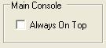
Figure 62: Always On Top
The Always On Top option is a common option for windows applications. With this option enabled, the main console will be painted on top of any other windows (even an active window).

Keyboard
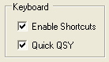
Figure 63: Quick QSY
This option enables the user to enable/disable the Keyboard Shortcuts and Quick QSY feature.
- Enable Shortcuts: Enables the use of keyboard keys to perform various PowerSDR functions. The keyboard shortcuts can be set on the Setup Form-Keyboard Tab, described below in this chapter.
- Quick QSY: Enables the user to quickly enter a frequency in MHz and hit [Enter] to jump to that frequency. With this option disabled, using a mouse to tune or to click inside the VFO is the quickest way to change frequency. This feature is normally enabled by default, but can be disabled to prevent accidentally moving the VFO frequency due to accidental key presses.

[The rest of this page has been left blank intentionally]

Calibration Sub-Tab
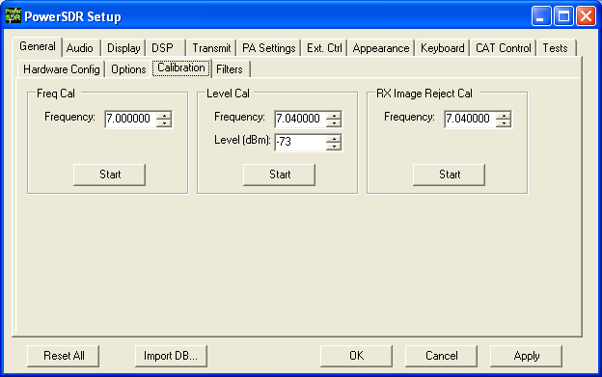
Figure 64: Setup Form - General Tab, Calibration Sub-Tab
The calibration section contains controls that are used to setup and start various calibration routines. For more information on calibrating, refer to the section called PowerSDR Calibration in the previous Software Installation & Setup chapter.

Freq Cal
Used to calibrate the frequency of the 200MHz oscillator in the SDR-1000. Enter the frequency of the signal source used for calibration in the control provided. The signal source can be a signal generator or a signal like WWV. Click the Start button to run the calibration.

Level Cal
Used to calibrate the power level in dBm for the display and the multimeter. Enter the frequency and level of the signal source used for calibration. The more accurate the signal source, the more accurate the display and multimeter will be. The multimeter is currently accurate with respect to the source to 0.1 dBm. Click the Start button to run the calibration.

[The rest of this page has been left blank intentionally]

RX Image Reject Cal
Used to calibrate the opposite sideband image rejection for the receiver. Enter the frequency of the signal source used to calibrate the rejection. Note that the calibration is done 22kHz above the signal frequency. Click the Start button to run the calibration.

Filters Sub-Tab
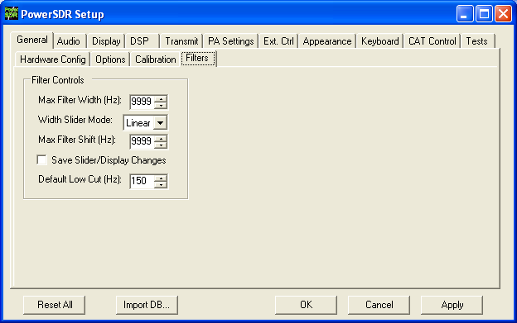
Figure 65: Setup Form - Filters Tab
- Max Filter Width: Sets the maximum filter width to be set by the Filter Width Slider on the front console.
- Width Slider Mode: Sets the behavior of the Width Slider. Linear, Log, and Log10 are the options. The log options offer more resolution on the smaller filter sizes.
- Max Filter Shift: Sets the maximum swing in Hz that the Filter Shift Slider on the front panel will allow in either direction.
- Save Slider/Display Changes: If checked, any changes to the filters made by the filter sliders or by using the click and drag on the filter edges on the display will be saved to the Variable filters and will be recalled as such. If not checked, the Var filters can only be changed by adjusting the Filter Low and High Cut controls on the front panel.
- Default Low Cut (Hz): Sets the default low frequency cut-off for the all the filters.

Audio Tab

Sound Card Sub-Tab
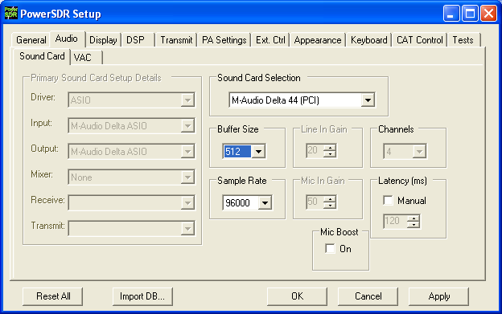
Figure 66: Setup Form - Audio Tab, Sound Card Sub-Tab
Take care when changing the controls to pay attention which Sub-Tab you are on as many of the controls on the Sound Card and VAC Sub-Tabs are similar.

Sound Card Selection
Allows simplified audio setup for recommended and legacy sound cards. Select the card you are using from the list. If your sound card is not in the list, select the Unsupported Card option. This will require additional setup using the controls in the Sound Card Setup Details section.
Note: When using a recommended or legacy card the Primary Sound Card Setup Details, Line In Gain, Mic In Gain and Channels are disabled (grayed out) as the values are defaulted for that specific card.

Buffer Size
Sets the size of the audio buffers in samples. Larger buffers mean more delay, but smoother audio. Smaller buffers yield less latency, but at the cost of CPU load. The 2048 sample buffer size means that a single buffer at 48kHz sampling rate is 2048/48000 = 42.7ms in length. Faster machines should be able to run 512 Sample buffers without issue. For best CW performance, set the audio buffer to 512 or less.

Sample Rate
The sample rate is locked to 48kHz unless your selected hardware supports higher rates (96 or 192kHz). Using these higher sampling rates will result in a wider panadapter display. For best CW performance set the sample rate to at least 96kHz

Line In Gain
Sets the Line In volume on the selected mixer for consumer grade cards. Note that recommended and legacy cards have been tested and the optimal value is set by default. Selecting Unsupported Card on the Sound Card Selection will unlock this control. This control is not used for the Delta-44 or Edirol FA-66.

Mic In Gain
Sets the Microphone volume on the selected mixer for consumer grade cards. This control should be set in order not to overload the sound card. The front panel MIC control can add software gain if using a professional grade card (Delta-44 or Edirol FA-66) or if your consumer card cannot provide adequate gain.

Latency
Using the manual option, the user may add additional latency (in milliseconds) to the audio buffering system for better audio performance. When the manual setting is off, the delay is set to 0ms. Note that some systems will have trouble with the manual setting on and values below around 15ms. We recommend using the default automatic latency setting for best results.

Output Voltage
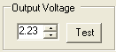
Figure 67:Sound Card Output Voltage
Note: The Sound Card Output Voltage is not displayed when using a recommended or legacy card. We have found that the variance from card to card (same model) is negligible (+/- 0.04V). For this reason, for recommended and legacy cards we only use our measured default values.
The sound card output voltage is the measured single channel AC voltage on the sound card Line Output when running the test. To run the test, first unplug the To Line Out cable from the SDR-1000 enclosure. Click the Test button to begin sending the full range signal. Use an AC voltmeter to measure the voltage between the connector tip and the connector ground. Next, record the measured value in the box. Using a value that is higher or lower than your actual output will cause the power calibration to be inaccurate.

Sound Card Setup Details
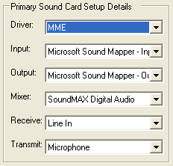
Figure 68: Sound Card Setup Details
If using a supported sound card, these controls will be set automatically. In order to change these settings, it is necessary to choose the Unsupported Card option from the Sound Card Selection drop down box.
- Driver: There are three audio drivers available through the PortAudio sound interface. These are in order from lowest to highest latency: ASIO, MME (multimedia extension), and DirectSound (part of the DirectX package). Note that lower latencies generally cause higher CPU loading. Therefore, it is likely that ASIO will take more CPU load than using MME or DirectSound. Selecting the Driver will populate the Input and Output Drop Down Boxes. ASIO is the recommended Driver type.
- Input: Selects the input audio device. While PortAudio allows different Input/Output devices, we recommend using the same device for both. The Mixer selection will attempt to follow the Input selection. However, if the naming is different, it will be necessary to manually select the mixer from the Mixer drop down box.
- Output: Selects the output audio device. Again, we recommend matching the Input/Output devices.
- Mixer: Selects the windows mixer device that will be used for volume control and transmit line switching. As noted above, this selection attempts to follow the Input selection. Manual selection is necessary if the driver name is different from the mixer name. Selecting the mixer device will populate the Receive and Transmit drop down boxes.
- Receive: Selects the audio line to be used in receive mode. This is typically Line In or Analog Mix.
- Transmit: Selects the audio line to be used in transmit mode. This is typically Microphone.

[The rest of this page has been left blank intentionally]

VAC Sub-Tab
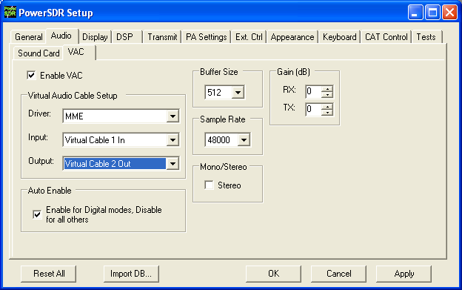
Figure 69: Setup Form - Audio Tab, VAC Sub-Tab
Use these controls to configure the VAC (Virtual Audio Cable) settings for use with the PowerSDR software. This is ideally for running digital modes, but can serve as another way to get audio in and out of the PowerSDR software. The Buffer Size, Sample Rate, and Setup details are all similar to those described for the sound card in the above section. Below we describe the unique controls on this form.

Gain (dB)
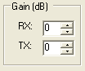
Figure 70: Gain (dB) Controls
These settings adjust the gain for signals coming in and out of the VAC interface. Use the RX control to adjust the audio level going to third party programs. Note that this control supercedes the front panel AF control for third party applications. Similarly, use the TX control to adjust the volume of audio coming from third party applications. Use this control instead of the MIC control on the front panel to calibrate transmit (adjust for 0 dB on the ALC meter).

Auto Enable
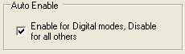
Figure 71: Auto Enable
Use this control to automatically enable VAC when operating digital modes (DIGL, DIGU, DRM). This allows the user to easily switch between digital modes and SSB/AM/FM without having to change this control to enable/disable VAC.

Display Tab
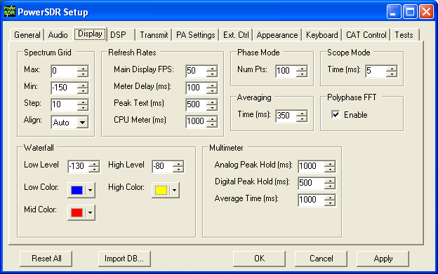
Figure 72: Setup Form - Display Tab

[The rest of this page has been left blank intentionally]

Spectrum Grid
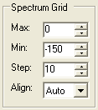
Figure 73: Spectrum Grid
The spectrum grid controls define the background grid shown in the Spectrum, Histogram, and Panadapter displays.
- Max: The maximum signal shown on the spectrum displays in dBm (i.e. top of the display). Raising this value will expand the limits of the display while compressing the range shown.
- Min: The minimum signal shown on the spectrum display in dBm (i.e. bottom of the display). Similar to the max setting, lowering this value will expand the limits of the display while compressing the range shown.
- Step: Spacing between vertical power spectra gridlines in dBm. This control can be used to spread the horizontal lines and vertical axis values on the display, which some people may find distracting. Use the Align control to turn them off completely.
- Align: Sets the position of the vertical axis. The Left, Center, Right, and Off settings are self-explanatory. The Auto option works based on the filter selection and operates as it did in previous PowerSDR versions.

Refresh Rates
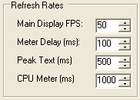
Figure 74: Refresh Rates
- Main Display FPS: Sets the update rate of the main display to the selected value in frames per second. Note that this is a good control to reduce if you are running on a slower machine to save CPU cycles. Raising this value will give faster updates at the cost of CPU load. Lowering the value will slow the display down.
- Meter Delay (ms): Sets the update rate of the multimeter on the front panel. This applies both to the text and the graphical display. Raising the value increases the delay between updates and slows the meter down. Conversely, lowering the value will accelerate the meter.
- Peak Text (ms): Sets the update rate of the peak signal location text box located just beneath the display. Raising the value increases the delay between peak updates and slows the display down. Conversely, lowering the value will accelerate the updates.
- CPU Meter (ms): Sets the update rate of the CPU Meter in the lower left corner of the front console. Raising the value will add more delay between updates while lowering the value will yield faster responses. Note that the CPU Meter measures your entire system load and not just that of PowerSDR process.

Waterfall
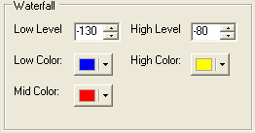
Figure 75: Waterfall
The waterfall display can be customized to your preferences in terms of dynamic range response and color coding. If a signal is at or below the Low Level, or at or above the High Level it is displayed using the Low or High Color respectively. If a signal is exactly halfway between these two levels it is displayed using the Mid Color. Otherwise the signal is displayed in a color according to a linear interpolation between the Mid Color and either the Low or High Color, whichever corresponding level is closer.
- Low Level: The lower end of the dynamic range to view in dBm. Signals at or below this level will use the Low Color.
- High Level: The high end of the dynamic range to view in dBm. Signals at or above this level will use the High Color.
- Low Color: Color used if the signal level is at or below the Low Level.
- High Color: Color used if the signal level is at or above the High Level.
- Mid Color: Color used if the signal level is exactly between the Low and High Levels.

[The rest of this page has been left blank intentionally]

Multimeter
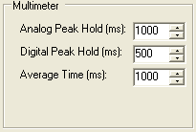
Figure 76: Multimeter Display options
- Analog Peak Hold (ms): The length of time in milliseconds to hold the peak on the analog bar meter. Raising this value will lengthen the hold time and peaks will be held for a longer period of time.
- Digital Peak Hold (ms): The length of time in milliseconds to hold the digital meter when using the Fwd Pwr TX Meter. Raising this value will lengthen the hold time and peaks will be held for a longer period of time.

Phase Resolution
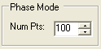
Figure 77: Phase Resolution
This control sets the phase resolution in number of points displayed per 360°.

Scope Time Base
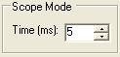
Figure 78: Scope Time Base
This control adjusts the time base in ms (horizontal time scale) of the Scope Display.

Averaging
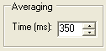
Figure 79: Display Averaging
This control sets the averaging time in ms of the spectrum displays (Spectrum, Panadapter, Waterfall, Histogram).

Polyphase FFT
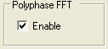
Figure 80: Polyphase FFT
Enable this feature to display peaks sharper in the spectrum displays (Spectrum, Panadapter, Waterfall, Histogram). Expect to see an up to 4 times narrower area of the displayed “spike” of a tone, especially when the displayed frequency span is relatively large in comparison.

DSP Tab

Options Sub-Tab
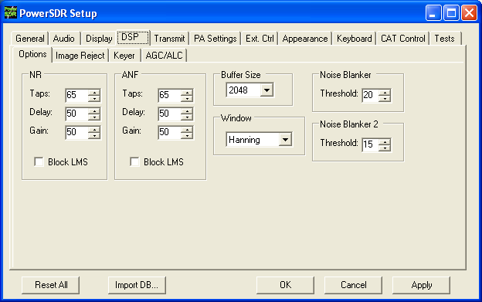
Figure 81: Setup Form - DSP Tab, Options Sub-Tab

[The rest of this page has been left blank intentionally]

Noise Reduction
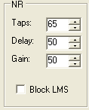
Figure 82: Noise Reduction Controls
Noise Reduction (NR) attempts automatic computation of a filter that maximizes the coherent or non-noise like signals and as a result, filters out the rest of the signal, which includes noise. It is best used for speech signals with a good signal to noise ratio or tones.
- #Taps: This determines the length of the computed filter. The longer the filter, the better the non-coherent signals (noise) will be cancelled. It also introduces latency equal to the number of filter taps divided by the sample rate in samples per second and is in addition to Delay (see below). The larger the number of taps, the longer it takes for the filter to converge but upon achieving convergence, the better the filter will be.
- Delay: Determines how far back to look in the signal before beginning to compute a coherent signal enhancement filter. With large delays, there is a higher likelihood of detrimental affects to normal speech. Latency is also introduced that is equal to the Delay.
- Gain: Determines the adaptation rate of the filter. The larger the number, the faster the filter will converge but the less stable it will be.
- Block LMS: We have implemented a fast Block LMS (least means square) routine. This routine is faster than the original routine, gives more taps in the filter, and will work on I/Q signals, which enables BIN (binaural audio) to remain available.

Automatic Notch Filter
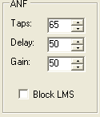
Figure 83: Automatic Notch Filter Controls
The Automatic Notch Filter (ANF) attempts automatic computation of a filter to remove one or more carrier tones that are interfering with the signal of interest.
- #Taps: This determines the length of the computed notch filter. The longer the filter, the larger the number of tones that can be cancelled and the more effective the cancellation will be. It also introduces latency (signal delay) equal to the number of filter taps divided by the sample rate in samples per second and is in addition to Delay (see below). The larger the number of taps, the longer it takes for the filter to converge but upon achieving convergence, the better the filter will be.
- Delay: Determines how far back to look in the signal before beginning to compute a cancellation filter. The larger the delay, the less the impact on normal speech, and the more likely the filter will be able to concentrate only on longer term coherent signals such as carrier tones. Latency is introduced that is equal to the Delay.
- Gain: Determines the adaptation rate of the filter. The larger the number, the faster the filter will converge and the less stable it will be.
- Block LMS: We have implemented a fast block LMS routine. This routine is faster than the old routine, gives more taps in the filter, and will work on I/Q signals which enables it to work in BIN mode.

Buffer Size
This controls the size of the DSP buffers, which determines the size of the FFT filter and therefore the group delay (latency) through the digital filter. Higher values will result in more latency and sharper (“brick wall”) filters. Lower values will allow nearly real time monitoring with filters that “roll off” (as opposed to the typical “brick wall” filters).
Note 1: Using lower values will negate the effects of some of the narrowest filters (25 or 50Hz).
Note 2: The DSP Buffer is completely independent of the Audio buffer size.

Noise Blanker
This controls the detection threshold for impulse noise. If a signal sample exceeds this detection threshold, the sample will be set to zero and the filtering in the radio serves to interpolate through this zero sample. This noise blanker is identical in theory to those in traditional radios. The detection threshold in our noise blanker has the unique feature that they are signal strength dependent. This enables them to function properly at all signal levels.
This control is preferable when the spikes are very large in comparison to the average signal. However, when the spike is smaller, Noise Blanker 2 provides a much cleaner reconstruction of the signal since the signal is more likely to look like the mean. For this reason, the Noise Blanker 2 threshold should always be about four or five less than the Noise Blanker threshold.

Noise Blanker 2
This controls the detection threshold for a pulse. If a signal, pulse or not, exceeds this detection threshold, the sample will be replaced by a computed estimation of what the signal sample should have been given an interpolation of the signal samples around it in time. By replacing the noise pulse with an interpolation of the signal, distortion is greatly reduced over that of traditional noise blankers.
When seeing a significant amount of impulsive noise, being too aggressive with Noise Blanker (NB) can damage the signal. However, completely removing the large pulses is desirable prior to operating the smoother acting Noise Blanker 2 (NB2). Therefore, when seeing many repetitive noise pulses, it is probably best to use both NB and NB2. The NB Threshold is adjusted to just begin to lower the noise from the pulses, after which NB2 is turned on, with a threshold of four or five less than that of NB. Both together can spectacularly reduce impulse noise, resulting in increased intelligibility of the signal under severely adverse conditions.
Window
This control selects the DSP windowing function that will be applied to the power spectrum in the main display when using Spectrum, Panadapter, Histogram, and Waterfall displays. The default is Hanning, which is the best setting for many high-level signal measurement needs. The purpose of the windowing is to diminish bleed-through to adjacent “bins” which results from a tone that is not exactly on the center frequency of one of the “bins” (or parallel filters) in the power spectrum calculation. The bleed through is caused by using the Fast Fourier Transform (FFT) to calculate the power spectrum. We need to use it for the sake of efficiency. That said, it is important to understand that the FFT writes the data (mathematically speaking) on a circle and not on a line. When the last sample meets the first sample on a circle, it is very probable that it will not meet up or join in a continuous fashion. This discontinuity acts in exactly the same manner a key click causes a wide spectrum. The window is used to mitigate this key click-like phenomenon. The Rectangular Window bleeds through the worst. The best in our selection is the Blackman-Harris Window, which bleeds through the least. For further reading on windowing, please see the following link.
Let us consider each option and some of their characteristics.
- Rectangular: This means the data has no window applied. No shaping is applied to the incoming signal. As a result, you will have the greatest sensitivity in the power spectrum and the greatest bleed through or interference with adjacent bins.

[The rest of this page has been left blank intentionally]
- Hanning, Hamming: These windows are based on a raised cosine shape. In addition to providing continuity (Hanning) or near continuity (Hamming), these both provide a shape that makes the slopes of the signal agree at the beginning and the end of the signal buffer. This filter provides for both good
Window |  | Mathematical Description | Graphical Depiction
Hanning | 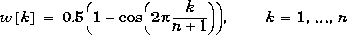 |  | 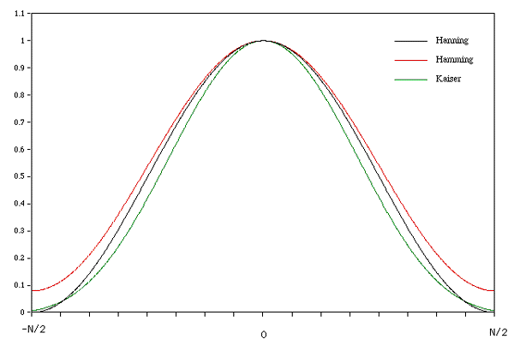
Hamming
Figure 84: Hanning and Hamming Windows (Kaiser also displayed)
- Welch: This applies a shaping function to the data before the FFT is computed. The figure gives its shape.
Window | Mathematical Description | Graphical Depiction
Welch | 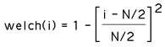 | 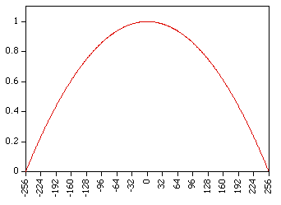
Figure 85: Welch Window
This picture is from a 512 long Welch Window. We actually use a 4096 long window but this does illustrate the qualitative features. Notice that at the left and the right end, we have forced the continuity by applying this tapering function. This continuous move to zero at the endpoints mitigates the “key-click” phenomenon that would otherwise result from the boxcar or rectangular window.
- Blackman, Blackman-Harris: We use Blackman-Harris to design all filters in the signal processing chain for all modes. This provides for minimal bleed through as we have described and the best shape factor for our needs in the overlap-save filtering routines. While it has some good features, these features are probably not ideal for the CW power spectrum displays. There is a penalty to pay for the smoothing near the ends afforded by the windows. If you have experience in the use of FFTs and the display of the power spectra that result, you know that a smaller FFT at a fixed sample rate causes a wider range of frequencies to be contained in one bin of the power spectral results. This means that a tone will look more like a large lobe or finger than a tone spike. The same phenomenon is present in the best windows. While the spreading of the “main lobe” of a tone is not as bad as taking an FFT of half the size, it is wider than one bin. The formulae for all of the Blackman filters are of this form:
f(x) = a₀ − a₁ cos(πx) + a₂ cos(2πx) − a₃ cos(3πx)
The individual parameters by type:
- Blackman: a₀ = 0.42, a₁ = −0.5, a₂ = 0.08, a₃ = 0
- Blackman Harris: a₀ = 0.35875, a₁ = 0.48829, a₂ = 0.14128, a₃ = 0.01168
- Blackman Nuttall: a₀ = 0.3635819, a₁ = 0.4891775, a₂ = 0.1365995, a₃ = 0.0106411
- Parzen, Bartlett, Exponential, and Riemann: These windows are much less widely used and are included for completeness. They sometimes perform better for a particular application and some experimentation on the users part should be undertaken to find the window that gives the most pleasing display to you.

[The rest of this page has been left blank intentionally]

Image Reject Sub-Tab
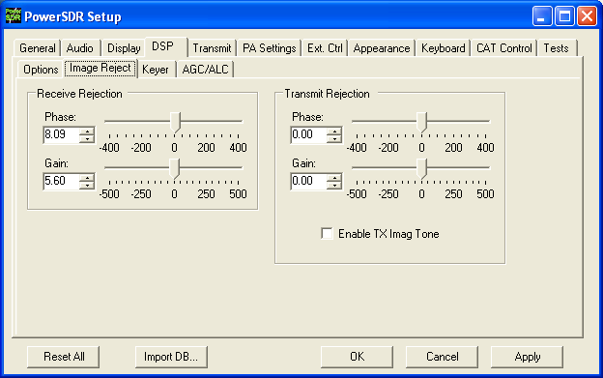
Figure 86: Setup Form - DSP Tab, Image Reject Sub-Tab
These controls enable the user to adjust the image to minimum in order to reject the opposite sideband. There is an automatic process for doing this on receive (signal source required). For transmit, the process is described below.

Receive Rejection
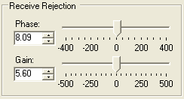
Figure 87: Receive Rejection
Image Rejection means finding adjustments for phase angle and gain differences between the left and right channels in your stereo card (or the in-phase (I) and quadrature (Q) signals). The algorithm that does this assumes that the phase offset and gain difference between the I and Q channels are constant across all bands and assumes that the audio channel is linear across the sound card bandwidth. This works extremely well in practice.
- Phase: Sets the phase offset between the I and Q channels. Ideally, the phase angle difference between I and Q (right and left channels) of a tone in our passband will be 90 degrees.
- Gain: Sets the amplitude offset between the I and Q channels. Ideally, the amplitude of both I and Q (left and right) channels of a received tone will be equal.

Transmit Rejection
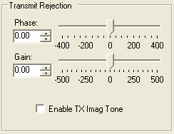
Figure 88: Transmit Rejection
Similarly to above, these controls enable the user to adjust the image rejection for the transmitter. Unlike Receive Rejection however, this is not an automatic procedure. The calibration requires external instruments. A spectrum analyzer is ideal but a second receiver should enable you to get satisfactory rejection levels.
To minimize the transmit image, proceed as follows:
- Set the radio to either USB or LSB. Connect the radio to a dummy load and select Enable TX Image Tone.
- Click MOX (front console) and a full strength tone will be transmitted at the frequency shown in VFO A. Adjust the output power with the Drive control (front console).
- If the radio is set to USB, look at the image signal BELOW the carrier in either the spectrum analyzer or the second receiver. If set to LSB, look at the image signal ABOVE the carrier.
- Using Phase and Gain controls, null the relevant image signal.
Note: The image rejection will only work in an asymmetric voice mode (SSB). In a symmetric voice mode, like AM, SAM, and FMN any small amount of image problem will likely be covered up.
[The rest of this page has been left blank intentionally]

Keyer Sub-Tab
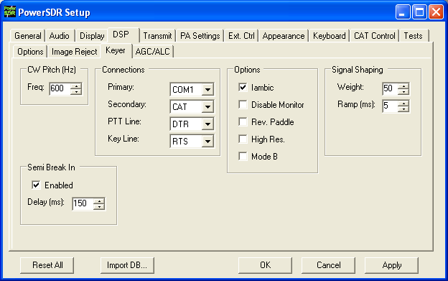
Figure 89: Setup Form - DSP Tab, Keyer Sub-Tab
Note: Modifying the Audio buffer size (as well as the sound card latency or buffer settings) can help bring the latency of the internal keyer down to a minimum. Also, we suggest using the serial port hookup for keying the radio via an external paddle or keyer. See the CW Operation section in the Operating chapter below for more information.

CW Pitch
This enables the user to set the desired audio frequency for CW listening at the center of the CW filters (1kHz and lower filters). This will determine the offset that is applied to the carrier in receive and transmit. The display will continue to read the actual carrier frequency (if the radio is calibrated) but the software will provide for an offset to get the desired CW tone. This pitch will determine the automated tuning frequency using the display and mouse “click tune” functions.

[The rest of this page has been left blank intentionally]

Connections
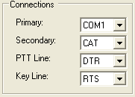
Figure 90: Connections
The internal keyer supports two inputs. We call these inputs the primary and secondary connections. The primary connection will override the secondary input. This was designed with the idea that the secondary connection might be used for automatic CW generation while the primary could be used with manual paddles to override the automatic output.
- Primary: Select the connection to be used for the primary connection. Selecting “SDR” allows use of the jack on the back of the SDR-1000.
- Secondary: Select the connection to be used for the secondary connection. Selecting CAT will allow use of the COM port that is currently being used by the CAT connection. This is useful as some programs allow both CAT commands and COM port line keying for CW. Note that the lower two controls will not show up if None is selected.
- PTT Line: Select the COM port line used for PTT.
- Key Line: Select the COM port line to be used to activate the key.

Options
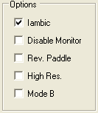
Figure 91: Internal Keyer Options
- Iambic: Check this box to enable Iambic mode A emulation unless mode B is selected (see below). With the box unchecked, the key input will act like a straight key.
- Disable Monitor: The monitor is typically turned on when using Semi Break In with the internal keyer. In order to keep the monitor off, check this option.
- Rev. Paddles: Using this option will reverse the paddle inputs so that the dot becomes a dash and vice versa.
- High Res.: This option will attempt to further improve CW latency by using the high frequency event timer (if present) on motherboards containing Intel Pentium 4+ (and AMD equivalent) type processors. If the CW timing or tone production becomes unstable after checking the box, your motherboard contains the low frequency timer and you should leave the box unchecked. The option works for both manual and automatic CW.
- Mode B: Check this box to enable Iambic mode B emulation. Uncheck it to enable mode A emulation.

Signal Shaping
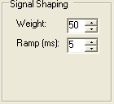
Figure 92: Signal Shaping Controls
- Weight: Sets the width ratio between the dot and dash.
- Ramp: Sets the length of the leading and trailing edge on the tones in milliseconds to avoid “key clicks.”

Semi Break In
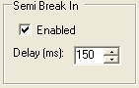
Figure 93: Internal Keyer Semi Break In Controls
- Enabled: Check this box to enable Semi Break In for the internal keyer.
- Delay (ms): Sets the amount of time between the last detected input and when the radio will drop back to receive. The smallest possible setting is 150 ms and it is recommended that this be set larger than 250ms. The SDR-1000 is not a QSK radio.

[The rest of this page has been left blank intentionally]

AGC/ALC Sub-Tab
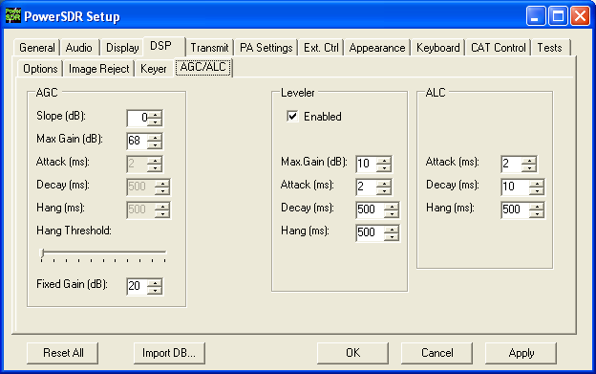
Figure 94: Setup Form - DSP Tab, AGC/ALC Sub-Tab
These controls allow the user to customize the AGC/Leveler/ALC to their own particular tastes.

AGC
The settings control the AGC Custom setting on the front panel.
- Slope (dB): Slope changes the rate at which gain increases with decreased signal. If you have the Slope set to 10 dB and the signal gets weaker by 1 dB, the gain will be increase by 10 dB. The increase is still limited by max gain. This provides different decay action in the AGC. Attack is unaffected. 0dB is default, 10 dB is maximum.
- Max/Neg Gain (dB): The maximum (or minimum) amount of gain the system is allowed to apply. When receiving (AGC), this can be used to minimize ambient noise that may cause listening fatigue.
- Attack (ms): This sets the time constant for the attack for the AGC. Note that in order for this and the two controls below it to be enabled, the AGC control on the front panel must be set to Custom.
- Decay (ms): This sets the time constant for the decay for the AGC. When a signal gets weaker, this determines how quickly the AGC will respond to the need for increased gain.
- Hang (ms): To keep the AGC system from doing too much up/down, an adjustable hang time is provided. After this time has expired, the Decay will then determine how quickly the AGC gain recovers.
- Hang Threshold: The hang will NOT occur if the signal is weaker than this threshold.
- Fixed Gain: When you choose Fixed AGC on the front panel, this number is used to amplify the signal.

Leveler
The Leveler is intended to even out the variations in input to your microphone caused by varying distance from or angle presented to it. It is an attempt to “level” the amplitude presented to the rest of the DSP audio processing. The leveler is disabled in DIGU and DIGL modes.

ALC
The ALC is what you would typically consider ALC to be in a transmitter. It is an attempt to prevent overdrive of the amplifier and the distortion that would accompany that. Because of the “dual channel” AGC algorithm we use, this ALC will allow very high average power while maintaining peaks at a controlled level. The Compressor and Compander (CMP and CPDR on front console (mode specific – phone) and on the Setup Form-Transmit Tab) work very well with the ALC to increase average power without overdrive.

[The rest of this page has been left blank intentionally]

Transmit Tab
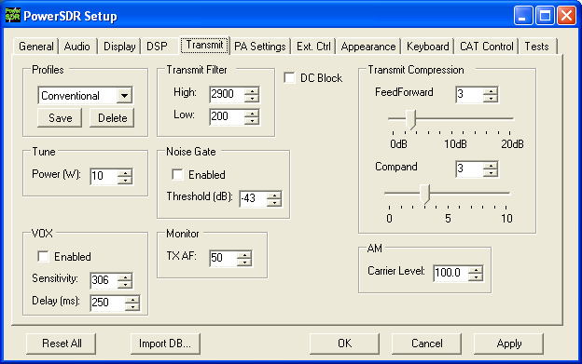
Figure 95: Setup Form Transmit Tab
The transmit Tab has controls that allow the user to tailor the transmit signal characteristics using features like compression and filtering.
- DC Block: Attempts to block any DC noise from entering the filter. This is used mainly with lower quality sound cards or on systems where there are grounding issues.
- Tune Power: Sets the power in Watts to be used whenever the TUN (Tune) function is used on the front console (sets the Drive control). Changes made to the Drive level while TUN is active will be reflected in this control.

[The rest of this page has been left blank intentionally]

TX Profiles
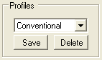
Figure 96: TX Profiles
The TX Profiles selection allows the user to save and restore the various TX settings with ease. The TX profile includes: EQ, Filter, Compression, MIC, Drive, COMP, CPDR, Leveler, and ALC settings. Click the Save button to save the current profile. You will be prompted for a name. To change profiles, select the named profile from the drop down list. To remove a profile, select it using the drop down menu, and then click the Delete button.

Transmit Filter
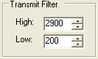
Figure 97: Transmit Filter Controls
- High: Controls the high cut of the Transmit Filter.
- Low: Controls the low cut of the Transmit Filter.
Note: You will receive a “good practice” warning if the transmit filter bandwidth exceeds 3kHz.

[The rest of this page has been left blank intentionally]

Noise Gate
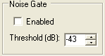
Figure 98: Noise Gate
- Enabled: Enables the transmit noise gate.
- Threshold (dB): The threshold below which the transmitter is silenced (gated). When adjusted correctly, the noise gate prevents prevailing noise in the room (ambient noise) from being transmitted while the mic is keyed and the operator is not talking. It is very useful if there are close by fans that degrade your signal and make your transmissions disturbing to copy. The noise gate operates identically, whether using VOX or PTT.
To adjust the noise gate:
  - While wearing headphones, activate MON and MOX on the front console (use a dummy load). Disable the noise gate and turn up the Monitor AF so that you can hear your ambient noise clearly and preferably louder than without headphones. Without speaking, enable the noise gate.
    - If you still hear your ambient noise, increase the noise gate threshold level until the noise is just silenced.
    - If your ambient noise disappears when enabling the noise gate, decrease the threshold level until you just start to hear it. Then increase it until it just disappears.
  - With the noise gate adjusted, speak into the microphone and verify that your voice sounds as natural as possible.

VOX
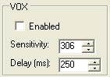
Figure 99: VOX
- Enabled: Enables/Disables the VOX operation.
- Sensitivity: The threshold above which the software automatically switches to transmit mode. Use this in combination with the Noise Gate for best results.
- Delay (ms): Time to stay in transmit after the last peak above the threshold.
Note: Due to current hardware limitations with the TR switch time, VOX will nearly always drop the first syllable during the transition.

TX Monitor
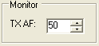
Figure 100: Transmit Monitor AF Control
Use the TX Monitor AF control to set the value that the AF control (front console) will use during transmission. Note that this is only functional with 4-port cards such as the Delta-44 and the Edirol FA-66.

Compression
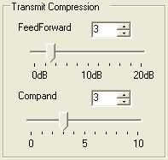
Figure 101: Transmit Compression
- Feed Forward Compression: Determines the “look forward” transmitter automatic gain setting. Unique to DSP implementations, it allows the required gain to anticipate the level before application rather than simply following the signal around. Raising the value will give higher average power without raising the peaks. It helps prevent pumping and popping with large signal onsets and allows for very high average power with low distortion. Note that depending on the microphone/sound card combination, higher values of compression may result in distortion on the output. This setting can be enabled by using the COMP button in the DSP group on the lower right hand section of the front console.
- Compand: The compand setting given here is really a compression setting. If you are familiar with “μLaw”, the compression that takes place is very similar. The setting here does not correspond to dB but to a slope of the compression algorithm near zero magnitude. In other words, how much are we pushing the signal up at small magnitudes. As the magnitude of the input signal goes up, less gain is applied and the fall-off of the gain is exponential in its decay. With the goal of introducing fully companded SSB in the near future, this control was put in to the console to allow us to gain experience with this algorithm.

AM Carrier Level
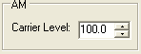
Figure 102: AM Carrier Level
The Carrier Level determines the percentage of carrier level to be applied to the transmit signal where 100% is one quarter of full power output (25W when Drive on the front console is set to 100). So a setting of 80 would yield roughly 16W when Drive is set to 100. This is useful as it allows the modulation to appear much stronger due to the weaker carrier.

[The rest of this page has been left blank intentionally]

PA Settings Tab
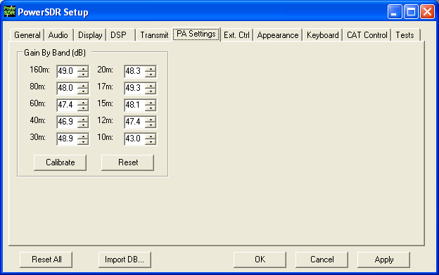
Figure 103: Setup Form - PA Settings Tab

Gain By Band (dB)
This shows the total hardware (radio + PA) signal chain gain. These controls are used to balance the output power across the ten supported amateur bands. A higher gain figure for the hardware (as shown) means a lower audio drive gain requirement.
- Calibrate: this button will allow those with 50-Ohm dummy loads to calibrate these values automatically. Failure to use a dummy load with this test could cause damage to the amplifier. Those without dummy loads should simply enter the values shipped with the unit.
- Reset: this button is included to reset all of the values to 48.0dB (low power output).

[The rest of this page has been left blank intentionally]

Ext. Ctrl Tab
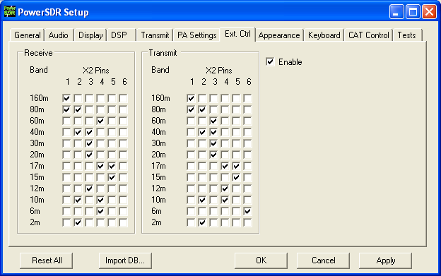
Figure 104: Setup Form - Ext. Control Tab
This form enables the user to map various bands to X2 pin outputs. This is a good way to control an external linear amplifier or transverter that needs to be switched in and out depending on what band you are on. Note that there are separate settings for transmit and receive. To use the controls, simply mark the boxes to indicate which pins should go logic high for that band. For example, if you check the 2 and 4 boxes on the 20m band on receive, those two pins will go high when in receive mode on that band.

[The rest of this page has been left blank intentionally]

Appearance Tab
The appearance controls allow the user to completely customize the appearance of the front console.

Display Sub-Tab
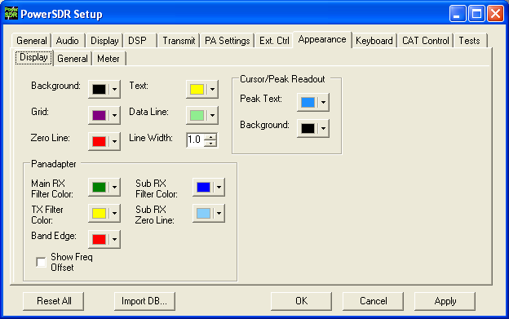
Figure 105: Setup Form-Appearance Tab, Display Sub-Tab

Overall Display
These controls change the appearance of all the display types, where relevant.
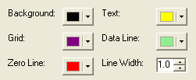
Figure 106: Overall Display Appearance Controls
- Background: The background color for the display.
- Grid: The color of the grid in display types where a grid is necessary.
- Zero Line: The color of the zero line in frequency displays.
- Text: The color of the text on the display for frequency and level callouts.
- Data Line: The color of the actual data being displayed.
- Line Width: The width in pixels of the actual data being displayed.

Cursor/Peak Readout
These controls change the appearance of the cursor and peak texts under the frequency displays.
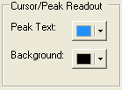
Figure 107: Cursor/Peak Readout Appearance Controls
- Peak Text: The color of the Peak signal location text located under the display.
- Background: The background color of the Peak signal location text.

Panadapter
These controls change the appearance unique to the Panadapter display.
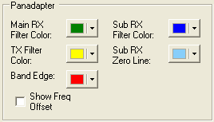
Figure 108: Panadapter Appearance Controls
- Main RX Filter Color: The color of the Main RX Filter.
- Sub RX Filter Color: The color of the Sub RX Filter.
- TX Filter Color: The color of the TX filter-edges.
- SUB RX Zero Line: The color of the 0 Hz line of the Sub RX Filter.
- Band Edge: The color of the lines marking the edge of an Amateur band.
- Show Freq. Offset: When selected, the offsets from the Main RX Filter 0Hz line are shown across the top as opposed to the actual frequencies.

General Sub-Tab
These controls change the appearance of the buttons and the VFOs.
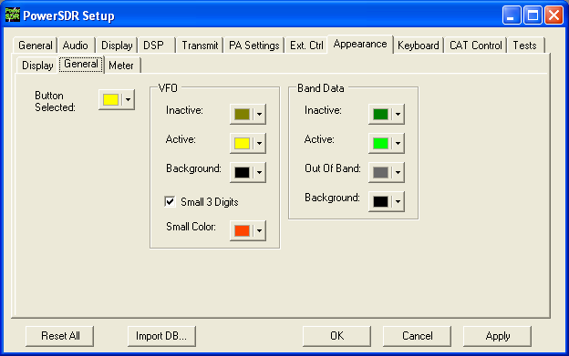
Figure 109: Setup Form-Appearance Tab, General Sub-Tab
Button Selected: The color of buttons when they are in the selected state.

[The rest of this page has been left blank intentionally]

VFO
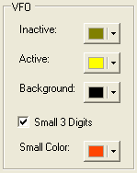
Figure 110: VFO Appearance Controls
- Inactive: The color of the text in the VFOs when they are inactive.
- Active: The color of the text in the VFOs when they are active.
- Background: The background color of the text in the VFOs.
- Small 3 Digits: When selected, the three least significant digits of the frequency displayed in the VFOs are shown smaller than the other digits for clarity.
- Small Color: The color of the smaller, least significant digits.

Band Data
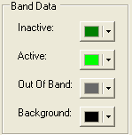
Figure 111: VFO Band Data Appearance Controls
- Inactive: The color of the band information text when that VFO is inactive.
- Active: The color of the band information text when that VFO is active.
- Out Of Band: The background color of the VFO band information when outside the amateur radio bands.
- Background: The background color of the VFO band information when inside the amateur radio bands.

Meter Sub-Tab
These controls enable selection of the analog meter style and change the appearance of the meters.
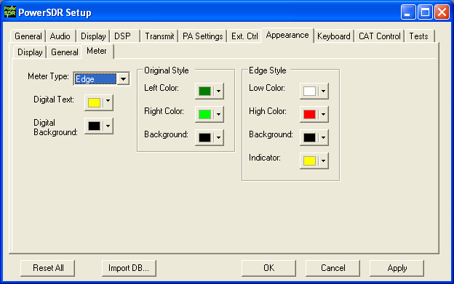
Figure 112: Setup Form-Appearance Tab, Meter Sub-Tab
- Meter Type: Selects the type of graphical meter to display: Original displays the bar graph meter and Edge displays an analog edge style meter.
- Digital Text: The color of the text of the digital meter.
- Digital Background: The background color of the digital meter.

[The rest of this page has been left blank intentionally]

Original Style
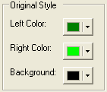
Figure 113: Appearance Controls for the Original Style Meter
- Left Color: The color of the left side of the original style meter gradient.
- Right Color: The color of the right side of the original style meter gradient.
- Background: The background color of the original style meter.

Edge Style
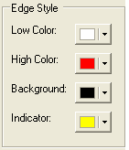
Figure 114: Appearance Controls for the Edge Style Meter
- Low Color: The color of the low values of the edge meter’s scale.
- High Color: The color of the high values of the edge meter’s scale.
- Background: The background color of the edge meter.
- Indicator: The color of the indicator in the edge meter.

[The rest of this page has been left blank intentionally]

Keyboard Tab
These controls associate keys on the keyboard with several operating functions as keyboard shortcuts.
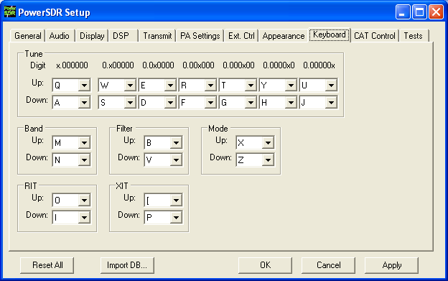
Figure 115: Setup Form - Keyboard Tab
The Tune mapping options allow you to tune each digit (with resolution to 1Hz) up or down using the key of your choice. The digit to be tuned is shown in the labels above these hot keys as an ‘x’. Similarly, you can map keys to change the Band, Filter, Mode, RIT, or XIT up or down using the drop down controls in the respective sections.
Note: Choosing any of the arrow keys will require using Alt + [arrow key].

[The rest of this page has been left blank intentionally]

Cat Control Tab
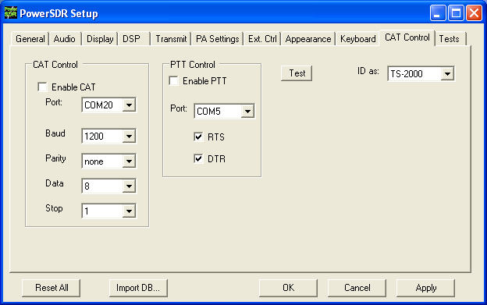
Figure 116: Setup Form - Cat Control Tab
The CAT (Computer Aided Transceiver) Controls enable the PowerSDR software to provide the user with a way to interface with third-party logging and remote control software. When used in conjunction with N8VB’s vCOM virtual serial port software (see the Digital Operations section in the Operation Chapter), the possibilities for interaction with programs such as Ham Radio Deluxe (HRD), DXLab, N1MM Contest Logger, MixW and numerous other third-party software (aids) are realized.

[The rest of this page has been left blank intentionally]

Cat Control
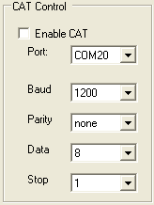
Figure 117: CAT Control
- Enable CAT: Check this box to open the com port using the settings below. Note that you will need to uncheck this box in order to adjust the settings.
- Port: Com port number to use. If using N8VB’s vCOM utility, note that you will use one end of the null-modem pair here and the other on the third-party software (e.g.. HRD).
- Baud: The speed at which to transfer data.
- Parity: Sets whether to send a parity bit.
- Data: Sets how many data bits are sent with each byte.
- Stop: Sets whether to send a stop bit.

[The rest of this page has been left blank intentionally]

PTT Control
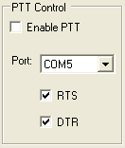
Figure 118: PTT Control
Some software utilizes a separate COM port than the CAT to activate PTT. These controls allow the user to configure this separate port to handle these signals.
- Enable PTT: Used to enable the hardware PTT. This control is unavailable (grayed out) unless a checkmark is placed in at least one of the RTS or DTR boxes (see below).
- Port: The COM port used for the PTT signal.
- RTS: Select this box to use the RTS line to engage PTT.
- DTR: Select this box to use the DTR line to engage PTT.

[The rest of this page has been left blank intentionally]

Test
Click Test to bring up the CAT Command Tester form as shown in the figure below. A valid CAT command may be entered in the CAT Command text box. Depending on the type of keyboard being used, the command will execute when a semicolon (the required CAT terminator) is entered, or when the “Enter” key is depressed, or when the “Execute” button is clicked. The CAT response will appear in the “CAT Response” text box..

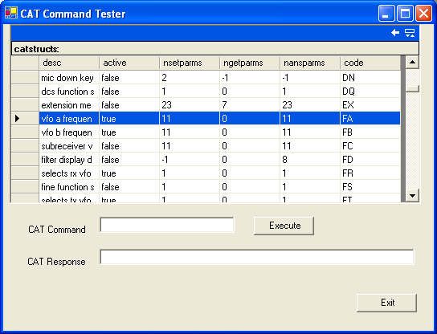
Figure 119: CAT Command Tester Form

[The rest of this page has been left blank intentionally]

Tests Tab
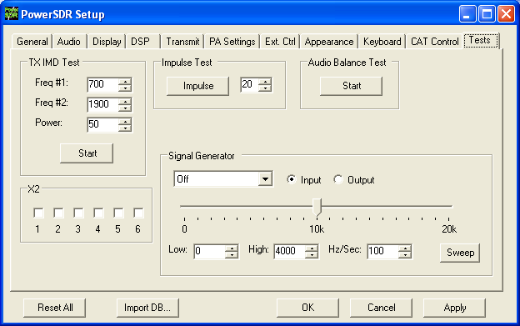
Figure 120: Setup Form - Tests Tab

TX IMD Text:
Used to test the two-tone IMD of the transmitter. To run the test, enter the two tone frequencies in the Freq #1 and Freq #2 controls. Enter the Power to be sent to the front panel Drive control. In practice, it generates equal amplitude tones at the entered frequencies. Click the Start button to begin sending a side-tone signal using the parameters entered. Manually adjust the Power control on this tab to set the tones to 6dB below PEP using a spectrum analyzer. Click the Start button again to stop the test and retrieve the Power value. A single sweep function on a spectrum analyzer is an excellent tool to capture the output for analysis.
CAUTION: Do not leave the radio in the two-tone test for periods longer than 15 seconds if using the power amplifier in order to avoid damage.

Audio Balance Test
Use this test to ensure that the Line Out cable is getting both output channels. The test will send a tone to each speaker and prompt to see if you hear audio in that one speaker. If you hear no audio or audio in both channels during this test, then you may have a problem with the cable going to the plug labeled “To Line Out” on the enclosure.

X2
These controls were added in order to help test the Universal Controller Board (UCB). These will likely be removed once the UCB is completely integrated into the console.

Impulse Test
Used to test the impulse response using the impulse generator on the RFE board. Enter the number of iterations (impulses) and click the Impulse button to run the test.

Signal Generator
Used to generate signals for testing the PowerSDR software and connected hardware. Send whether the signal should be an input or an output and then select the type of signal. When finished, set the signal type to “Off” to allow the SDR-1000 hardware to once again be used.

[The rest of this page has been left blank intentionally]

Operating Forms
This chapter describes each of the so-called operating forms. You can access each form individually by clicking on the relevant menu item to the right of Setup at the top left of the front console (see image below). For ease of reference, the numerical identifiers from the previous chapter on the Front Console are repeated in this chapter.
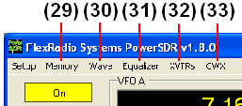
Figure 121: Operating Form Identifiers

[The rest of this page has been left blank intentionally]

(29) Memory Form
Click the Memory menu allows saving and retrieving information such as frequency, mode, filter and various other settings.

Save…
Opens the Save Memory Channel form as shown in the figure below.
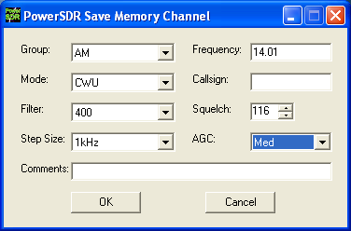
Figure 122: Save Memory Channel Form
The current Mode, Filter, Step Size, Frequency, Squelch and AGC settings are automatically transferred from the console. The Group Drop Down Box allows a further level of characterization of the type of entry. In the future this Group list will be customizable. The Callsign and Comments fields are free form and the user can enter details as desired. Clicking the OK button will save the information shown above into the memory database before closing the form. Clicking Cancel simply closes the form (the data is not saved).

[The rest of this page has been left blank intentionally]

Recall…
Presents the user with a Memory form with data from all previously stored memory locations (shown in the figure below).
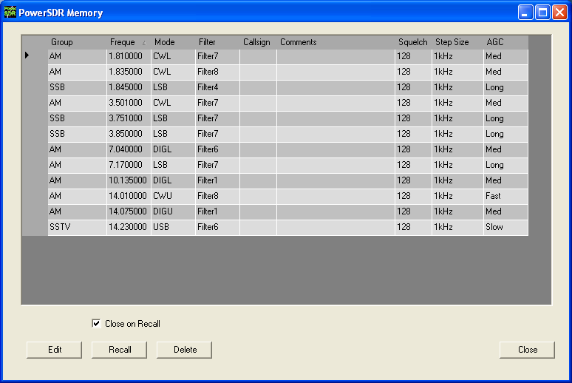
Figure 123: Memory Form
The data grid displays each memory that has been saved to the database. Clicking in the left hand margin will allows a particular memory to be selected. Clicking on the column titles will sort the data using the information in that column.
- Edit: Click the Edit button manually change the saved memories. Make sure to click the button again when finished editing to prevent unintended changes from getting saved to the database.
- Recall: Click the Recall button to send the data in the memory to the front console (i.e. restore a memory). You can also double-click on a row to accomplish this, although this method is less consistent. Select Close on Recall to close the Memory Form when clicking Recall.
- Delete: Click the Delete button to remove a memory from the database. A prompt will be shown to prevent unintended loss of memories.

(30) Wave Form
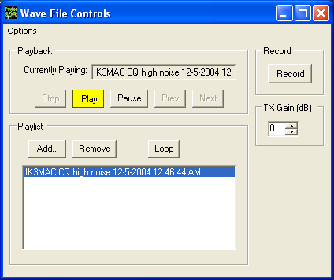
Figure 124: Wave Form
The Wave form allows the user to Record and Playback either the post-processed audio of the current station, or up to 192kHz bandwidth (as determined by the sampling rate of your sound card) of pre-processed IF (I and Q) “audio” from the SDR-1000.

Playback
- Currently Playing: Displays the filename of the currently playing wave file.
- Play: Click this button to start or stop playback of the current wave file. Note that clicking this button twice while a file is playing will restart the file.
- Pause: Pauses the wave file playback. Click once to pause and again to resume playback.
- Prev (Previous): When there is more then one file in the playlist, clicking this button will cause the previous file in the list to begin playing.
- Next: When there is more than one file in the playlist, clicking this button will cause the next file in the list to begin playing.

Playlist
- Add…: Click this button to open a file menu to select wave file(s) to add to the playlist. Note that incompatible wave files will be removed from the list when they are played for the first time.
- Remove: Removes the currently selected file in the playlist. If the file is currently being played, then you will be prompted asking if you would like to stop playing the file and remove it from the list.
- Loop: When there is more than one file in the playlist, this option is enabled and allows playback to continue after finishing the last wave file in the list. At this point it will start playing the file at the top of the list.

Record
Click the Record button to begin recording a wave file. Click it again to complete the recording. The wave file will be date and time stamped automatically and saved in the default folder (where the PowerSDR software resides).

TX Gain (dB)
Use this control to adjust the volume of audio being played back when transmitting. Use this control instead of the MIC control on the front console to calibrate transmit (adjust for 0 dB on the ALC meter).

Record Options
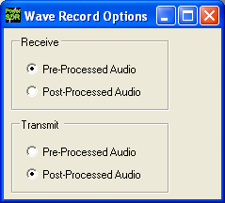
Figure 125: Wave Recording Options
The Wave Record Options can be used to modify what is recorded in either receive or transmit modes.

[The rest of this page has been left blank intentionally]

Receive
- Pre-Processed Audio will record the whole bandwidth of the receiver input. The bandwidth is determined by the sample rate you set for your sound card on the Setup Form-Audio Tab, Sound Card Sub-Tab. This is useful for playing back through the console at a later time (e.g. for demonstration purposes).
- Post-Processed Audio will record only the filtered, AGC’d audio as you hear it coming out of the speaker. This is useful for playing back the received audio through a typical wav file player.

Transmit
- Pre-Processed Audio will capture the audio as it is seen at the microphone input without any of the effects of filtering, compression, companding, equalization or any other audio processing features that may be turned on in the transmit chain.
- Post-Processed Audio allows the recording to capture the audio after it has been filtered, compressed, companded, equalized or modified by any other audio processing feature turned on in the transmit chain.

(31) Equalizer Form
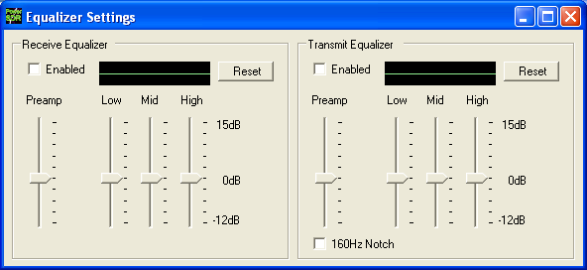
Figure 126: Equalizer Form
The Equalizer Form allows the receive and transmit audio to be modified by 3 band graphic settings. Use the sliders to adjust the gain for the Low, Mid and High audio bands. The Preamp applies gain across the whole audio spectrum. Easily compare the audio with and without the equalizer using the Enabled checkbox. The Reset button will reset all of the sliders to the 0dB position. For the TX Equalizer, there is an additional control that will turn on a 160 Hz notch filter. This gives about 12 dB of suppression at 160 Hz and is enabled only if TX equalizer is turned on. This is very fast in that it uses the same FFT Overlap Save approach used by the main filters.

(32) XVTRs Form
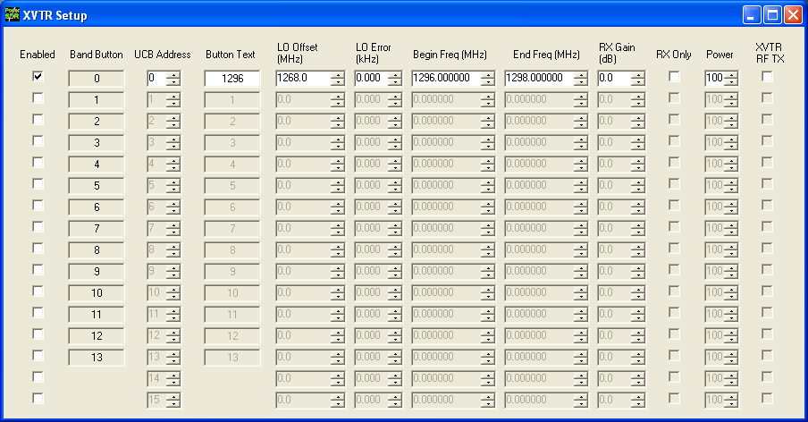
Figure 127: XVTR Setup Form
The XVTR (transverters) Setup Form allows the user to configure up to 16 external transverters for use with the PowerSDR software.
- Enabled: Enables that particular Band Button on the front console with the options selected.
- Band Button: Band button to use for the particular transverter that is being configured.
- UCB Address: Used to set the X2 port for switching the external device (or a relay that controls the external device).
- Button Text: The text that will be shown on the Band Button.
- LO Offset (MHz): The difference between the transverter low frequency and the IF frequency. For example, on 2m, you might use 144-28MHz = 116.0.
- LO Error (kHz): This setting allows the user to correct for any error in the transverter’s oscillator.
- Begin Frequency (MHz): The lower frequency bound for the transverter.
- End Frequency (MHz): The upper frequency bound for the transverter.
- RX Gain (dB): Amount of gain to apply to the incoming signals to compensate for gain within the transverter.
- RX Only: If this box is checked, the radio will not transmit while in this configured band.
- Power: Sets the Drive control on the front console to this value whenever the VFO is within the configured band.
- XVTR RF TX: Determines whether to use the normal 1W RF output or the lower power XVTR output on the RFE board.
- Hide Tune Step: When checked, hides the Tune Step text box on the front console.

(33) CWX Form
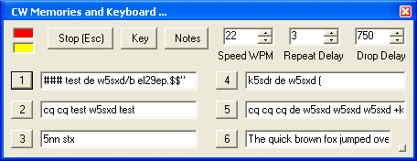
Figure 128: Standard CWX Form

The CWX form is designed to allow you to control automatic Morse code transmission and to send code from your computer keyboard. Pressing the CWX button on the main console menu opens this form. The radio must be in either CWL or CWU mode for transmission to take place.

Standard CWX Controls
- Red Indicator: The small red indicator shows when the radio is transmitting.
- Yellow Indicator: The yellow indicator shows when the key is being ‘pressed’ by the program.
- Key: Clicking this button will cause the radio to start transmitting a steady carrier for up to one minute. Clicking Key again will stop the steady sending.
- Stop (ESC): Clicking this button or the pressing the Esc key on your keyboard will terminate most functions and prepare the program to receive new orders or allow the iambic paddle to be used.
- Notes: Clicking this button will cause a small page of useful notes to be displayed. You can leave the notes up on the screen while you continue to work.
- Speed WPM: This control lets you set the speed of the Morse code being sent. The speed is computed by the standard PARIS method. The softness of the edges may be set by the RAMP control on the Setup Form - DSP Tab, Keyer Sub-Tab. The weighting is always 50% for the memory/keyboard keyer.
Note: This setting is separate from the control on the front console.
- Repeat Delay: This control specifies the amount of time that the keyer will wait when a special pause character is encountered.
- Drop Delay: This control specifies the amount of time that the semi-break in keying will wait before dropping the transmitter when there is no keying occurring.

CWX Memories
There are nine CWX memories, three of which are hidden on the extended form to the right (see below). Each memory can hold thousands of characters and in a standard single line text box. The numbered buttons to the left of each memory box may be clicked to start the message. A message may be stopped at any time by clicking the Stop (Esc) button or pressing the Esc key. Starting a message will seamlessly stop any current message or other automatically keyed transmissions from the radio, including the iambic paddle. The keyer will start the transmitter and send the Morse code for each character until the message ends, at which time the transmitter will shut down. Messages may be edited at any time but the changes will not take place until the memory is started again.

Special Characters
There are several predefined characters that provide non-Morse code functionality or to send familiar combinations like AR and SK (see table below). For beacon transmissions, the character # will send a long 23 element time dash comparable to a zero, with the key down the whole time. Multiple # characters can be strung together for longer continuous dashes. The $ character works in a similar manner but generates a long 23 element time space. The “or ditto” character may be placed at the end of a message. When encountered, the keyer will shut down for the delay time set in the Repeat Delay control and then restart the message. This allows you to program a CQ and then listen for a reply with the radio back in receive. If the delay is set to zero then the message will simply repeat without the radio switching to receive. Six special combinations are preprogrammed, as shown in the table.

[The rest of this page has been left blank intentionally]
Table 8: Overview of Special Characters
Special Character | Action
# | Beacon - transmits 23 element “zero” time dash
$ | Beacon – transmits 23 element time “space”
+ | AR (.-.-.)
( | KN (-.--.)
* | SK (…-.-)
! | SN (…-.)
= | BT (-…-)
\ | BK (-…-.-)
& ‘ ) : ; < > [ ] ^ | User definable, up to any combination of 9 contiguous dots or dashes

The remaining special characters & ‘ ) : ; < > [ ] and ^ are undefined and may be defined to produce any combination of nine contiguous dots and dashes. Characters that are undefined have no dots and dashes and are simply sent as a space.

Keyboard and Extended Controls
Click the little square button in the lower right corner of the form to expand it. When you do this, the remainder of the memories and controls will be visible including the keyboard window as shown below.
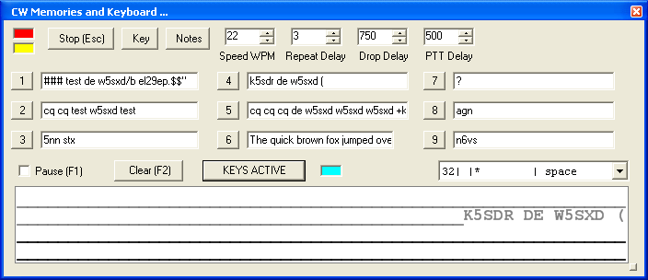
Figure 129: Extended CWX Form

Extended CWX Controls
- Keyboard area: the four-line text box at the bottom. Unsent characters are shown in black and sent characters in gray.
- KEYS ACTIVE. Clicking this button will enable you to use the keyboard to enter characters at the end of the unsent area. As soon as a character is typed it will be sent and then moved to the unsent area. If you type faster than the code is being sent, it will be buffered in the bottom area. cyan indicator shows that Keys Active is enabled.
  - The Backspace key will work in the unsent area.
  - Other editing keys like cut and paste are not implemented.
  - Pressing Alt 1 to Alt 9 or right clicking on the message number button will cause the numbered message memory to be copied into the unsent area just as if you had typed it.
  - The ditto character is ignored in the keyboard mode.
- Pause (F1): Clicking this button or the pressing the F1 key will cause keyboard buffer sending to pause.
- Clear (F2): Clicking this button or pressing the F2 key will clear the keyboard area and stop it sending. Of course, the Stop (Esc) button or the Esc key will do the same.
- PTT Delay: This control allows you to set the time delay between switching the radio to transmit and the first key closure.

[The rest of this page has been left blank intentionally]

Morse Definition Editor
The Morse definition editor allows you to define and even redefine almost all of the characters in the sixty-four-character set. The combo box control to the right of the cyan indicator lets you view and select any of the characters in the set. Each one is displayed as four fixed width fields separated by the | character. There are five special control characters that you may not change and they have an * in the element field.
Once you have selected the character that you wish to edit, left click to select and then right click to bring up the editor dialog.
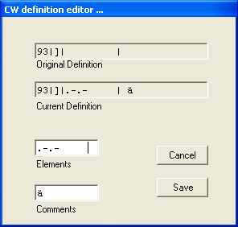
Figure 130: CW Definition Editor
The editor dialog example above shows the ‘]’ character being changed to send didahdidah which is the German code for ä (umlaut a). When your definition appears to be correct, click the Save button and the definition file will be resaved to the disk.
- The definition file is called morsedef.txt and can be found in the same folder as PowerSDR.exe and PowerSDR.mdb. It will not be automatically carried from one version to the next so if you make many changes you might want to save a copy elsewhere.
- The morsedef.txt file can be manually edited with a simple character editor like notepad (not Word), but the format must be followed exactly. Each line must be 26 characters long, not including the two end-of-line codes. It is not free-formatted. The line structure is: a two-digit number field (the decimal ASCII code) | a one-character code field | a nine character elements field | a ten-character comment field preceded by a space and followed by a carriage return and linefeed code. If you mess this file up too badly, simply close PowerSDR, delete morsedef.txt, and a clean, default copy will be created the next time you start. The editor makes simple changes relatively easy to do.

Operation
How to use the SDR-1000 in a typical operating environment.
This chapter is intended to provide the user with a clear understanding of how the SDR-1000 should be used when performing basic operations such as Powering Up or making a voice transmission. We chose to use this section in this way in lieu of listing all of the features of the radio since the feature list would essentially repeat the information given in the three preceding chapters. Please refer to those chapters for complete feature descriptions and how to use the controls.
Note 1: For consistency we will use the same control identifiers as in the preceding Front Console chapter and for clarity we will leave out any identifiers of controls not referenced in the relevant section
Note: The procedures outlined in this chapter assume that the calibration routines outlined in the Calibration section of the Setup Form chapter above have already been carried out.

[The rest of this page has been left blank intentionally]

Power-Up Procedure
The SDR-1000 is unique in that the software does not have a way to cut the 13.8V power to the hardware unit. For this reason, we recommend the following procedure to ensure that the radio starts in a stable, safe state on Power Up:
- Connect the SDR-1000 to the sound card, parallel port (or USB port if you are using the USB to parallel adapter), external key and power supply. Check the connections to ensure good contact.
- Boot up the computer and make sure the PowerSDR software is ready to be launched (no hour glass cursor).
- Turn on the power supply for the radio and flip the SDR-1000 Enclosure switch to the “On” (up) position. You should hear relays click as they receive power. The current should read in the 1A range before starting the software (possibly more depending on installed options).
- Start up the PowerSDR software. You should hear the relays switch as they are reset to the “Stand By” setting. Make sure this step takes place fairly soon after step three as the relays should not be left in the higher current setting for long periods of time. The current should read around 700mA after starting the software.

Power-Down Procedure
The power-down sequence is almost the reverse of the power-up procedure.
- Close the PowerSDR software by clicking on the “X” in the upper right hand corner of the Front Console. This will put the radio in the low power “Stand By” state.
- Flip the SDR-1000 Enclosure power switch to the “Off” (down) position and turn off the power supply.
Note: It is necessary to cut the power at the supply in order to completely power down the radio and ensure the amplifier circuitry is not in a bias state.

CAUTION: Always power down and disconnect the radio before running any other software that requires the use of the parallel port to prevent sending unintended settings to the radio. Such signals could cause damage to the unit.
[The rest of this page has been left blank intentionally]

Tuning Methods

Spectrum Drag and Click
The easiest way to tune signals on the display when set to Panadapter is to simply left click on the signal, and drag it into the filter area. You can also drag the displayed filter edges to adjust the filter width as well.

Mouse Wheel
A mouse wheel is the next easiest way to tune the radio. While the PowerSDR window is active, tune VFO A using the mouse wheel, with the mouse cursor anywhere on the screen. The frequency will change in steps equal to the selected Tune Step (2) for each click of the mouse wheel. Adjust the Tune Step using the controls, clicking the mouse wheel or pressing Ctrl + Left or Right Arrow key.
Note: When the Tune Step equals 1kHz, each click of the mouse wheel will first snap tuning up or down to the nearest 1kHz and then change in 1kHz steps. E.g. if VFO A is tuned to say 14.000258MHz then with the tuning rate set to 1kHz, using the mouse wheel to tune up will first increase VFO A to 14.001000MHz and then to 14.002000MHz, and so on.

Hint: Holding down the Shift key while turning the mouse wheel will change VFO A at the next lower Tune Rate.

Mouse Wheel Hover
Hover with the mouse over a digit in either VFO A or VFO B and increase or decrease its value using the mouse wheel. The digit to be tuned will be underlined.

Spectrum Click Tuning
With the display set to Spectrum, Panadapter, Waterfall or Histogram, hover with the mouse over the display and right-click to cycle through yellow cross-hairs (tune VFO A), red cross-hairs (tune VFO B) or no cross-hairs (click tuning off). With the cross-hairs visible, hover over the desired signal in the display and click the left mouse button. The VFO will be immediately tune to the frequency of the selected signal. When in the CW, AM, or FM modes, the VFO will tune the cursor frequency to the center of the filter pass band. In SSB modes, the VFO will tune to the carrier frequency for the sideband selected.

[The rest of this page has been left blank intentionally]
Note: The red cross-hairs will only be available when either Sub RX (10) or SPLT (12) (or both) is activated. Clicking will then tune the SUB RX frequency and/or the transmit frequency (check Show TX Filter on Display (8) to visualize the latter).

Hint: You can very quickly center a CW, AM or FM signal after click tuning it by clicking the 0 Beat (12) button on the Front Console (make sure the display AVG (9) button is on to enable 0 Beat).

Keyboard Keys
Use he following keys on your keyboard to tune the VFO.
- Numeric Keypad: Key any frequency in MHz (e.g. 7.250) into the numeric keypad and hit enter to immediately jump to that frequency.
- Mapped Keys: You can map keys on your keyboard to tune each of the digits in VFO A using the Keyboard Tab on the Setup Form.
- Ctrl +Arrow Keys: Hold the Control key and press the
  - Up or Down Arrow key to tune VFO A up or down by the Tune Step (2).
  - Right or Left Arrow key to increase or decrease the Tune Step (2).

USB Tuning Knob
Both the Griffin PowerMate and the Contour Designs Shuttle Pro v2 can be used to tune the radio. See the FlexRadio Systems website for documents describing how to setup and use these controllers.

[The rest of this page is intentionally left blank]

Voice Transmission Operation
The following procedure outlines how to setup quickly for voice transmission operation (SSB, AM, or FMN). If something in this procedure is unclear, please contact us, as we would like this to be as simple as possible.
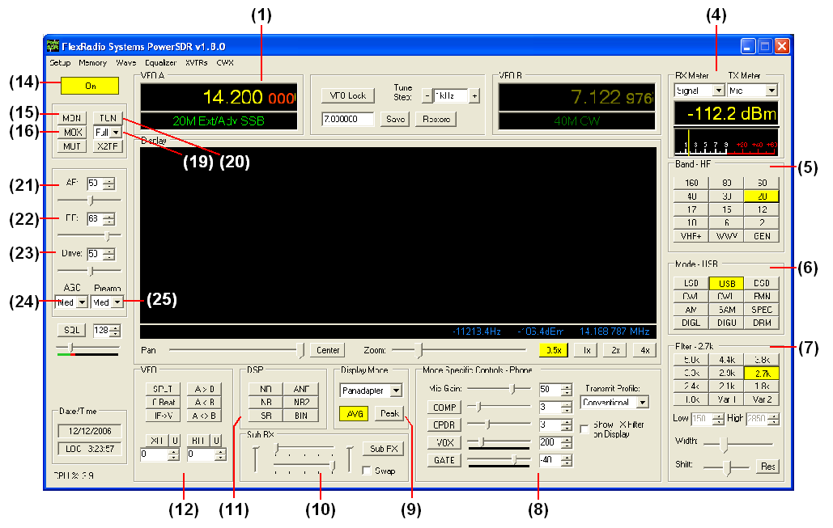
Figure 131 Front Panel Controls Used for Basic Voice Operation.
Please use the above figure to identify the controls referenced in the following step-by-step instruction.

[The rest of this page has been left blank intentionally]
- Follow the Power Up Procedure, described above. Then click the On button (14). Set the following controls as specified. (These are the default settings, so if you have not changed them the settings will be correct).
Table 9: Initial Control Values for Voice Operation
Ctrl | Value | Reference to Figure Above
VFO A | 14.2MHz | (1)
RX Meter | Signal | (4)
TX Meter | MIC | (4)
BAND | 20 | (5)
Mode | USB | (6)
Filter | 2.7kHz | (7)
MIC | 50 | (8)
COMP | Off | (8)
CPDR | Off | (8)
VOX | Off | (8)
GATE | Off | (8)
Display Mode | Panadapter | (9)
Sub RX | Off | (10)
XIT | Off | (12)
RIT | Off | (12)
AF | 50 | (21)
RF | 68 | (22)
Drive | 50 | (23)
AGC | Med | (24)
Preamp | Med | (25)

- Connect a 50 ohm dummy load or tune VFO A (1) to a quiet frequency on the selected band. If using the 100W PA, use the TUN button (20) to verify power output on the TX Meter (4) (Set to Fwd Pow). If using the integrated ATU, select Full on the ATU Mode selection (19) and then click the TUN button (20). See the section below on ATU Operation for more on how to use the ATU.
CAUTION: If not using the ATU and not using a 50 ohm dummy load, ensure that the antenna presents a 50 ohm load with a low SWR or damage may occur to the SDR output transistors.
- Press the Push-to-talk button on the microphone or click the MOX button (16) and speak into the microphone to transmit your voice. Release the Push-to-talk button or click the MOX button (16) to switch the transceiver back to receive. If you do not see modulation on the spectrum, please reference the Troubleshooting chapter below.
- Now that you can see the modulation on the spectrum, it is time to adjust the input. While transmitting, monitor the values with the TX Meter (4) set to Mic. Modify the MIC (8) setting until the TX Meter shows 0dB on peaks while talking in a normal voice at a normal distance from the microphone (above 0dB the signal will be compressed).
- You are now ready to begin a QSO. If a 50 ohm dummy load was connected, connect an antenna in its place. Tune to the desired frequency using one of the methods outlined in the Tuning Methods section above.
Use the Mode Specific Controls – Phone (8) including Compression, Compand, VOX and Noise Gate. Generally, use the compressor to increase average power without adjusting the peaks. Check Show Transmit Filter on Display to visualize the band edges of the transmit filter. This filter can be adjusted on the Transmit Tab of the Setup Form. Detailed explanations of each of these transmit
Hint: For information on how to optimize your audio further, please refer to the Knowledge Base of our website.
- In order to monitor voice transmissions, enable the MON button (15). You may notice a delay due to buffering in the audio/DSP system. This processing delay is normal and is largest when using large buffer sizes and low sound card sampling rates. If you find this delay objectionable, try decreasing it by reducing the Buffer Size and increasing the Sample Rate settings on the Audio Tab and/or DSP Tab of the Setup Form. See the Setup Form chapter above for complete details of the ramifications of changing these controls. Also see the CW Operations section below and our Knowledge Base on how to adjust the driver buffers for our supported sound cards.
- The Fwd Pow setting on the TX Meter (4) will read out average power in Watts according to the DSP or the PA ADC (if the PA is installed). While the average has a short time constant, it is still an average and will not approach 1W (or 100W) in voice modes if calibrated properly even when the Drive control (21) is set to 100. This is also true when monitoring voice transmissions on an external wattmeter.
Note: The typical male voice has a peak to average power ratio of 14dB. Therefore a typical male voice transmission that is peaking at 100W will only average less than 10W. To raise the average power, use the COMP control (8) and the associated slider to increase the compression in 1dB steps. This must be done carefully and incrementally as adding too much compression can result in high levels of distortion.

[The rest of this page has been left blank intentionally]

CW Transmission Operation
The following procedure outlines how to quickly setup for CW transmissions using the Internal Keyer and paddles, an external keyer, the CWX-form or a third party program. For the latter, we will use MixW as an example.
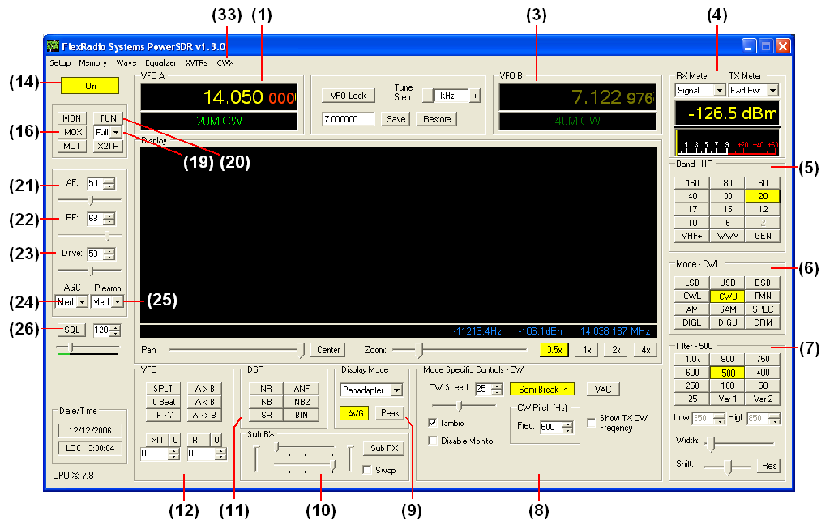
Figure 132: Front Panel Controls Used for CW Operation
Please use the above figure to identify the controls referenced in the following step-by-step instruction.

[The rest of this page has been left blank intentionally]

Initial Settings
- Follow the Power Up Procedure, described above. Then click the On button (14). Set the following controls as specified.
Table 10: Initial Control Values for CW Transmission
Ctrl | Value | Reference to Figure Above
VFO A | 14.05MHz | (1)
RX Meter | Signal | (4)
TX Meter | Fwd Pwr | (4)
Band | 20m | (5)
Mode | CWU | (6)
Filter | 500Hz | (7)
Display Mode | Panadapter | (9)
Sub RX | Off | (10)
XIT | Off | (12)
RIT | Off | (12)
AF | 50 | (21)
RF | 68 | (22)
Drive | 50 | (23)
AGC | Med | (24)
Preamp | Med | (25)

- Connect a 50 ohm dummy load or tune VFO A (1) to a quiet frequency on the selected band. If using the 100W PA, use the TUN button (20) to verify power output on the TX Meter (Set to Fwd Pow). If using the integrated ATU, select Full on the ATU Mode selection (19) and then click the TUN button (20). See the section below on ATU Operation for more on how to use the ATU.
CAUTION: If not using the ATU and not using a 50 ohm dummy load, ensure the antenna presents a 50 ohm load with a low SWR or damage may occur to the SDR output transistor.

[The rest of this page has been left blank intentionally]
Hint: It is important to adjust the latency of the sound card for minimal latency for optimal CW operation. First, adjust the Audio Buffer size as low as possible (512 is a good starting point). Then adjust the sound card buffer settings. For the Delta-44, set the DMA Buffer size (Hardware Settings Tab of Delta Control Panel) to 512 initially. On the Edirol FA-66 Control Panel, adjust the buffer sizes to minimum. Use the highest sampling rate that your system will allow as the higher the sampling rate, the less the latency. Finally, adjust the DSP Buffer size as high as possible for maximum filter sharpness. 2048 is a good default. Further information on optimizing latency can be found in our Knowledge Base.

Internal Keyer
If using PowerSDR’s internal keyer, open the Setup Form – DSP Tab, Keyer Sub-Tab shown below. Several of the controls in this form are also available in the Mode Specific Controls – CW (8) section on the Front Console.
Figure 133: Setup Form – DSP Tab, Keyer Sub-Tab
- If you have your paddles or external keyer connected to a COM port, set the Primary Connection to this COM port. Set the Primary Connection to SDR if you have your paddles or external keyer connected to the SDR keyer input plug (see preceding Plug Pin-Outs chapter).
Hint: For best CW performance, connect your paddles to a serial port using the following table to make the connections.
Table 11: Serial Port CW Pinout
Pin* | Connection
4 (DTR) | Common
6 (DSR) | Dot
8 (CTS) | Dash
* Assumes a 9-Pin connector
- In the Options section, check Iambic for Iambic mode or leave unchecked for a straight key. If the paddles seem reversed, check Rev. Paddle. The Semi Break In option allows the radio to be put into transmit mode simply with detection of keyer input. Set Delay to the amount of time between the last detected input and when the radio will switch back to receive (This should preferably be set higher than 250ms).
- Select the settings for CW Pitch, Weight and Ramp as desired (refer to the Keyer Sub-Tab section of the preceding Setup Form chapter for more detail).
- If not using Semi Break In, click MOX (16) on the Front Console and begin transmitting using your paddles. If using Semi Break In (8), simply begin transmitting to key the radio. If using Iambic mode, adjust the speed with CW Speed (8) on the Front Console. If Disable Monitor is unchecked, you should hear the side tone. Verify with the TX Meter (4) set to Fwd Pwr that there is forward power.
- You are now ready to begin a QSO. If a 50 ohm dummy load was connected, connect an antenna in its place. Tune to the desired frequency using one of the methods outlined in the Tuning Methods section above. Select either CWL or CWU (6) and proceed with the QSO.

External Keyer
- If you have your external keyer connected to a COM port, set the Primary Connection to this COM port. Set the Primary Connection to SDR if you have your external keyer connected to the SDR keyer input plug (see preceding Plug Pin-Outs chapter).
Hint: For best CW performance, connect your external keyer to a serial port. See the table above on how to make the connections.
- In the Options section, leave Iambic unchecked. If your external keyer seems reversed, check Rev. Paddle. If using an external keyer with a sidetone, check the Disable Monitor checkbox to avoid hearing the side tone from the internal keyer. The Semi Break In option allows the radio to be put into transmit mode simply with detection of keyer input. Set Delay to the amount of time between the last detected input and when the radio will switch back to receive (preferably higher than 250ms).
- If using the sidetone from the internal keyer, select the settings for CW Pitch. Select the settings for Weight and Ramp as desired (refer to the Keyer Sub-Tab section of the preceding Setup Form chapter for more detail).
- If not using Semi Break In, click MOX (16) on the Front Console and begin transmitting using your external keyer. If using Semi Break In, simply begin transmitting to key the radio If Disable Monitor is unchecked, you should hear the side tone. Verify with the TX Meter (4) set to Fwd Pwr that there is forward power.
- You are now ready to begin a QSO. If a 50 ohm dummy load was connected, connect an antenna in its place. Tune to the desired frequency using one of the methods outlined in the Tuning Methods section above. Select either CWL or CWU (6) and proceed with the QSO.

CWX Form
If you wish to send CW automatically, click on CWX (33) on the Front Console menu to open the CWX Form shown below. (Refer to the CWX Form section of the preceding Operating Forms chapter for more detail on how to use this form).
Figure 134: CWX Form
- Click on one of the numbered buttons to start transmitting the corresponding CW sequence. Verify with the TX Meter (4) set to Fwd Pwr that there is forward power.
- You are now ready to begin a QSO. If a 50 ohm dummy load was connected, connect an antenna in its place. Tune to the desired frequency using one of the methods outlined in the Tuning Methods section above. Select either CWL or CWU (6) and proceed with the QSO.

[The rest of this page has been left blank intentionally]

Third Party Program
To operate CW with a third party program, you will need to download and install N8VB’s vCOM driver to create a virtual COM port pair through which PowerSDR can be connected to your third party program. The installation and setup of vCOM is described below in the Digital Mode Operation section of this chapter.
In the following we will use MixW as an illustrative example and we will assume the COM6-COM16 virtual COM port pair. We will also assume that PowerSDR is connected to COM6 and MixW to COM16 of this pair (see the Digital Mode Operation section below for details on how to do this)
- In PowerSDR open the Setup Form – DSP Tab, Keyer Sub-Tab shown below to access the Internal Keyer controls
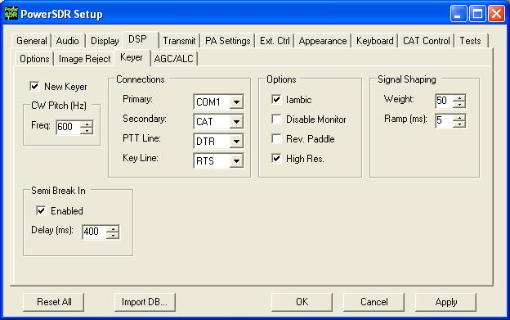
Figure 135: Setup Form – DSP Tab, Keyer Sub-Tab
- Set Secondary Connection to CAT to use the same virtual COM port COM16, as selected on the CAT Control TAB. This will open up two additional selection boxes. Set PTT Line to DTR and Key Line to RTS as shown above.
- In MixW, click Configure on the Menu bar and then select TRCVR CAT/PTT to open the following screen.
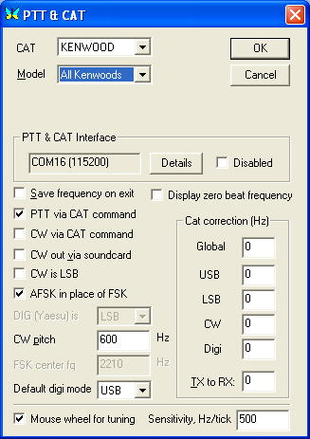
Figure 136: MixW PTT & CAT
- On the PTT & CAT Interface, click on the Details button to open the following form:

[The rest of this page has been left blank intentionally]

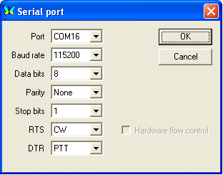
Figure 137: MixW Serial Port Details
- Set the Port to COM16, RTS to CW and DTR to PTT. Click OK on this form and the previous form.
- Change the mode in MixW to CW. Click on the TX button on MixW’s main panel. It should key PowerSDR without generating a tone. Click RX in MixW and PowerSDR should return to receive. If you have entered your callsign in MixW, click on the CQ button. It should key the radio and produce Morse code calling CQ with your call sign. Verify with the TX Meter (4) set to Fwd Pwr that there is forward power.
- You are now ready to begin a QSO. If a 50 ohm dummy load was connected, connect an antenna in its place. Tune to the desired frequency using one of the methods outlined in the Tuning Methods section above. Select either CWL or CWU (6) and proceed with the QSO.
Note: CW VFO Frequency Offset
The VFO on the PowerSDR software is designed to show the zero beat of the CW tone using the selected CW Pitch. For this reason, when in the CW Modes, the center zero line is actually offset by the CW Pitch frequency. This allows click-tuning of CW signals as well as the traditional CW VFO readout. This also enables the VFO to remain constant when switching from CWL to CWU mode. Every effort possible is made to preserve a CW signal when switching between any SSB and CW modes.

[The rest of this page has been left blank intentionally]

Digital Mode Operation
To operate digital modes, PowerSDR needs to connect to third party digital mode programs with both CAT control and Audio connections. PowerSDR realizes the CAT control connection through N8VB’s virtual COM port utility (VCOM) and the Audio connection through the Virtual Audio Cable (VAC) utility. We will explain later in this section how to install and setup each of these two utilities. First, however, we will outline how to operate digital modes with these utilities installed and setup.
Note: Throughout this section we will refer to digital mode programs, which also include logging programs. For the latter the CAT control section applies to enable reading and possibly also controlling PowerSDR’s frequency, band, and operating mode. If the logging program includes a voice keyer, the VAC section may also be relevant.
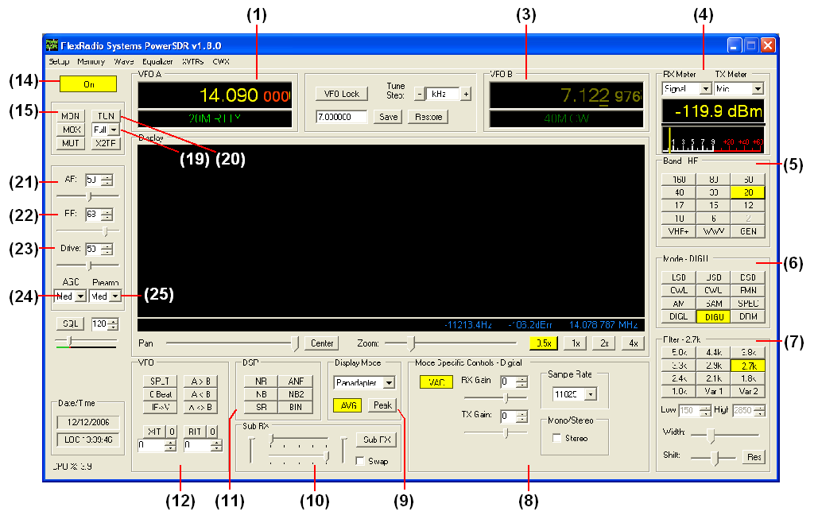
Figure 138: Front Panel Controls Used for Basic Digital Mode Operation
Please use the above figure to identify the controls referenced in the following step-by-step instruction. For consistency we have used the same control identifiers as in the preceding Front Console chapter and for clarity we have left out any identifiers of controls not referenced.
- Follow the Power Up Procedure, described above. Then click the On button (14). Set the following controls as specified.
Table 12: Initial Control Values for Digital Mode Operation
Ctrl | Value | Reference to  Figure Above
VFO A | 14.09MHz | (1)
RX Meter | Signal | (4)
TX Meter | MIC | (4)
BAND | 20 | (5)
Mode | DIGU | (6)
Filter | 2.7kHz | (7)
VAC | On | (8)
Display Mode | Panadapter | (9)
SUB RX | Off | (10)
XIT | Off | (12)
RIT | Off | (12)
AF | 50 | (21)
RF | 68 | (22)
Drive | 50 | (23)
AGC | Med | (24)
Preamp | Med | (25)

- Ensure that on the PowerSDR Setup Form Cat Control is enabled. Also check that VAC (8) is enabled (if VAC is auto-enabled on the Setup Form it will automatically be enabled when DIGL, DIGU or DRM (6) modes are selected).
- Start up your digital mode program and ensure its CAT control and sound card selection are configured to connect to PowerSDR. If so, your digital mode program’s frequency should correspond to PowerSDR’s VFO frequency and it should be receiving Audio from PowerSDR. Use the RX Gain (8) control to adjust the audio level going to your digital mode program (instead of the AF (21) ).
- Connect a 50 ohm dummy load or tune VFO A (1) to a quiet frequency on the selected band. If using the 100W PA, use the TUN button (20) to verify power output on the TX Meter (4) (Set to Fwd Pow). If using the integrated ATU, select Full on the ATU Mode selection (19) and then click the TUN button (20). See the section below on ATU Operation for more on how to use the ATU.
CAUTION: If not using the ATU and not using a 50 ohm dummy load, ensure that the antenna presents a 50 ohm load with a low SWR or damage may occur to the SDR output transistors.
[The rest of this page has been left blank intentionally]
- Click on the Transmit button of your digital mode program. It should switch PowerSDR to transmit. Transmit a test signal (e.g. several CQ calls) in the mode you plan to operate and use the TX Gain (8) control to adjust the volume of audio coming from your digital mode program. Set the TX Meter (4) to ALC and adjust for 0dB to calibrate transmit. Click on Receive on your digital mode program and PowerSDR should switch back to receive.
- You are now ready to begin a QSO. If a 50 ohm dummy load was connected, connect an antenna in its place. Tune to the desired frequency using one of the methods outlined in the Tuning Methods section above. Select either DIGL or DIGU (6) for lower or upper side band digital mode operation respectively. Select DRM (6) for DRM mode operation.
Note 1: The DIGL, DIGU and DRM (6) mode buttons bypass all signal processing in PowerSDR, except for AGC and Filtering. With DIGL and DIGU you have control over the filter width using the filter buttons (7). DRM mode invokes a fixed 10kHz wide double side band filter.
Note 2: DIGL and DIGU (6) apply an offset when using Spectrum Click Tuning (see above). By default, the offsets are set to 1200 Hz (SSTV) in DIGU mode and 2210 Hz (RTTY) in DIGL mode respectively. These offsets can be modified on the Setup Form - General Tab, Options Sub-Tab.

Hint: When operating digital modes you have two options with regards to using filters. On the one hand you can use a wide band-pass filter in PowerSDR and use the filters within your digital mode program for selectivity. On the other hand you can home in on a specific signal with PowerSDR’s filters and ignore the filters in your digital mode program. Although circumstances and operator preference will dictate which to use, many operators have found especially the second option to be of value to them.
If you already have VCOM and VAC up and running, you may ignore the following sub-sections.
We will now focus on installing and setting up N8VB’s VCOM driver and VAC. We will then use MixW as an example on how to use these utilities to operate digital modes.

[The rest of this page has been left blank intentionally]

CAT Control Setup
The CAT control commands of PowerSDR are based on those of the Kenwood TS2000 and have been extended to cover PowerSDR’s many unique features. Additionally, PowerSDR can provide a virtual COM port connection to third party software through VCOM port driver. Special thanks go to N8VB, K5KDN, and KD5TFD for their work on the CAT interface to make all of this work.
The following procedure outlines how to install and setup VCOM.

Install VCOM
First download and install the Virtual Serial Port Driver (VCOM ) from the Downloads page on the FlexRadio website. This program installs one or more pairs of virtual COM ports connected in null modem style. Locate the file you just downloaded (N8VBvCOMSetup-226a.exe) and double-click to start the Windows installer. The following screen will appear.

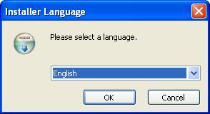
Figure 139: VCOM Installer Language
Select your language of choice and click OK. The welcome screen appears.

[The rest of this page has been left blank intentionally]
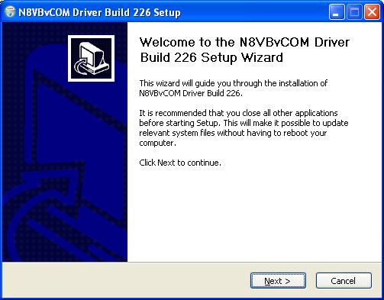.
Figure 140: VCOM Installer Welcome Screen.
Click the Next button to continue the driver installation.

[The rest of this page has been left blank intentionally]
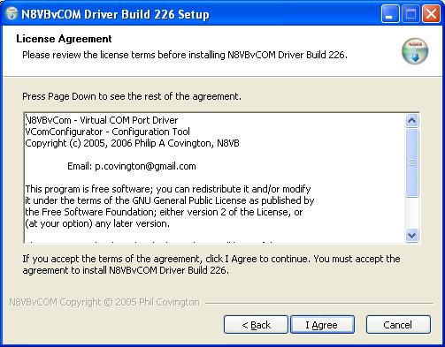
Figure 141: VCOM License Agreement.
Review the License Agreement and click the I Agree button.

[The rest of this page has been left blank intentionally]
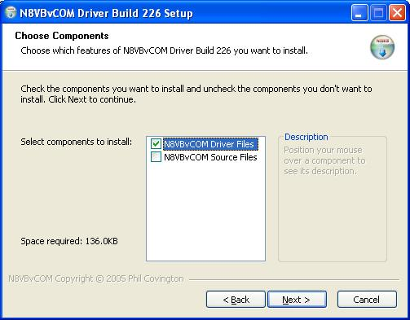
Figure 142: VCOM Installer Component Selection.
Select the components you wish to install and click the Next button.

[The rest of this page has been left blank intentionally]
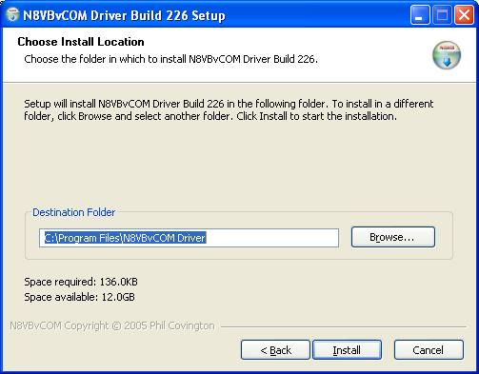
Figure 143: VCOM Install Location
Choose the folder in which to install the driver application in and click the Install button.

[The rest of this page has been left blank intentionally]
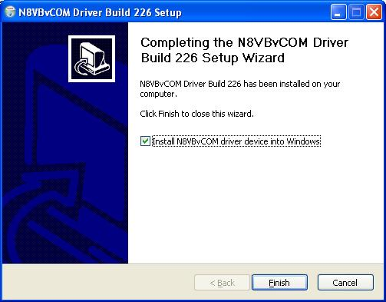
Figure 144: VCOM Installer Complete
Click the Finish button to complete the installation of VCOM. The virtual serial port driver will now be installed on your system. A Command Prompt window displaying status messages will open followed by the warning screen shown below.

[The rest of this page has been left blank intentionally]

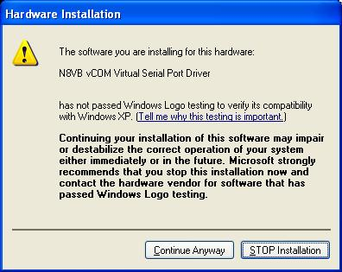
Figure 145: Hardware Installation Warning
Click on the Continue Anyway button to complete the installation.

Configure the VCOM Port Pairs
By default VCOM will install 4 COM port pairs. To view these pairs, to change the default or to remove the driver, locate and start the VCOMConfigurator application (Start→All Programs).

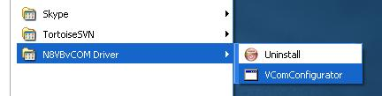
Figure 146: VCOMConfigurator Application
This will open the following screen.

[The rest of this page has been left blank intentionally]
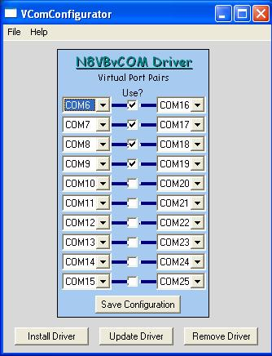
Figure 147: VCOMConfigurator
With VCOMConfigurator, you can select, unselect and modify the desired COM port pairs. Click the Save Configuration button to save your configuration and click Update Driver to update the driver with the new settings. From here you can also remove and install the driver. When you are finished, close VCOMConfigurator .
Now that the virtual COM port pairs are installed, we need to setup the applications to use them. We’ll start with the PowerSDR software. Start up the program and pull up the CAT Control Tab on the Setup Form. For the purpose of this example, we will use the COM6-COM16 pair.

[The rest of this page has been left blank intentionally]

Configure PowerSDR CAT Control
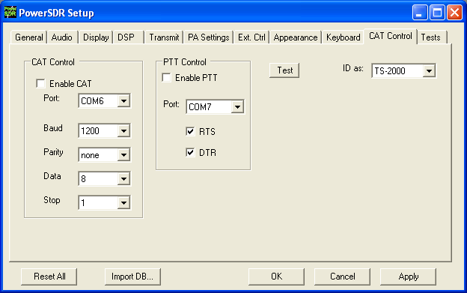
Figure 148: Setup Form Cat Control Tab
Set the controls in the CAT Control Group on the left side of this form to match those shown above to connect PowerSDR to COM 6 of the COM6-COM16 pair. (If you changed the COM port pair settings in VCOMConfigurator you will need to modify the COMx setting to match that change). Set the ID as TS-2000. Once all of the settings are correct, click the Enable CAT check box.
Note 1: As more external applications follow Ham Radio Deluxe to incorporate the Flex Radio SDR-1000 with its extended set of CAT controls, the ID can be changed to SDR-1000. However, in the meantime it is more prudent to select the TS-2000.
Note 2: Some third party applications do not allow you to connect to a high COM port number. In such a case swap COM6 to COM16 above and connect the digital program to COM6. Alternatively, create a different virtual Com port pair, e.g. COM6-COM7.

[The rest of this page has been left blank intentionally]

Configure PowerSDR Keyer Connections
We can setup PowerSDR to connect to third party CW programs using the CAT port (i.e. the COM port used for CAT control - COM 6 in the previous figure). To do so, on the PowerSDR Setup Form, select the DSP Tab and then the Keyer Sub-Tab.
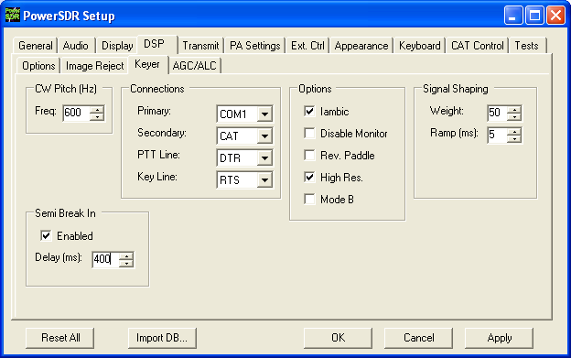
Figure 149: Setup Form - DSP Tab, Keyer Sub-Tab
Within the Connections Group, set Primary to the physical COM port you have your paddles or straight key connected to. Set Secondary (used for keyers and programs) to CAT to use the same (virtual) COM port used for CAT Control. Set PTT Line to DTR and Key Line to RTS. Note that CAT Control must be enabled (see the previous section) before this will work. Click OK.

[The rest of this page has been left blank intentionally]

Virtual Sound Connection
Although you can use a second sound card to connect to an external digital mode program, PowerSDR has the ability to use a virtual sound connection. To do so you will first need to download and install the third party Virtual Audio Cable (VAC) application from one of many sources. VAC is neither free nor open source.
Note: PowerSDR will work correctly with VAC versions 3.09 through 3.12 as well as version 4.02 and above.
In essence VAC enables the creation of so called digital virtual audio cables between two software applications. When setup correctly, these cables appear as input and output audio devices, as if they belonged to a sound card.

Create the Virtual Audio Cables
The first step is to create the two identical virtual cables. To do so open the Virtual Audio Control Panel.
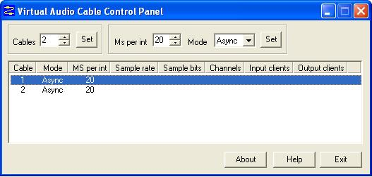
Figure 150: VAC Control Panel
Select 2 Cables and click Set – the 2 cables appear in the lower half of the screen (see the figure above). For each cable in turn select 20 ms per interrupt and Async Mode and click Set. Do not close the Control Panel just yet.

[The rest of this page has been left blank intentionally]

Setup VAC in PowerSDR
Next we need to connect PowerSDR to one side of each of these cables. Startup PowerSDR, but leave it in Standby. Open the Setup Form, click on the Audio Tab and then click on the VAC Sub-Tab.
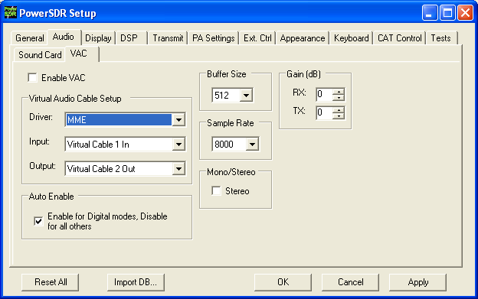
Figure 151: Setup Form - Audio Tab, VAC Sub-Tab
Configure the settings as shown above. Click Enable VAC to manually enable the virtual audio connection or click Auto Enable to automatically enable it when clicking the DigL, DigU or DRM mode button on the Front Console.
Note: The sample rate and Mono/Stereo mode settings shown in the figure above will work for most digital programs. However, especially in the case of DRM the sample rate will need to be increased to 48000 and the mode set to Stereo.

Setting up Third Party Digital Programs
Each third party program has its own method of configuring CAT Control and selecting the COM port and the sound card. In the following, we will use MixW as an illustrative example. We will also discuss how to deal with digital programs that are only able to connect to the default sound device.
Note: Instructions for MMTTY, MMSSTV and WSJT 6 can be found in the VAC Setup and Use Guide in our Knowledge Base.

Using MixW with PowerSDR
Start MixW, which may be downloaded from http://www.mixw.net/.
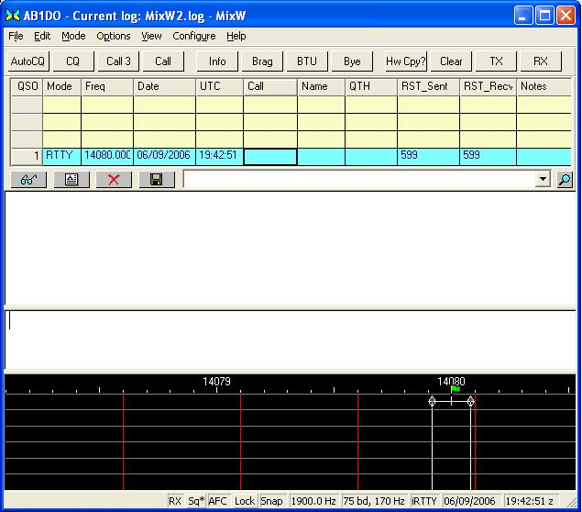
Figure 152: MixW Console
First we will configure MixW to connect through the virtual COM port pair to PowerSDR. Click Configure on the Menu bar and then select TRCVR CAT/PTT to open the following screen.
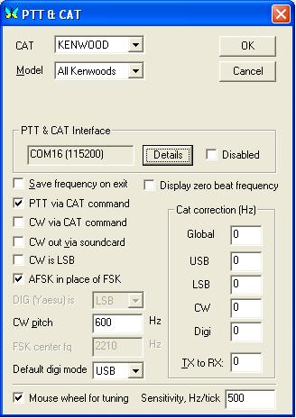
Figure 153: MixW PTT & CAT
Configure the controls as shown above. MixW does not recognize the extended SDR-1000 CAT controls yet. Therefore we set it up as if PowerSDR were a Kenwood radio (In MixW All Kenwoods is the only option available when CAT is set to Kenwood).
On the PTT & CAT Interface, click on the Details button to open the following form:

[The rest of this page has been left blank intentionally]
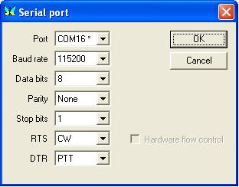
Figure 154: MixW Serial Port Settings
Recall that we are using the COM6-COM16 virtual COM port pair and that we setup PowerSDR to connect to the COM6 end of this pair (see the CAT Control Setup section above). We therefore now select COM16 as the Port in the form above. Set the Baud rate to 115200 (it makes no difference what you set this to).
For RTS and DTR we need to match the settings on the PowerSDR Setup Form, Keyer Sub-Tab. Therefore set RTS to CW and DTR to PTT as shown above. Click OK on this form and then on the PTT & CAT form respectively to accept the settings and close the forms.
On the MixW front console, click again on Configure on the menu bar and this time select Sound device settings… to open the following form:

[The rest of this page has been left blank intentionally]
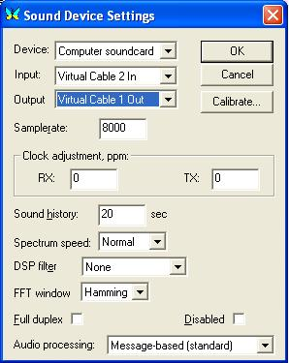
Figure 155: MixW Sound Device Settings
Recall that we previously created 2 virtual audio cables and then configured the PowerSDR VAC Input as Virtual Cable 1 In and Output as Virtual Cable 2 Out.
We now need to connect MixW to the other ends of those two virtual audio cables respectively. Therefore, set Device to Computer sound card, Input to Virtual Cable 2 In and Output to Virtual Cable 1 Out as shown above. If you change the Samplerate setting, MixW will tell you to exit and restart MixW.
Exit MixW for now so we can illustrate the functioning of the virtual audio cables.
Click the Standby/On button to turn PowerSDR on. When you do, the Virtual Audio Cable Control Panel should look like this:

[The rest of this page has been left blank intentionally]
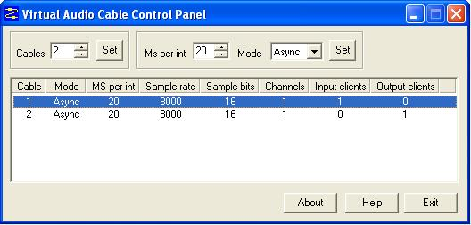
Figure 156: VAC Control Panel - Only PowerSDR Running
Notice that you have two cables. Each of them is a monaural channel (Channels = 1). You have one Input and one Output client. This is PowerSDR.
Now start MixW. You will see a subtle change in the VAC Control Panel:
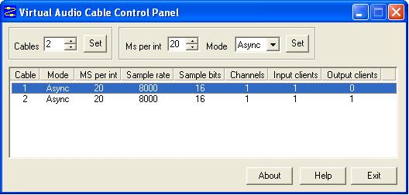
Figure 157: VAC Control Panel: PowerSDR Running and MixW Receiving
MixW is receiving audio from PowerSDR and is the Input client that is now present on Cable 2. If you transmit, this will drop and the first audio cable will get an output client. The MixW display should show signals and its frequency information should correspond to that of PowerSDR. Change frequency in either MixW or PowerSDR and the other will follow.
Change the mode in MixW to CW. Click on the TX button on MixW’s main panel. It should key PowerSDR without generating a tone. Click RX in MixW and PowerSDR should return to receive. If you have entered your callsign in MixW, click on the CQ button. It should key the radio and produce Morse code calling CQ with your call sign. Close the VAC Control Panel; you will no longer need this, unless you intend to create more.

Programs Needing to Connect to the Default Sound Device
Certain digital programs can only select the default sound card (or at best choose a single card by index). For example, MMTTY and MMSSTV choose by index. To enable PowerSDR to work with these programs you will need to change the system default sound card. VAC offers the ability to continue to use your other audio applications through its Audio Repeater utility, which we will now discuss.
To change the default sound card, in Windows click Start and then Control Panel. In Control Panel, double-click on Sounds and Audio Devices to open the Sounds and Audio Devices Properties Form:
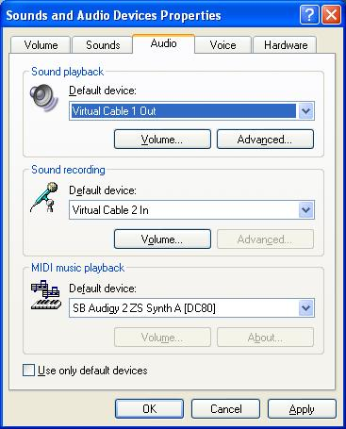
Figure 158: Sounds and Audio Devices Properties Form
Set up the Default device for Sound playback and Sound recording as shown above. (Midi playback is of no concern). Click Apply and then OK.
If you now setup your digital program to select the default sound card, it will work with PowerSDR.
To enable you to continue using other sound programs (MP3 players, etc) despite changing your default sound card settings, VAC comes with a utility called Audio Repeater. Locate Audio Repeater in the VAC program folder and double-click to start it. You should see the following screen:
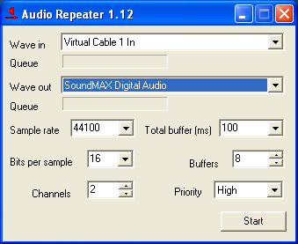
Figure 159: Audio Repeater Utility
To play back audio, set Wave in to Virtual Cable 1 In and Wave Out to the sound card you wish to use. You should keep the Total buffer (ms) as small as practicable to prevent long latency between the sound arriving at the virtual audio cable and it being played to the sound card.

[The rest of this page has been left blank intentionally]

ATU (Antenna Tuning Unit) Operation
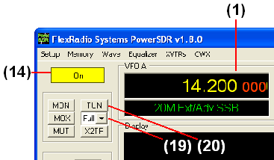
Figure 160: Front Panel Controls Used to Operate the ATU

Note: The ATU offered by FlexRadio is a customized version of the LDG Z-100. For more detailed information please refer to the Z-100 operating manual, which can be found at:
http://www.ldgelectronics.com/manuals/Z-100Manual.pdf.
In the following we will describe how to operate the ATU using the PowerSDR software. Please use the above figure to identify the controls referenced.
- Follow the Power Up Procedure, described above. Then click the On button (14).
- Calibrate the 100W PA using the procedure discussed above in the Automatic Amplifier Gain Calibration section of the Software Setup chapter.
- Select either the Memory or Full tuning mode on the ATU Tuning Mode (19) control.
Note 1: If the ATU Tuning Mode (19) control is not visible on the front panel, enable the ATU Present checkbox on the Hardware Config Sub-Tab of the General Tab of the Setup Form.
Note 2: Bypass will bypass the ATU. Memory will attempt to tune from memory and if no tuned setting is saved near the present frequency, the ATU will perform a full tuning cycle. Full will immediately perform a full tuning cycle, ignoring any previously saved settings.
- Tune VFO A (1) to the frequency/band of choice.
- Click the TUN button (20) to begin the tuning process.
CAUTION: If you change bands after tuning, the ATU is automatically put in Bypass mode for protection. Even if you just change and come back to the same band, you will need to tune again. If you proceed to transmit without retuning, you must present a 50 ohm load with low SWR or damage may occur to the SDR output transistors.
If you get an error message like the one shown below, the PowerSDR and the ATU are not communicating correctly. Please reference the Troubleshooting chapter below.
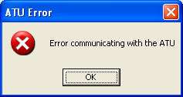
Figure 161: ATU Error Message

[The rest of this page has been left blank intentionally]

Troubleshooting
This section is intended to be a collection of solutions to commonly seen problems with the SDR-1000. While this is not a comprehensive list of everything that could go wrong, there is a good chance that if you are having a problem, the solution may be here. If your problem is not dealt with here, you may be able to find the solution on the Support Pages of our website, in our Knowledge Base, or through our highly active Reflector. If none of these sources provide you the assistance required, please contact FlexRadio Systems using the information provided on the Contact page of our website.

The software is oscillating quickly between receive and transmit modes.
Possible Hardware Causes:
Parallel connection is not solid. Double check that the parallel port is making good contact on both ends. If running the PowerSDR software without hardware connected, it is necessary to check the Disable PTT checkbox on the Options Sub-Tab of the General Tab of the Setup Form.

Relays do not click when starting the software or when cycling the software power button.
Possible Hardware Causes:
- Power Supply/Enclosure switch is not connected/turned on. Verify that the power supply connection is secure and that it is powered up. Ensure that the front panel power switch on the enclosure is in the “On” position. Make sure the power supply can handle the current load of the radio (1.25A without PA, 25A with PA).
- Parallel Cable problem. The parallel cable must be short (no more than 6 feet) and must have straight through connections on all 25 pins. Note that many cables with
- the same 25-pin D-connectors may not work properly because some of the pins are not connected or some are crossed (as used in null modem cables). Check the connections on both ends (PC and enclosure) to ensure that good contact is made. Low line drive could also be an issue. Verify that the signal levels on the parallel port are ~5V (when high) and that the rise time is fast and clean.
Possible Software Causes:
- Incorrect Configuration Settings. Verify that your physical configuration (RFE, PA, XVTR, etc.) matches the Check Boxes in the Setup Form - General Tab, Hardware Config Sub-Tab. Failure to match these settings could cause the software to send the radio commands that it would not understand.
- Incorrect LPT Address. Verify that the parallel port address is set correctly on the Setup Form - General Tab, Hardware Config Sub-Tab. This should almost always be 378 (Hex), but if using an add-on card for the parallel port, it could use a different address. You can verify the address using the following steps. Right Click on My Computer and select Properties to open the System Properties window.
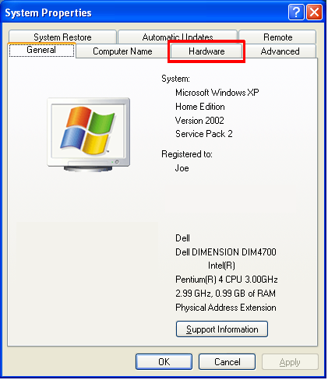
Figure 162: System Properties - General
Click the Hardware Tab.
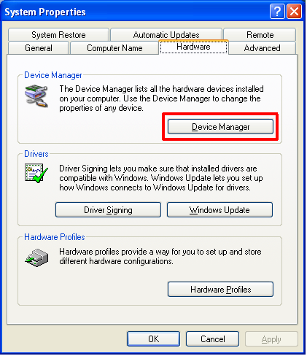
Figure 163: System Properties – Hardware
Click the Device Manager button.

[The rest of this page has been left blank intentionally]

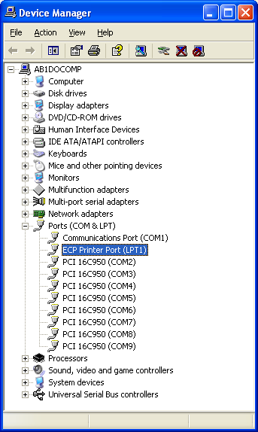
Figure 164: Device Manager
Expand the Ports menu. Right click on the device labeled LPT1 (or LPT2, etc if using an add-on card) and select Properties.

[The rest of this page has been left blank intentionally]

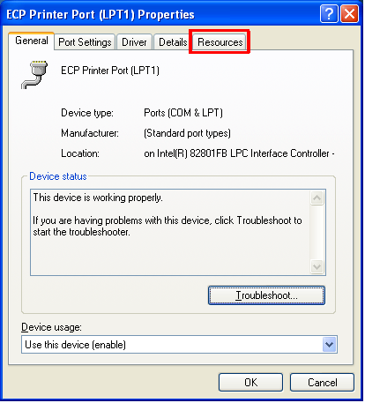
Figure 165: LPT1 Properties - General
Click on the Resources Tab.

[The rest of this page has been left blank intentionally]

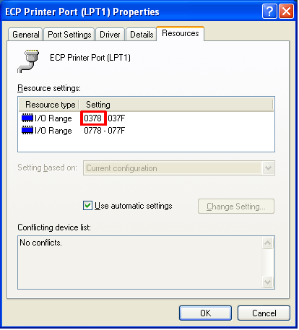
Figure 166: LPT1 Properties – Resources
The first number adjacent to the first I/O Range is the printer port address that should be used in the PowerSDR software (Setup Form - General Tab, Hardware Config Sub-Tab)

Relays click, but I have no audio.
Possible Hardware Causes:
- Powered speakers off or turned down. Ensure that powered (amplified) speakers are connected to the Speaker ports on the sound card and that they are turned on and the volume level is not all the way down.
- Audio cable connections. Check the To Line Out cable for contact and ensure that this is plugged correctly into the sound card. Reference the appropriate quick start guide for your sound card. You should be able to hear noise even without a radio connected.
Possible Software Causes:
- Sound Card issues. Make sure to use a supported sound card as listed on the FlexRadio website (specifications page). These are the only cards we guarantee will work with the radio (others may work, but we can not support them). Make sure that general Windows sounds can be heard through the speakers. Power down the radio first. Then open up the Control Panel (Start → Settings → Control Panel). Select Sounds and Audio Devices.
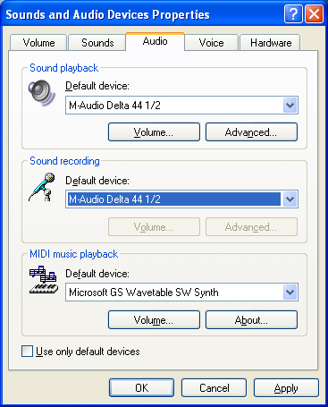
Figure 167: Sounds and Audio Devices – Audio
Select the Audio Tab and temporarily set the default playback and recording device to the sound card attached to the radio (note settings before changing so that you can return to these settings when finished testing). Then click the Sounds Tab.

[The rest of this page has been left blank intentionally]
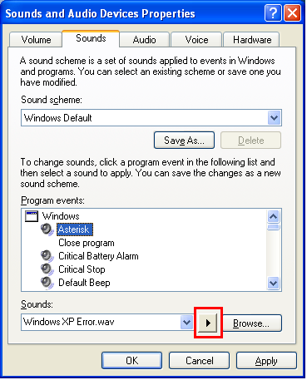
Figure 168: Sounds and Audio Devices – Sounds
Under Program events, select an event that has a speaker next to it (in this case, Asterisk). Click the Play button just to the left of Browse. If you do not hear any sounds, then something is wrong with the audio system. Try reloading the sound card driver and rebooting. The radio will not work without a functional sound card.
- AF and/or RF control is set too low. Setting either of these controls too low could effectively mute the receiver. Try moving this control up to the default level of 50 if it has been turned down.
- PowerSDR Audio Setup. Make sure that the settings on the Audio Tab of the Setup Form reflect the sound card being used. Select the supported sound card from the list of devices using the Combo Box near the top right of the form. If using an external sound card, make sure that it is connected and powered on before launching the PowerSDR software. If this was not the case, close the application, plug in the sound card and turn it on, restart the software, and then double check the settings on the Audio Tab. Reference the Audio Tab, Sound Card Sub-Tab description in the Setup Form chapter above for more information.

Relays click and I hear static, but no signals.
Possible Hardware Causes:
- Audio cable connections. Make sure the To Line In cable is making firm contact on both ends. Reference the quick start guide for your sound card to verify the wiring. A good test to ensure the audio system is working is to unplug the cable from the To Line In plug on the enclosure and place your thumb over the end of the connector. The spectral display noise floor should “jump” each time the connector plug is touched if everything is setup properly.
- Parallel Cable problem. As noted above, if the parallel cable is too long, some of the signals may make it through while others may not. This could cause sporadic tuning and/or relay switching that would prevent normal signals from being heard. Check the connections on both ends (PC and enclosure) to ensure that good contact is made. Low line drive could also be an issue. Verify that the signal levels on the parallel port are ~5V (when high) and that the rise time is fast and clean.
- USB Adapter Problem. If you are using the USB Adapter, make sure that the checkbox on the Setup Form - General Tab, Hardware Config Sub-Tab is checked. If you get an error message, please see the USB Adapter section below.
Possible Software Causes:
Incorrect PowerSDR Audio Setup. Make sure that the settings on the Audio Tab, Sound Card Sub-Tab of the Setup Form reflect the sound card being used. Select the supported sound card from the list of devices using the Combo Box near the top right of the form. If using an external sound card, make sure that it is connected and powered on before launching the PowerSDR software. If this was not the case, close the application, plug in the sound card and turn it on, restart the software, and then double check the settings on the Audio Tab. Reference the Audio Tab, Sound Card Sub-Tab description in the Setup Form chapter above for more information.

I hear signals, but they sound chopped up, like a motorboat.
Possible Software Causes:
- DMA/Latency Setting. If using the M-Audio Delta-44, make sure that the DMA Buffer Size on the Hardware Settings Tab of the Delta Control Panel is set to 512 as shown in the Delta-44 Quick Start Guide. Note that if you are running both the Audio and DSP buffers lower than 512, it will be necessary to adjust the DMA size down to match this. Not all computers will be able to support settings this aggressive due to the increased load on the CPU. If using the Edirol FA-66, check that the Buffer Size settings are adjust according to the FA-66 Quick Start Guide.
- Other applications. The PowerSDR Console is a real time audio application and as such it needs a fair amount of CPU resources in order to keep up with the audio, display, etc. Computer systems close to the minimum specification (1.5GHz) will have a hard time running other applications concurrently with the console without audio artifacts. While faster machines may be able to keep up, we recommend that you close all other applications to get the best performance out of the PowerSDR Console.

I hear signals, but cannot null the image.
Possible Hardware Causes:
- Partially plugged in audio cable. The software uses the left and right channels to feed the I (in phase) and Q (quadrature) signals into and out of the radio. Without both of these channels, opposite sideband rejection is not possible. Quite often this issue is caused by an audio cable that is not making good contact with the stereo plug on the radio (or the sound card). This results in only receiving a single channel of audio. Ensure that all stereo audio cables are completely connected on both ends. Gold plated cables with larger connectors are not recommended as they may prevent the cable from making good contact with the radio plugs due to the larger headers binding on the rear panel of the enclosure. If needed, FlexRadio Systems sells a set of qualified cables. You can monitor the input levels by comparing the RX Meter ADC L and ADC R levels. If they are more than 1.0dB apart, then there is likely a cable problem.
- Stereo Line In required. As noted above, both the I and Q channels are required to run the radio. For this reason, a stereo input to the sound card is necessary. If using an unsupported sound card, double check that the input is indeed a stereo input.
Note: Microphone inputs are generally only mono connections even if they have a balance control associated with them. Laptops generally only have microphone inputs, so using an external USB sound card is recommended for most laptop configurations.
- Reversed Line In cables. Some sound cards use separated cables for the left and right channels. If these cables are reversed, the image would actually be at 22kHz below the actual signal (rather than above). This is easily recognized by looking at what appears to be the actual signal (22kHz below the “Image”). When moving the actual signal up and down, observe whether the signal in the software follows the movements or moves in reverse. If the signal moves in reverse, then the channels are reversed and what you are looking at is the image (hence the reflected behavior).
- Bad Cable. Occasionally, an audio cable will develop a short or open across one or both of the audio lines. This will cause issues similar to what happens if a cable is partially plugged in. This is easily tested using a Voltmeter to check that the tip, ring, and ground sections of each plug are electrically connected.
Possible Software Causes:
Mixer balance offset. Some sound cards like the PreSonus FireBox have balance controls on their mixer. If the balance is offset, one channel will be much stronger than the other and balancing the amplitude of the two channels will not be possible. Make sure the balance control is centered for all mixer controls. You can center the balance controls on the FireBox Mixer by double clicking on the indicator bar. You can verify whether the audio coming into the sound card is balanced using the ADC L and ADC R settings on the multimeter display. These numbers should be within 1.0dB of each other. If not, the software compensation will not be adequate to resolve the difference.

The signals are all off frequency.
Possible Hardware Causes:
If using the external clock option, make sure that the source is truly 10 or 20MHz. Any error in the source will be multiplied up to the DDS. The multiplier should be set so that the source is multiplied up to 200MHz. For example, if your source is 40MHz, a multiplier of 5 should be used.
Possible Software Causes:
- Run Frequency Calibration. The frequency calibration routine described in the Software Installation and Setup chapter fixes this very problem. The radio will likely be off by varying amounts (depending on the frequency) until this calibration is run. Note that some sound cards have error in the sampling rate clock (sometimes due to drift) that can partially be compensated using this calibration routine. For this reason, you may get better results by re-running the calibration after the sound card has been active for a few minutes.
- External Clock Option Frequency Setting. Make sure that if you are using the external clock option that the source frequency/multiplier is set correctly in the software (10 or 20MHz with 20 or 10 as a multiplier).

The noise hiss when no signals are present is fatiguing.
Possible Software Causes:
If you are listening to anything other than very weak signals, the default RF setting on the front panel may be set too high. Decrease the value to prevent the AGC from amplifying the noise to annoying levels. Note that this may make very weak signals (close to the noise floor) harder to copy.

Software does not respond to PTT signals.
Possible Hardware Causes:
Wiring problem. Double check the wiring for the Mic connector and/or the X2 PTT lines using the diagrams in the chapter on Plug Pinouts.
Possible Software Causes:
Disable PTT is checked. Check this setting on the General Tab, Options Sub-Tab of the Setup Form.

The receiver works great, but I am getting no output power.
Possible Hardware Causes:
- Sound card cable issues. Try clicking the TUN button on the front panel with the monitor on (MON) and see if you can hear a tone. It may help to connect speakers or headphones to the end of the cable that is typically plugged into the To Line Out connector. This allows the drive audio to be listened to directly. If no tone is heard, then double check the audio wiring using the quick start guide for your sound card.
- Microphone Cable setup. If the TUN button test works, but voice transmission does not, double check that the microphone is setup correctly. If using a microphone connected to the front panel of the SDR-1000 enclosure, it is necessary to connect the plug on the back labeled To Mic In to the microphone port on the sound card (see quick start guide).
Possible Software Causes:
Drive setting too low. Check the Drive setting on the left side of the front panel. If using the 100W PA, this should set the output to something near the value in watts (i.e. a setting of 65 should give a tone when tuning around 65W). If using the 1W configuration, this will set the output to a percentage of the audio drive where 100 represents full drive (~1W – depending on the frequency being transmitted and sound card output).

I am getting some power out, but the power seems low (also, see above—no power issue).
Possible Hardware Causes:
- I/Q imbalance on output. If the output cable connecting the sound card to the plug labeled To Line Out is damaged, one of the channels may not be as strong as the other. This will result in lower output power, little to no opposite sideband rejection, and distortion. Controls are available to test this on the Test Tab of the Setup Form.
- Drop in power supply voltage. In order to reach full output, the radio needs to have a full 13.8V from the power supply. If the voltage drops even a few tenths of a Volt at the power terminals on keydown, then the amplifier may not be able to operate at full output. Make sure that there is at least #12 AWG wiring from the power supply to the terminals.

[The rest of this page has been left blank intentionally]

Possible Software Causes:
- Drive setting too low. Check the Drive setting on the left side of the front panel. If using the 100W PA, this should set the output to something near the value in watts (i.e. a setting of 65 should give a tone when tuning around 65W). If using the 1W configuration, this will set the output to a percentage of the audio drive where 100 represents a full watt (depends on the sound card).
- Calibration needed. It may be necessary to run the PA calibration routine to calibrate the amplifier using a 100W dummy load. This will set the audio drive through an iterative process using the ADC on board the PA for calculating correction factors by band.

I am getting signal reports that indicate echoing or distortion.
Possible Hardware Causes:
- Audio feedback due to Monitor. Using the monitor during voice communications is not recommended as sensitive microphones can easily pick up amplified signals. Due to the processing delay, this can sound like a repeated, fading echo. If using the monitor during voice communications is absolutely necessary, headphones are recommended.
- Microphone wiring problem. Many microphones are wired similarly to our 8-pin connector. However, our setup requires that we separate the Mic ground from the chassis ground while most microphones have these connected. Having those lines connected creates a ground loop in our system that can result in distortion, echoing, or hum. For these reasons, it is preferable to connect the microphone directly to the sound card if possible.

I am getting signal reports that indicate I am transmitting DSB while in SSB modes.
Possible Hardware Causes:
Line Out cable partially unplugged or damaged. Make sure that the cable going to the plug marked To Line Out is fully seated on both ends (enclosure and sound card). A single output channel (I or Q) will transmit in double sideband.
Possible Software Causes:
TX Image Reject is set incorrectly. Try resetting the controls on the Setup Form - DSP Tab, Image Reject Sub-Tab to zero for both Gain and Phase.

[The rest of this page has been left blank intentionally]

I am getting an error message that says, “Error communicating with ATU.”
Possible Hardware Causes:
Connector broken/not connected. This error is an indication that the software is not seeing the signals from the ATU unit. If you are comfortable opening the enclosure, take the cover off and verify that the larger cables connecting the ATU to the PA are making good contact.

Possible Software Causes:
ATU selected with hardware not present. Note that the software will not work if the ATU is selected without the ATU hardware connected.

It seems like the ATU is not tuning correctly. Is there a way to check?
Yes. Checking the tuning is as easy as taking off the top of the enclosure and monitoring the LEDs on the ATU. While tuning, you will see the red LED flash and you should hear the relays clicking until the ATU finishes. If there is an error while tuning (like not enough RF), the red LED will flash. When the ATU is sent a Bypass command, the Green LED will flash three times. The following table details the feedback from the LEDs after a successful tune.
Table 13: ATU LED SWR Indicators
SWR | Indicator
< 1.5 | Steady Green
1.5 - 2.5 | Flashing Green
> 2.5 | No Green

For more information about the ATU, please reference the manual at:
http://www.ldgelectronics.com/manuals/Z-100Manual.pdf

[The rest of this page has been left blank intentionally]

I get an error when I try to use my USB Adapter that says “USB Device not found. (-1)”
Possible Hardware Causes:
USB adapter not plugged in. The USB adapter must be installed and plugged in to use this option. Make sure that the driver is loaded before checking the box.
Possible Software Causes:
Driver not loaded. The USB adapter requires that a third party driver (USBIO Adapter Driver) be loaded before it will work with the PowerSDR software. Install this driver before checking the USB Adapter box. It may be necessary to update the driver in the Device Manager using the new files located in our Knowledge Base after installing the software mentioned above.

I see a hump around 10kHz below the center line on the display, that doesn’t seem to go away.
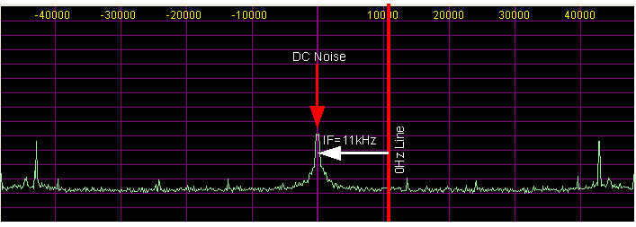
Figure 169: DC Noise "Hump" Below the Center Line
The “hump” that you are seeing on the display is noise around DC (60Hz noise, ground hum, etc). It is offset by 11kHz due to our final RX IF. If Spur Reduction is enabled, the “hump” will move around within a 3kHz window. (See also the section on Panadapter View Controls in the Front Console chapter.) This signal is normal and does not indicate that anything is wrong with the radio or the software setup.
There are several things that you can do to minimize this signal, most of which have to do with ground loops. Having a good solid earth ground seems to have the most effect. Some customers have had success experimenting with various ground lash-ups between the radio and the computer. Another solution is to use an Uninterrupted Power Supply (UPS) to filter the AC line on any components that are attached to the radio (computer, radio power supply, etc.).

PowerSDR is a trademark of Bronze Bear Communications, Inc.
FlexRadio Systems is a registered trademark of Bronze Bear Communications Inc.
G. Youngblood, “A Software Defined Radio for the Masses: Part 1, Part 2, Part 3, and Part 4,” QEX Jul/Aug 2002, Sep/Oct 2002, Nov/Dec 2002, and Mar/Apr 2003 respectively.
An optional filter bank is supplied that can be configured for bands below 160m. Requires external user supplied pre-selector for best operation below 160m
Sound Card: Edirol FA-66 @ 96kHz sampling rate.
40W continuous carrier (100% duty cycle)
We recommend the Astron SS-30 or SS-30M or equivalent power supply for the SDR-1000

